Tenth Sunday after Trinity
Sunday, August 4th, 2024
Divine Service 1, Page 151

Divine Shepherd Lutheran Church & School

7308 Wedgewood Drive
Black Hawk, SD 57718
“We are baptized children of God, forgiven and redeemed by Jesus. We are His family, called together to receive His gifts and serve others.”
Pastor Randy Sturzenbecher
Pastor Dennis Mercer

Office 605-787-6438 Pastor S. Cell 605-391-0428
Pastor M. Cell 443-980-7338
ECC 605-791-1131
Email: dslcpsturz@divineshep.org
dslcpmercer@divineshep.org
dslcsecretary@divineshep.org
Greetings to all in the Name of the Risen Lord!
May our worship this glorious morning celebrate the joy and hope, peace and presence, of our Lord Jesus Christ, raised to life for us. We welcome all, especially our guests. If you do not have a church home, please consider Divine Shepherd. We would love to have you as part of our family. Please take a minute and sign our guest book.

A prayer before Worship
This is the day you have made, O Lord Jesus, a day of new life and eternal celebration! The stone is moved; death is defeated; heaven is open. As Your disciples first saw and believed Your victory over the tomb, so give us joy in the promise You made and keep for us: because You live, we live also! Amen.

The Lord’s Supper
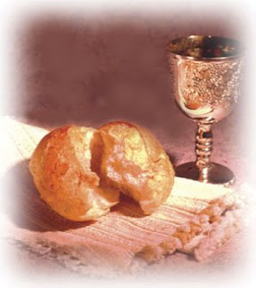
The Lord’s Supper is celebrated by us this morning in the confession and gladness that, as our Lord says, He gives into our mouth not only bread and wine but His very body and blood to eat and drink for the forgiveness of sins and to strengthen our union with Him and with one another. Our Lord Jesus invites to His table those who trust His Words, repent of all sin, and set aside any refusal to forgive and love as He forgives and loves us, that they may show forth His death until He comes.

Whoever, therefore, eats the bread or drinks the blood of the Lord in an unworthy manner will be guilty concerning the body and blood of the Lord.
(1 Cor 11:28 ESV) Holy Communion is a confession of the faith which is confessed at this altar. Any who holds a confession differing from that of the Holy Scriptures or are not a member in good standing with the LC-MS, are asked to speak with Pastor Sturzenbecher.
583 God Has Spoken by His Prophets
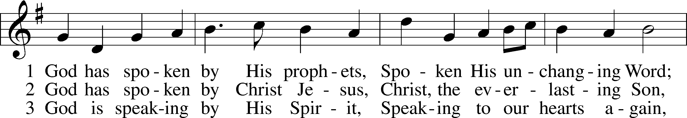
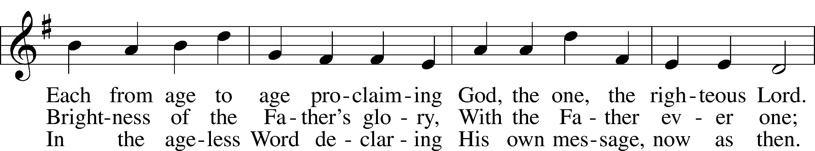
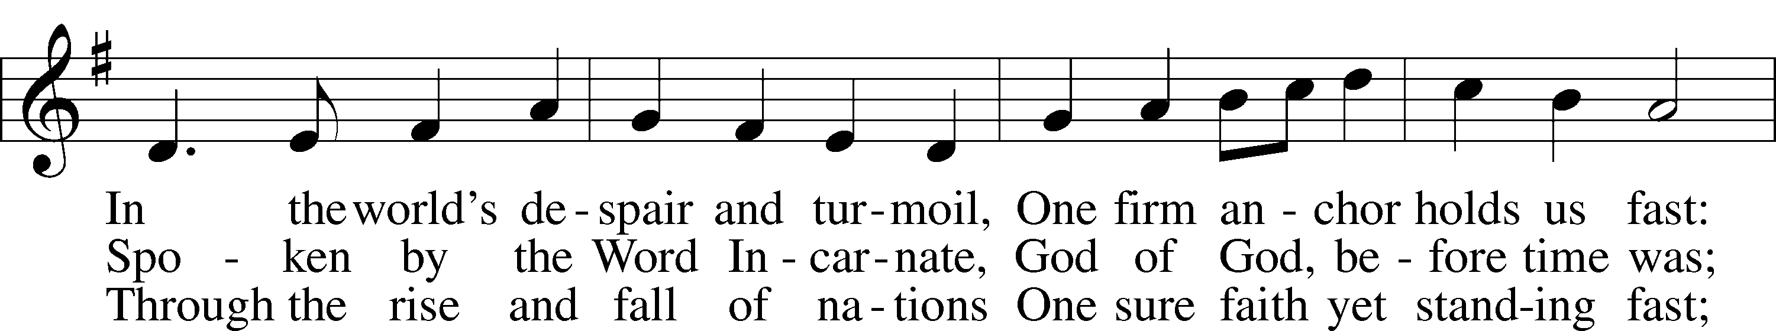
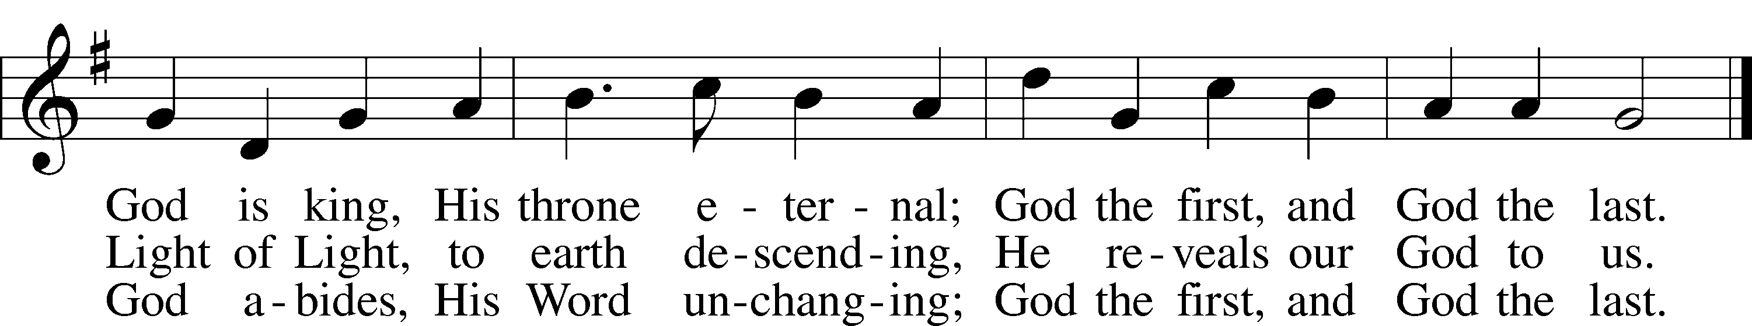
Text: George W. Briggs, 1875–1959, alt.
Tune: Henry T. Smart, 1813–79
Text: © 1953, renewed 1981 The Hymn Society, admin. Hope Publishing Co. Used by permission: LSB Hymn License no. 110004822
Tune: Public domain

Invocation & Exhortation
P In the name of the Father and of the + Son and of the Holy Spirit.
C Amen.
P If we say we have no sin, we deceive ourselves, and the truth is not in us.
C But if we confess our sins, God, who is faithful and just, will forgive our sins and cleanse us from all unrighteousness.

Confession of Sins
P Let us then confess our sins to God our Father.
C Most merciful God, we confess that we are by nature sinful and unclean. We have sinned against You in thought, word, and deed, by what we have done and by what we have left undone.
We have not loved You with our whole heart; we have not loved our neighbors as ourselves. We justly deserve Your present and eternal punishment. For the sake of Your Son, Jesus Christ, have mercy on us. Forgive us, renew us, and lead us, so that we may delight in Your will and walk in Your ways to the glory of Your holy name. Amen.

Absolution
P Almighty God in His mercy has given His Son to die for you and for His sake forgives you all your sins. As a called and ordained servant of Christ, and by His authority, I therefore forgive you all your sins in the name of the Father and of the + Son and of the Holy Spirit.
C Amen.

Introit Psalm 55:1, 4–5, 16
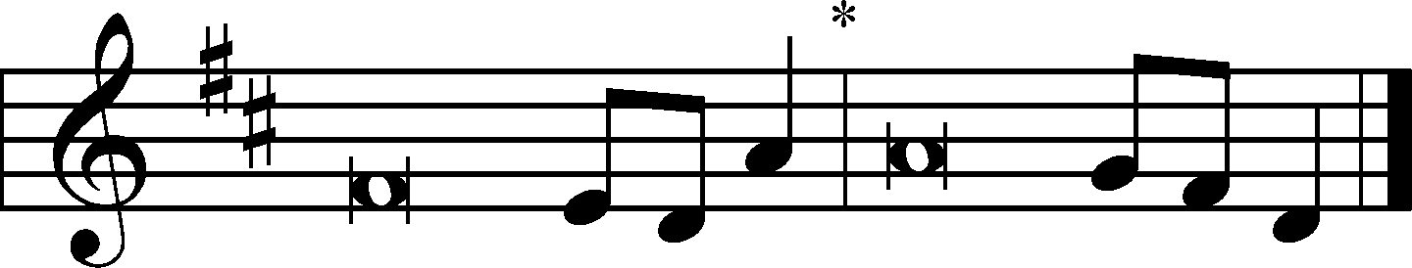
I call to God, and he | hears my voice;*
he redeems my soul in | safety.
Cast your burden | on the Lord,*
and he will sus- | tain you.
Give ear to my prayer, | O God,*
and hide not yourself from my plea for | mercy!
My heart is in anguish with- | in me;*
the terrors of death have fallen up- | on me.
Fear and trembling come up- | on me,*
and horror over- | whelms me.
But I | call to God,*
and the Lord will | save me.
Glory be to the Father and | to the Son*
and to the Holy | Spirit;
as it was in the be- | ginning,*
is now, and will be forever. | Amen.
I call to God, and he | hears my voice;*
he redeems my soul in | safety.
Cast your burden | on the Lord,*
and he will sus- | tain you.

Kyrie
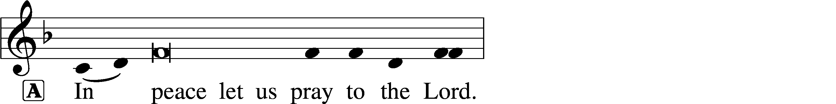
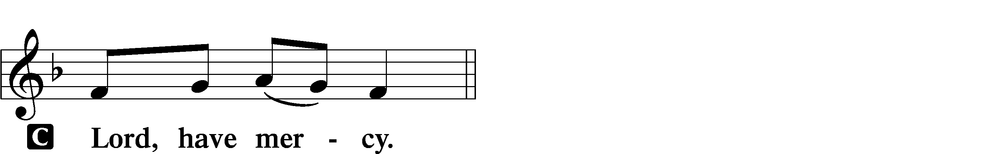
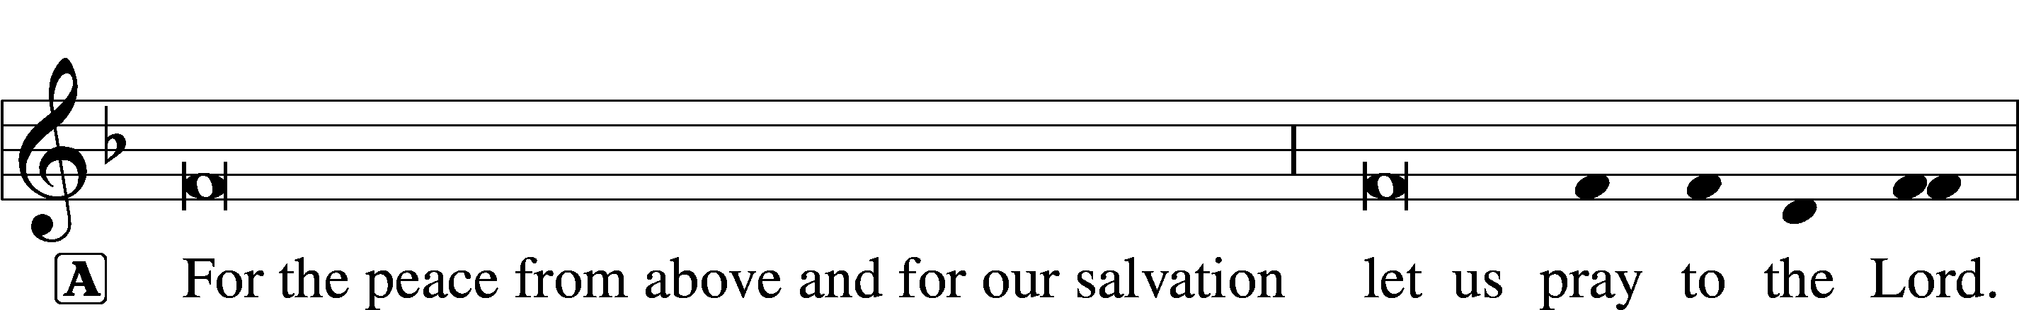
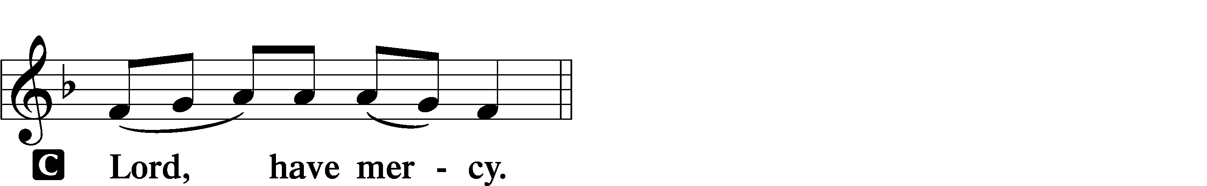
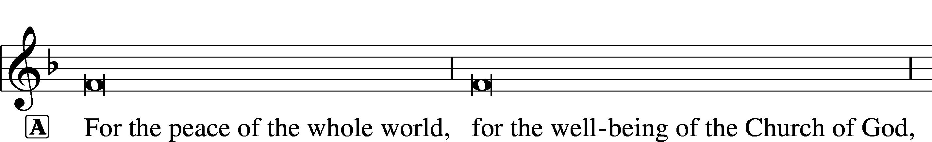
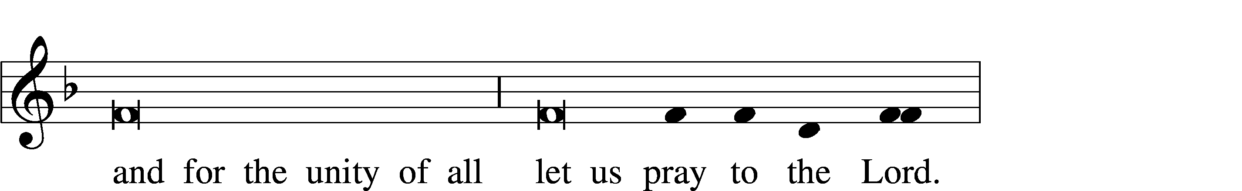
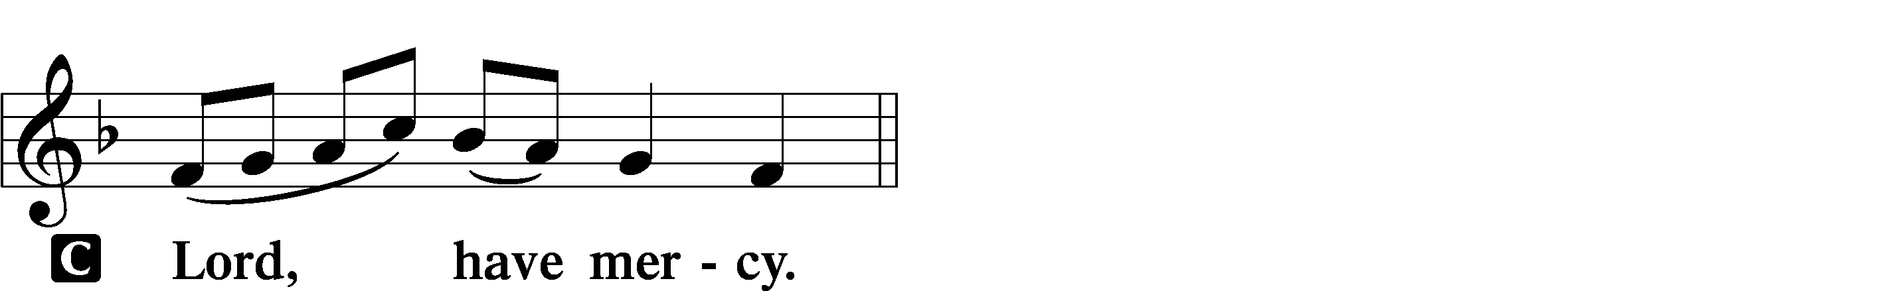
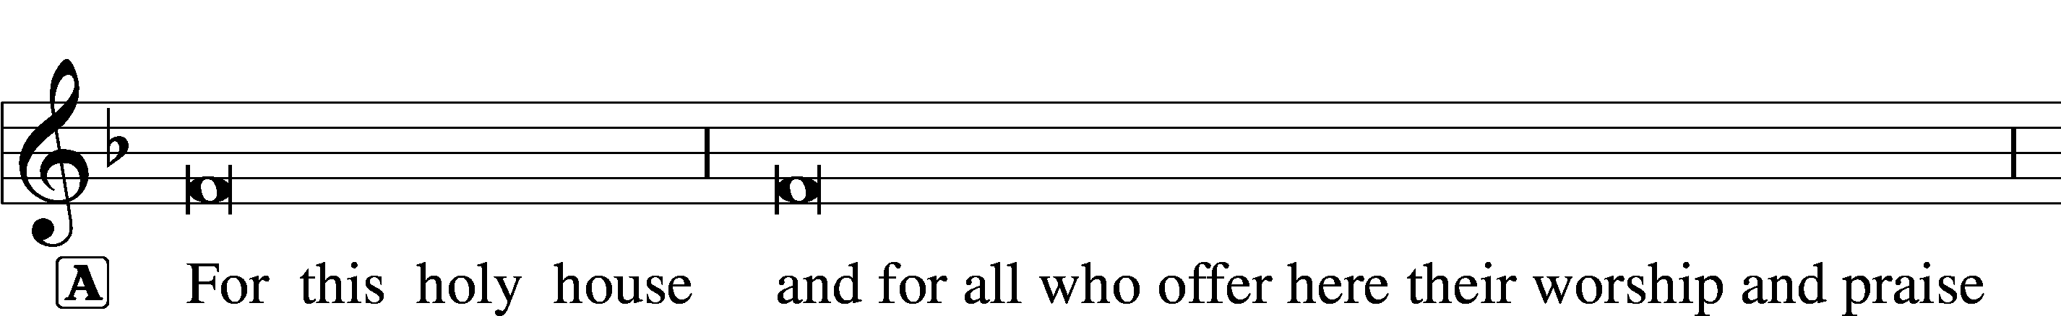
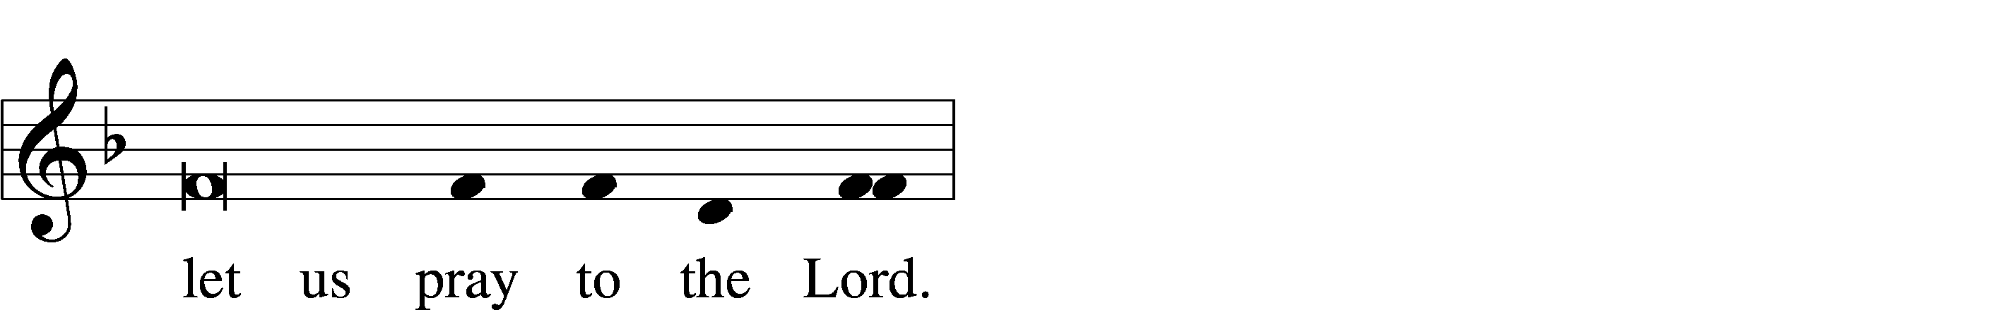
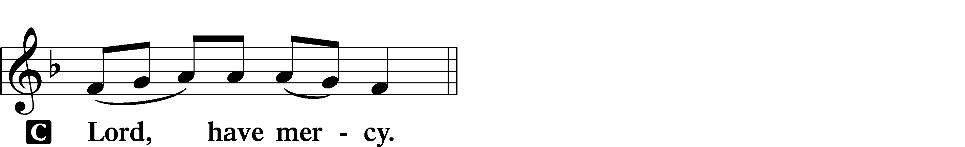
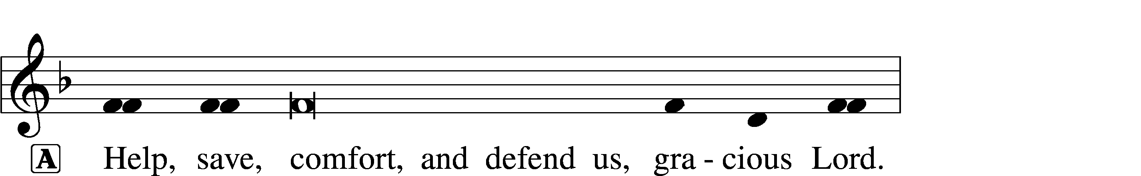
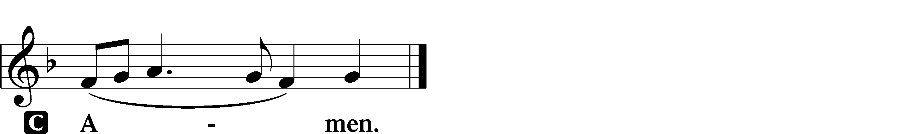

Gloria in Excelsis
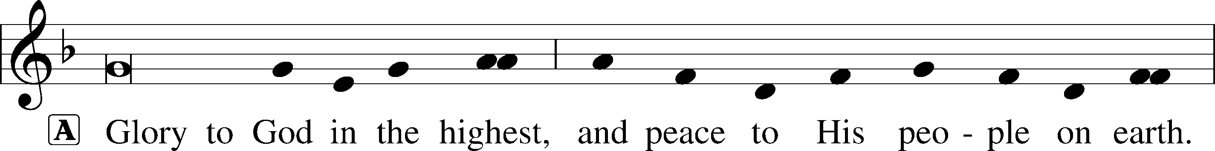
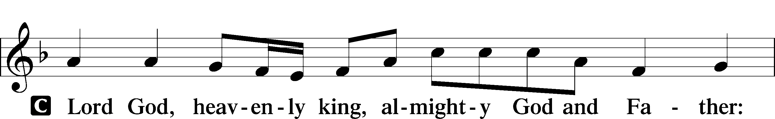
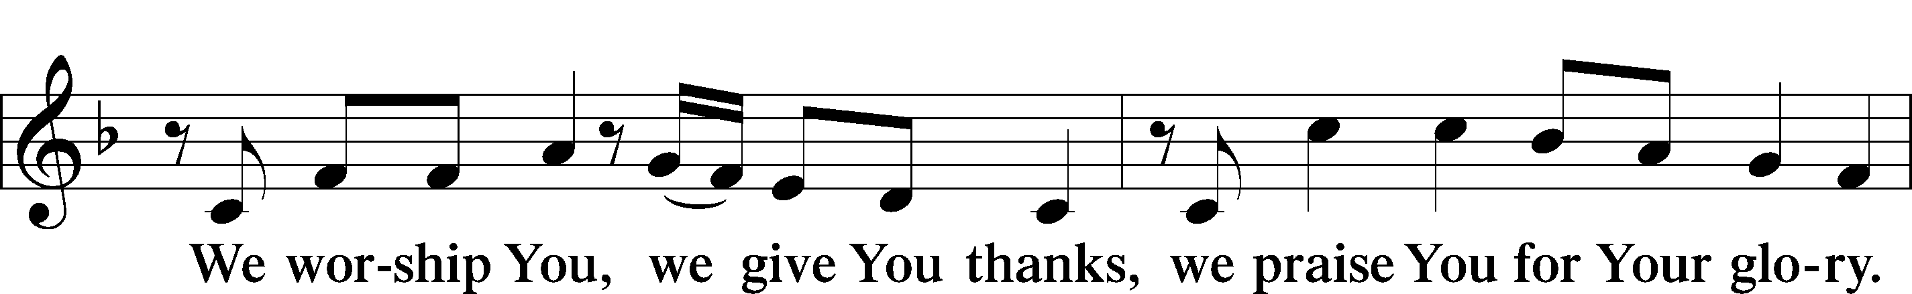
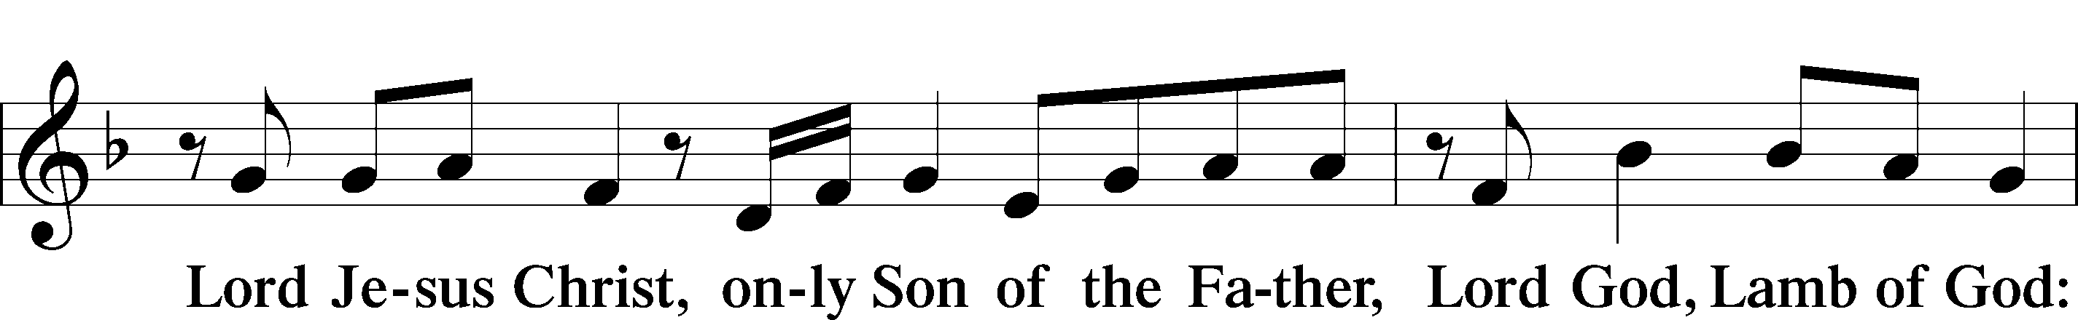
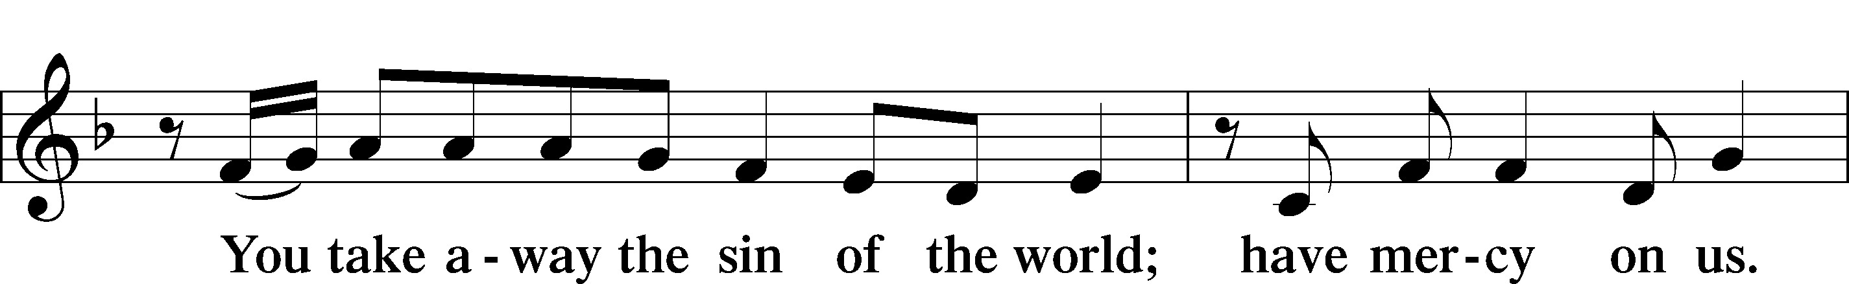
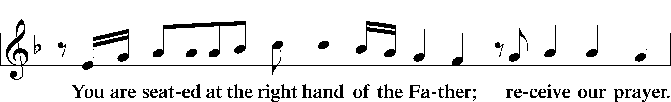
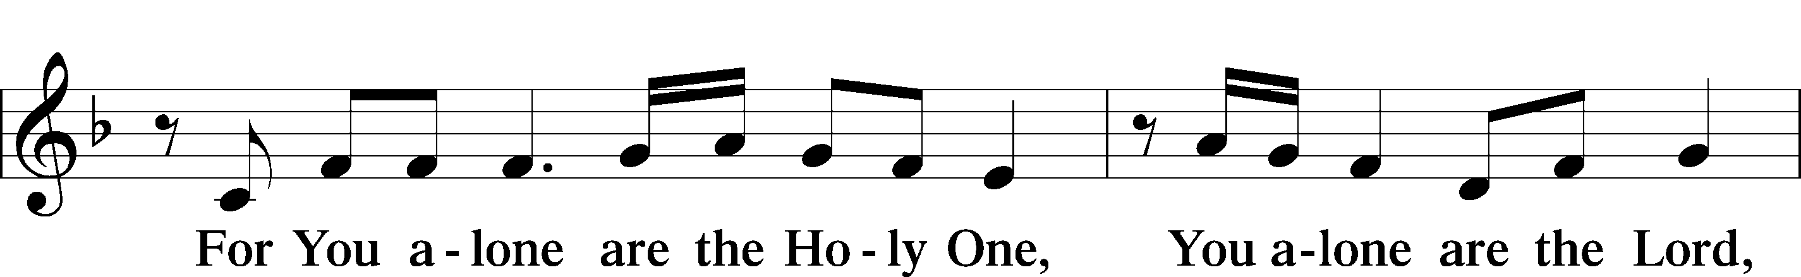
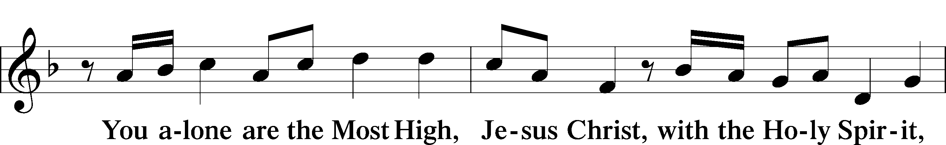
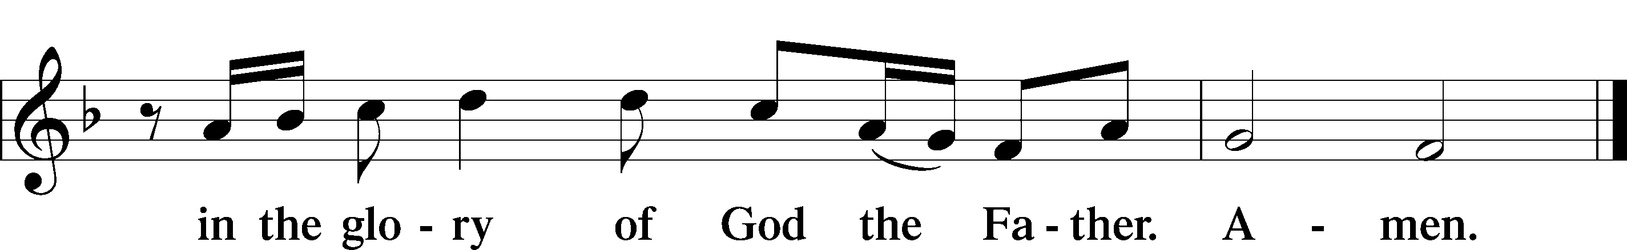

Salutation and Collect of the Day
P The Lord be with you.
C And also with you.
P Let us pray.
O God, You declare Your almighty power above all in showing mercy and pity. Mercifully grant us such a measure of Your grace that we may obtain Your gracious promises and be made partakers of Your heavenly treasures; through Jesus Christ, Your Son, our Lord, who lives and reigns with You and the Holy Spirit, one God, now and forever.
C Amen.

Old Testament Reading Jeremiah 7:1–11
¹The word that came to Jeremiah from the Lord: ²“Stand in the gate of the Lord’s house, and proclaim there this word, and say, Hear the word of the Lord, all you men of Judah who enter these gates to worship the Lord. ³Thus says the Lord of hosts, the God of Israel: Amend your ways and your deeds, and I will let you dwell in this place. ⁴Do not trust in these deceptive words: ‘This is the temple of the Lord, the temple of the Lord, the temple of the Lord.’⁵“For if you truly amend your ways and your deeds, if you truly execute justice one with another, ⁶if you do not oppress the sojourner, the fatherless, or the widow, or shed innocent blood in this place, and if you do not go after other gods to your own harm, ⁷then I will let you dwell in this place, in the land that I gave of old to your fathers forever.⁸“Behold, you trust in deceptive words to no avail. ⁹Will you steal, murder, commit adultery, swear falsely, make offerings to Baal, and go after other gods that you have not known, ¹⁰and then come and stand before me in this house, which is called by my name, and say, ‘We are delivered!’—only to go on doing all these abominations? ¹¹Has this house, which is called by my name, become a den of robbers in your eyes? Behold, I myself have seen it, declares the Lord.”

Catechetical Review
The Second Petition of The Lord’s Prayer
Thy kingdom come.
What does this mean?
The kingdom of God certainly comes by itself without our prayer, but we pray in this petition that it may come to us also.

How does God’s kingdom come?
God’s kingdom comes when our heavenly Father gives us His Holy Spirit, so that by His grace we believe His holy Word and lead godly lives here in time and there in eternity.

The Third Petition of The Lord’s Prayer
Thy will be done on earth as it is in heaven.
What does this mean?
The good and gracious will of God is done even without our prayer, but we pray in this petition that it may be done among us also.
How is God’s will done?
God’s will is done when He breaks and hinders every evil plan and purpose of the devil, the world, and our sinful nature, which do not want us to hallow God’s name or let His kingdom come; and when He strengthens and keeps us firm in His Word and faith until we die. This is His good and gracious will.

Epistle Romans 9:30—10:4
³⁰What shall we say, then? That Gentiles who did not pursue righteousness have attained it, that is, a righteousness that is by faith; ³¹but that Israel who pursued a law that would lead to righteousness did not succeed in reaching that law. ³²Why? Because they did not pursue it by faith, but as if it were based on works. They have stumbled over the stumbling stone, ³³as it is written, “Behold, I am laying in Zion a stone of stumbling, and a rock of offense; and whoever believes in him will not be put to shame.” ¹Brothers, my heart’s desire and prayer to God for them is that they may be saved. ²I bear them witness that they have a zeal for God, but not according to knowledge. ³For, being ignorant of the righteousness that comes from God, and seeking to establish their own, they did not submit to God’s righteousness. ⁴For Christ is the end of the law for righteousness to everyone who believes.
Alleluia and Verse
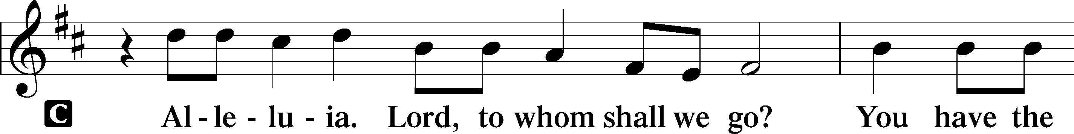
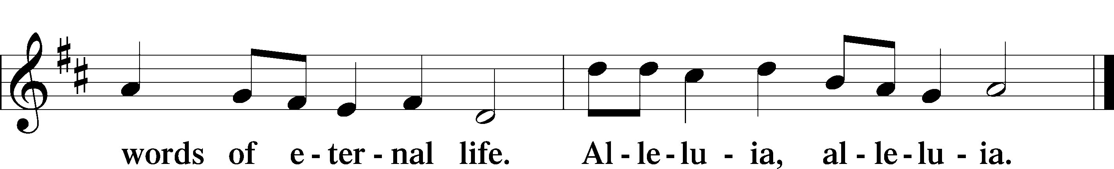

Holy Gospel Luke 19:41–48
P The Holy Gospel according to St. Luke, the nineteenth chapter.
C Glory to You, O Lord.
⁴¹When [Jesus] drew near and saw the city, he wept over it, ⁴²saying, “Would that you, even you, had known on this day the things that make for peace! But now they are hidden from your eyes. ⁴³For the days will come upon you, when your enemies will set up a barricade around you and surround you and hem you in on every side ⁴⁴and tear you down to the ground, you and your children within you. And they will not leave one stone upon another in you, because you did not know the time of your visitation.” ⁴⁵And he entered the temple and began to drive out those who sold, ⁴⁶saying to them, “It is written, ‘My house shall be a house of prayer,’ but you have made it a den of robbers.” ⁴⁷And he was teaching daily in the temple. The chief priests and the scribes and the principal men of the people were seeking to destroy him, ⁴⁸but they did not find anything they could do, for all the people were hanging on his words.
P This is the Gospel of the Lord.
C Praise to You, O Christ.

Children’s Message

540 Christ, the Word of God Incarnate
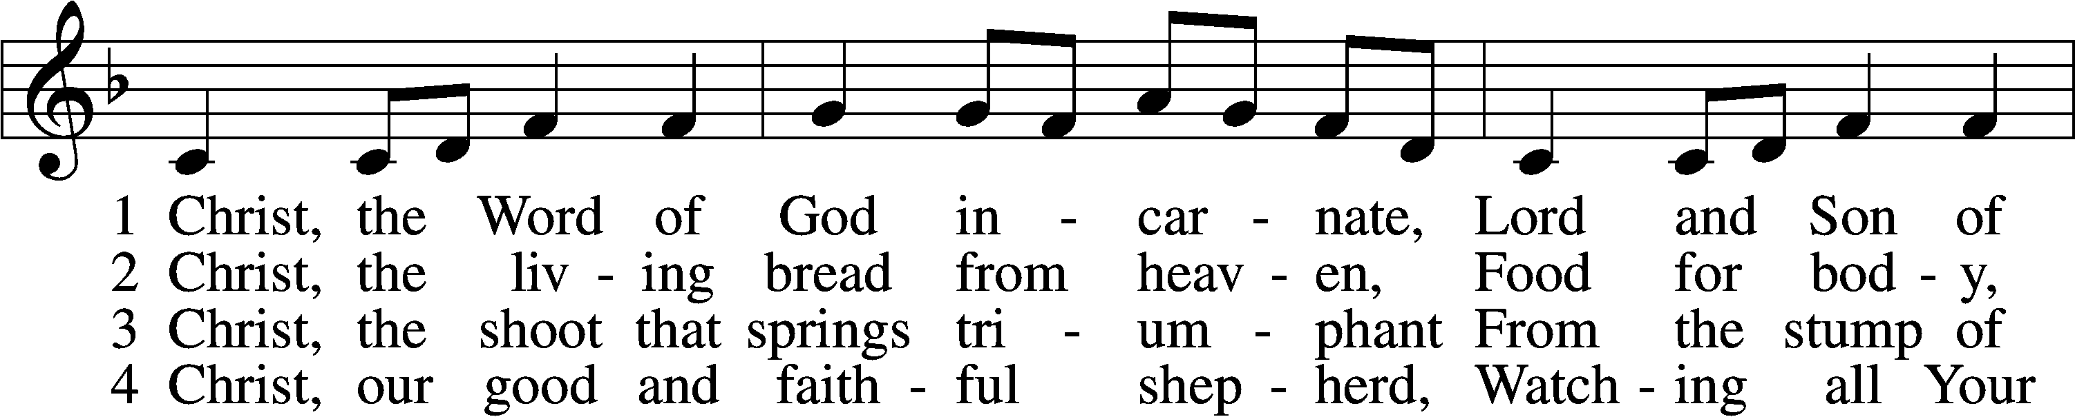
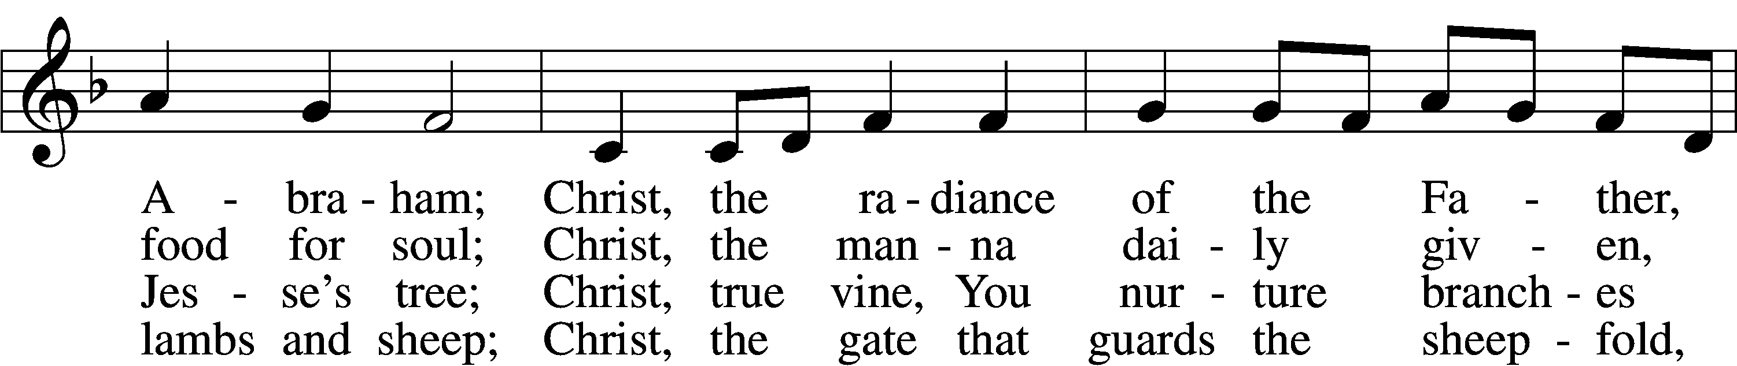
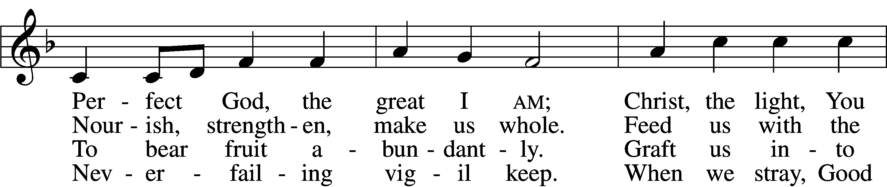
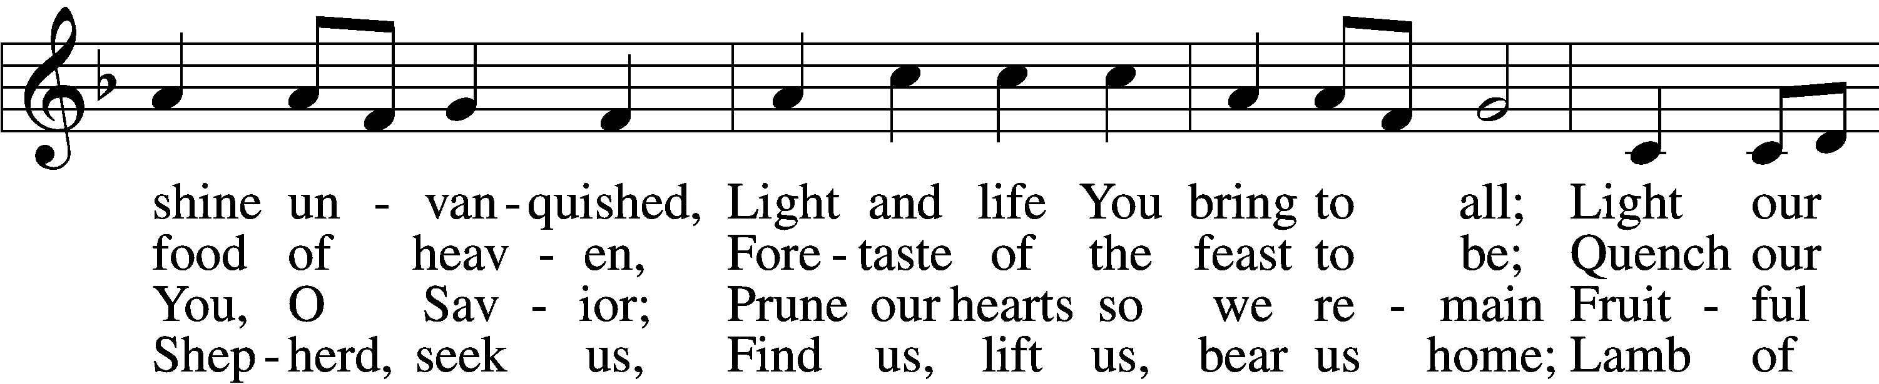
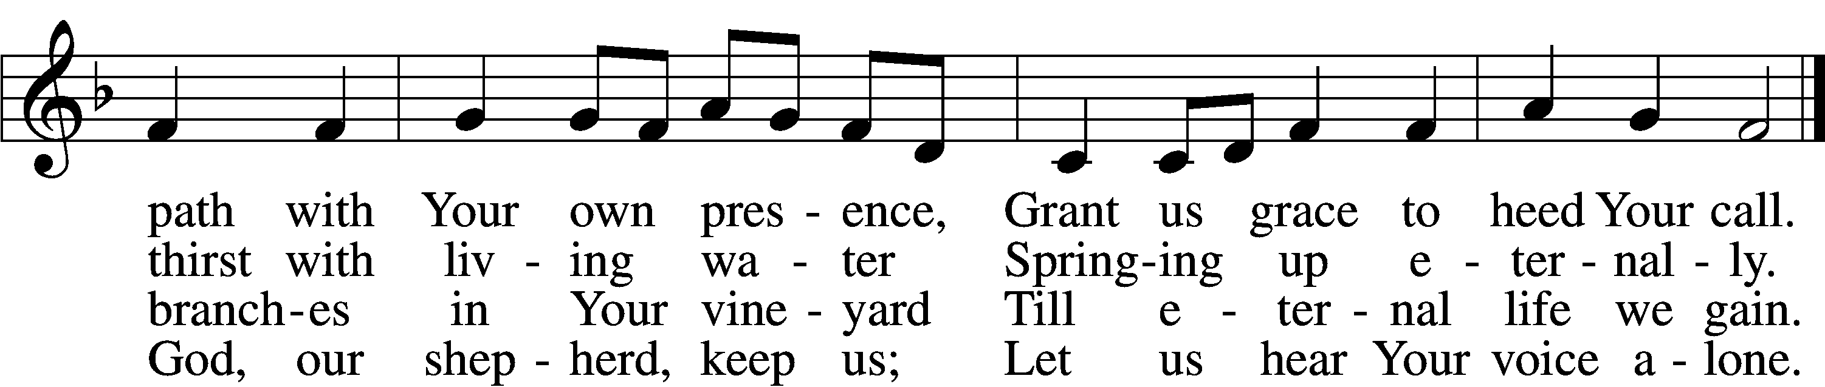
5 Christ, the way that leads unfailing
To the Father’s home on high,
Christ, the truth that frees the captive,
Christ, the life that cannot die.
Mediator to the Father,
Sacrifice and great High Priest:
Lead us to Your heav’nly mansions,
There to share Your wedding feast.

D6 Christ, the Alpha and Omega,
Christ, the firstborn from the dead,
Christ, the life and resurrection,
Christ, the Church’s glorious head:
Praise and thanks and adoration
And unending worship be
To the Father and the Spirit
And to You eternally.
Text: Steven P. Mueller, 1964
Tune: Columbian Harmony, 1825, Cincinnati
Text: © 2001 Steven P. Mueller. Used by permission: LSB Hymn License no. 110004822
Tune: Public domain

Sermon

Nicene Creed
C I believe in one God, the Father Almighty, maker of heaven and earth and of all things visible and invisible. And in one Lord Jesus Christ, the only-begotten Son of God, begotten of His Father before all worlds, God of God, Light of Light, very God of very God, begotten, not made, being of one substance with the Father, by whom all things were made; who for us men and for our salvation came down from heaven and was incarnate by the Holy Spirit of the virgin Mary and was made man; and was crucified also for us under Pontius Pilate.
He suffered and was buried. And the third day He rose again according to the Scriptures and ascended into heaven and sits at the right hand of the Father. And He will come again with glory to judge both the living and the dead, whose kingdom will have no end. And I believe in the Holy Spirit, the Lord and giver of life, who proceeds from the Father and the Son, who with the Father and the Son together is worshiped and glorified, who spoke by the prophets. And I believe in one holy Christian and apostolic Church, I acknowledge one Baptism for the remission of sins, and I look for the resurrection of the dead and the life + of the world to come. Amen.
Prayer of the Church “Hear Our Prayer”

Offering

Offertory
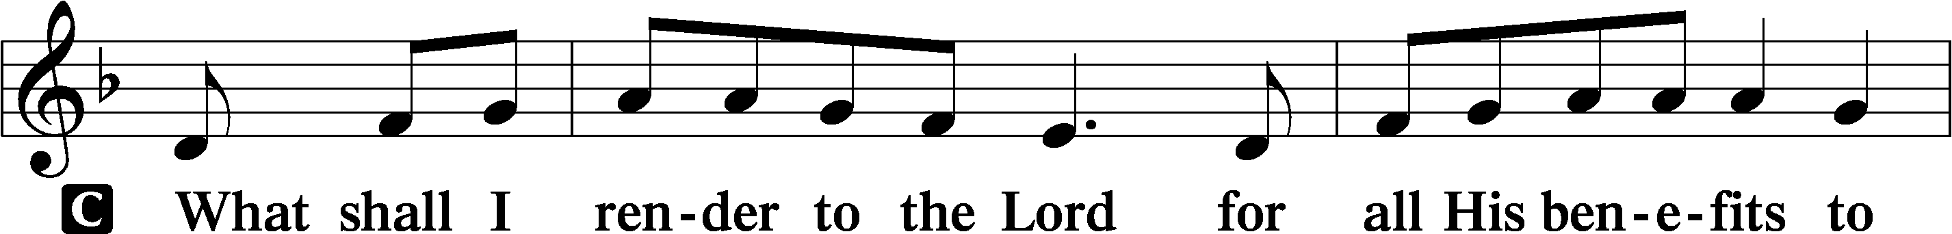
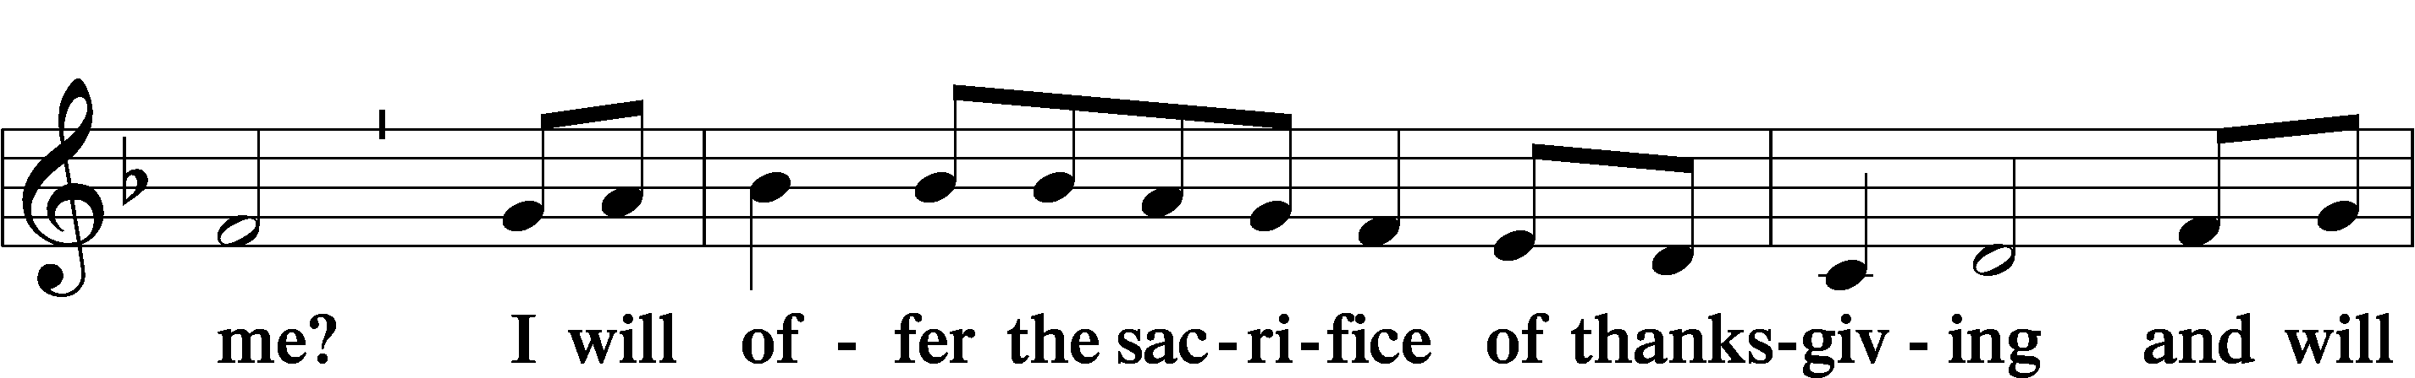
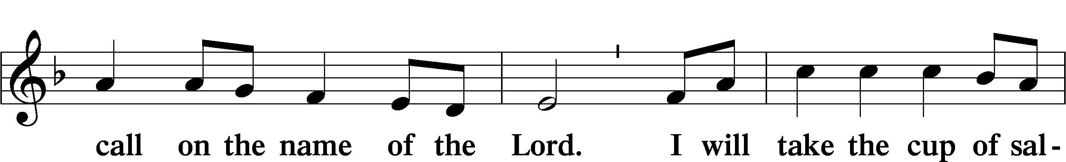
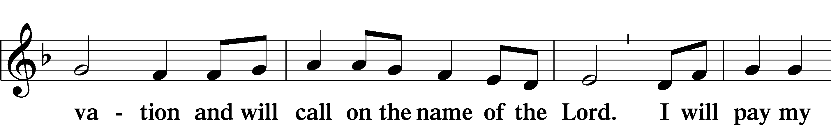
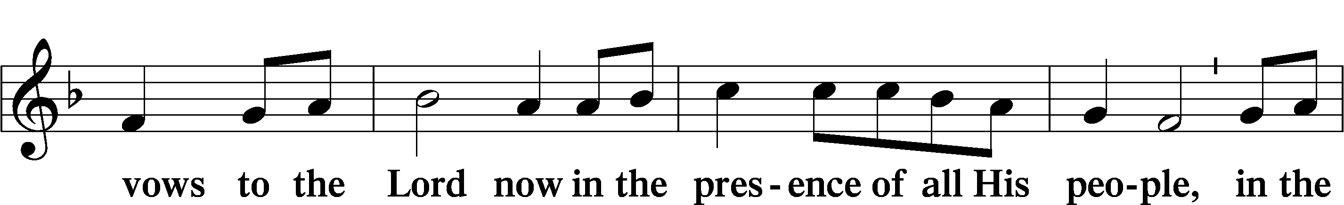
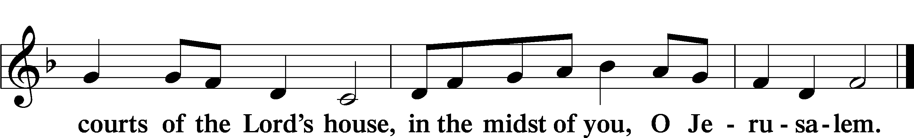

Preface
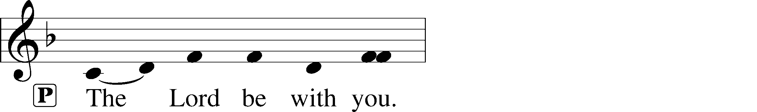
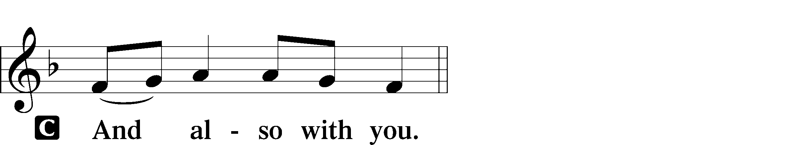
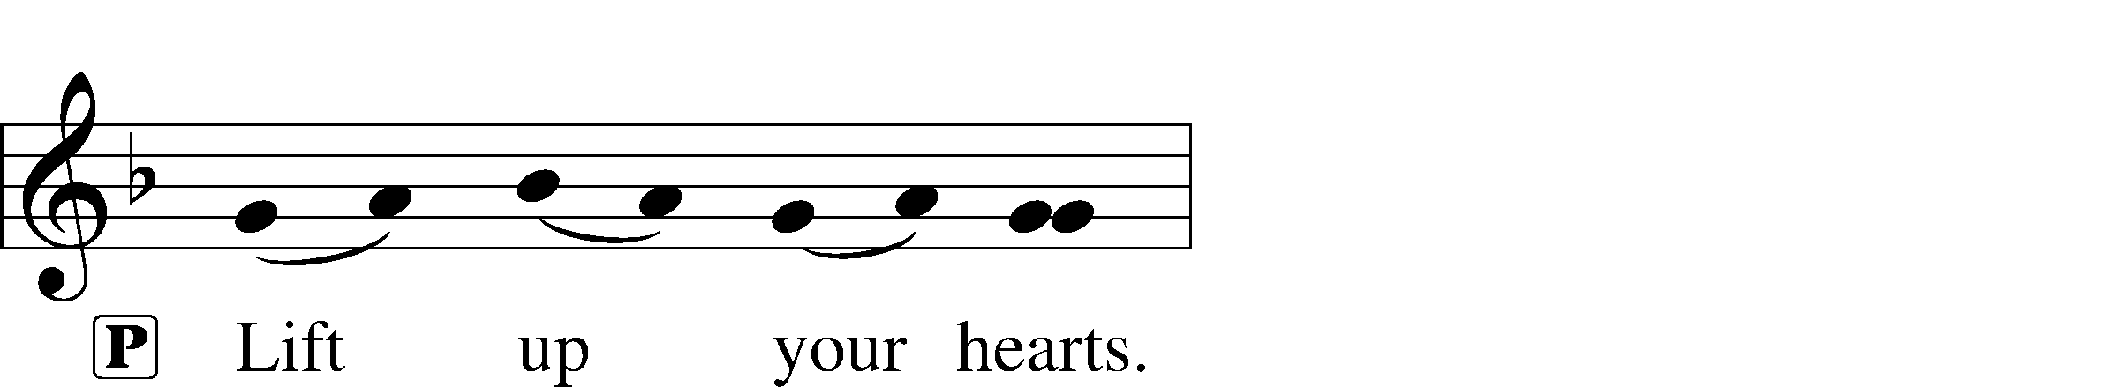
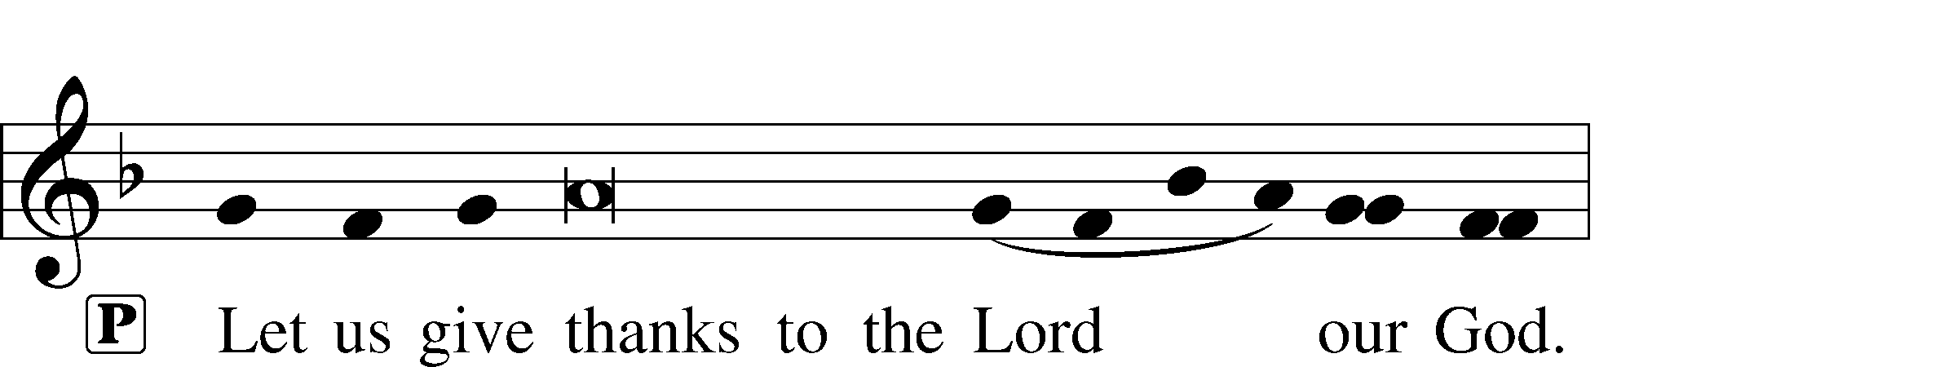
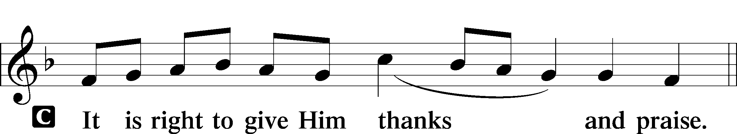

Sanctus
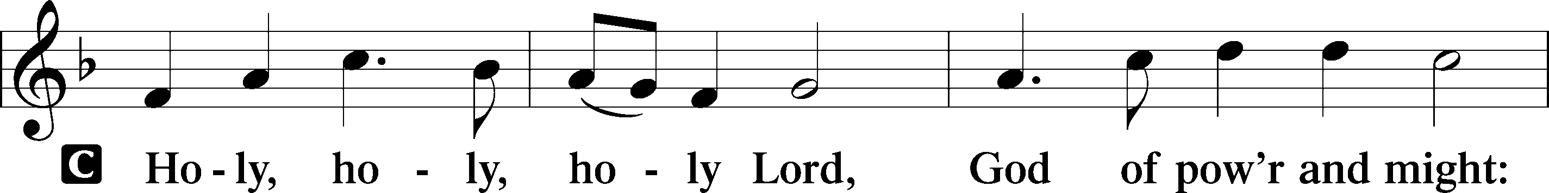
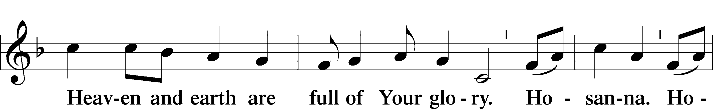
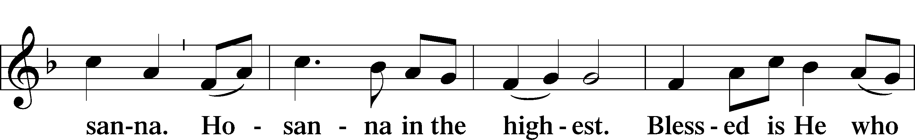
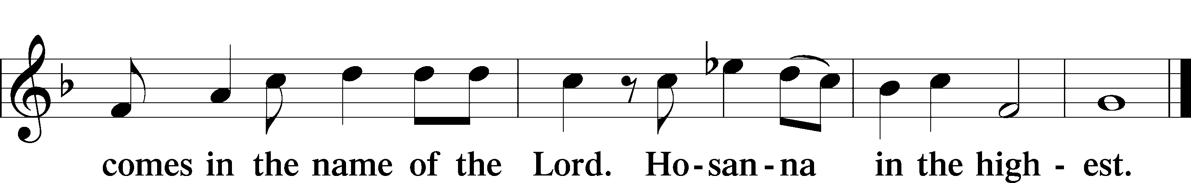

Lord’s Prayer
C Our Father who art in heaven, hallowed be Thy name, Thy kingdom come, Thy will be done on earth as it is in heaven; give us this day our daily bread; and forgive us our trespasses as we forgive those who trespass against us; and lead us not into temptation, but deliver us from evil. For Thine is the kingdom and the power and the glory forever and ever. Amen.

The Words of Our Lord

Pax Domini
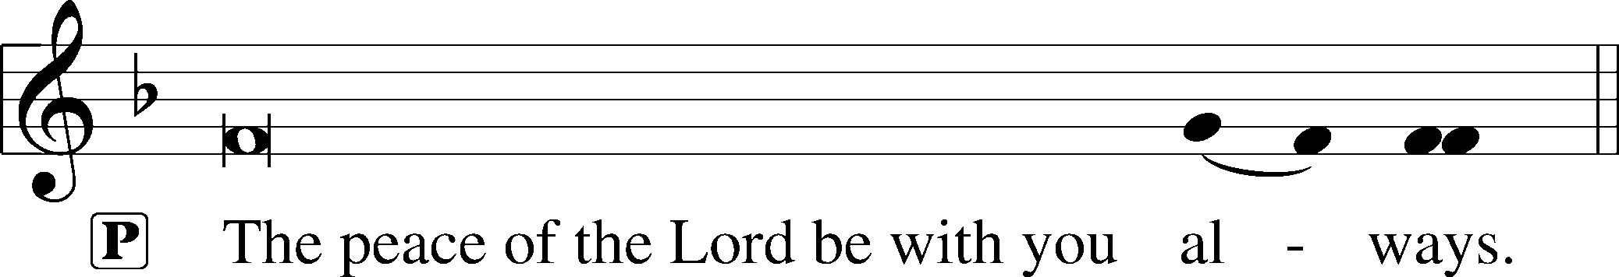
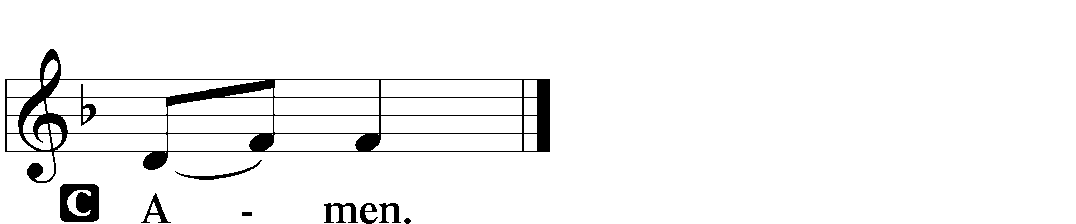

Agnus Dei
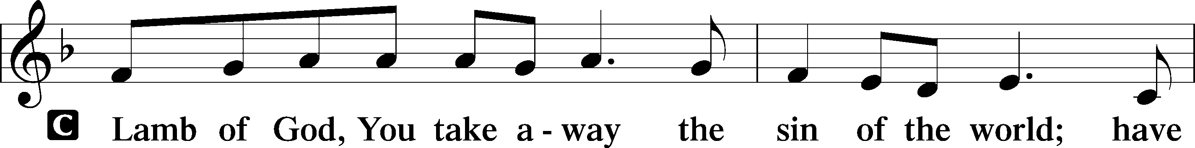
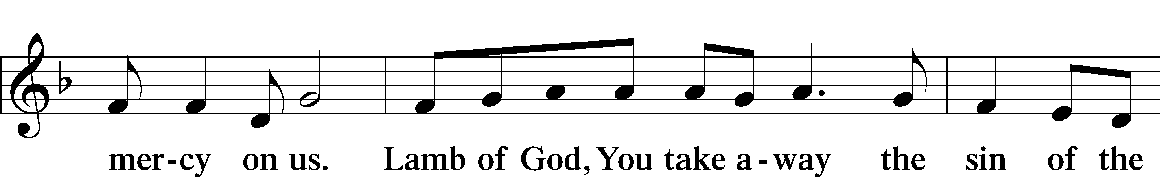
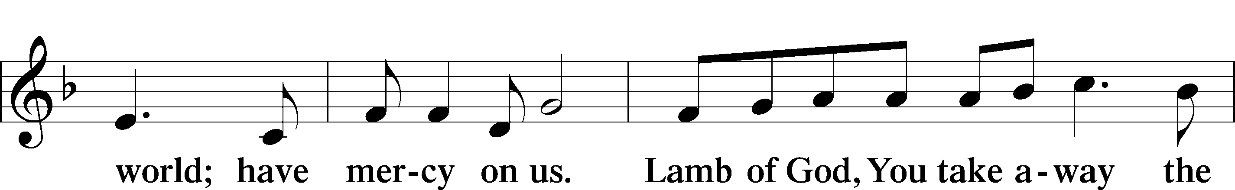
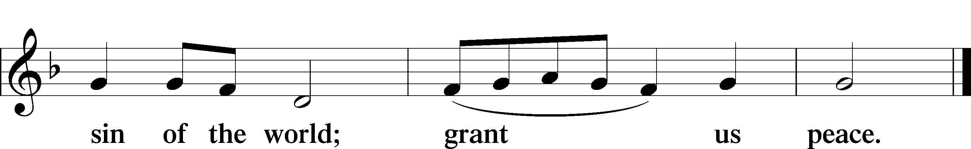
Distribution Hymns
623 Lord Jesus Christ, We Humbly Pray
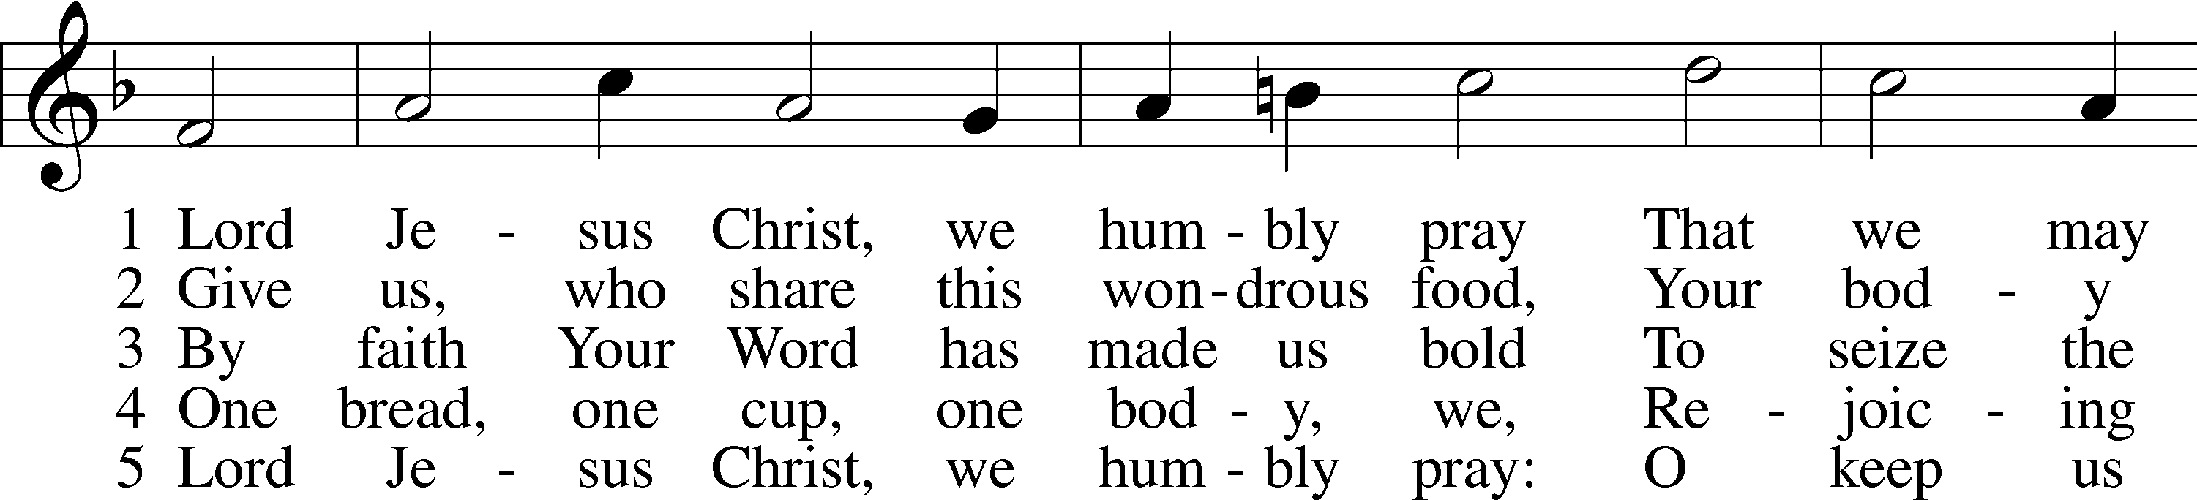
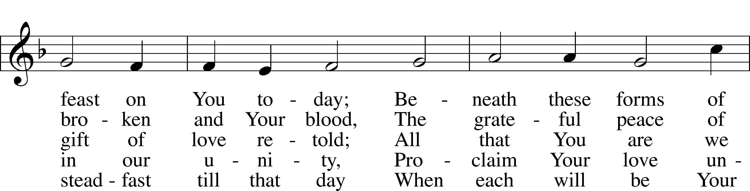
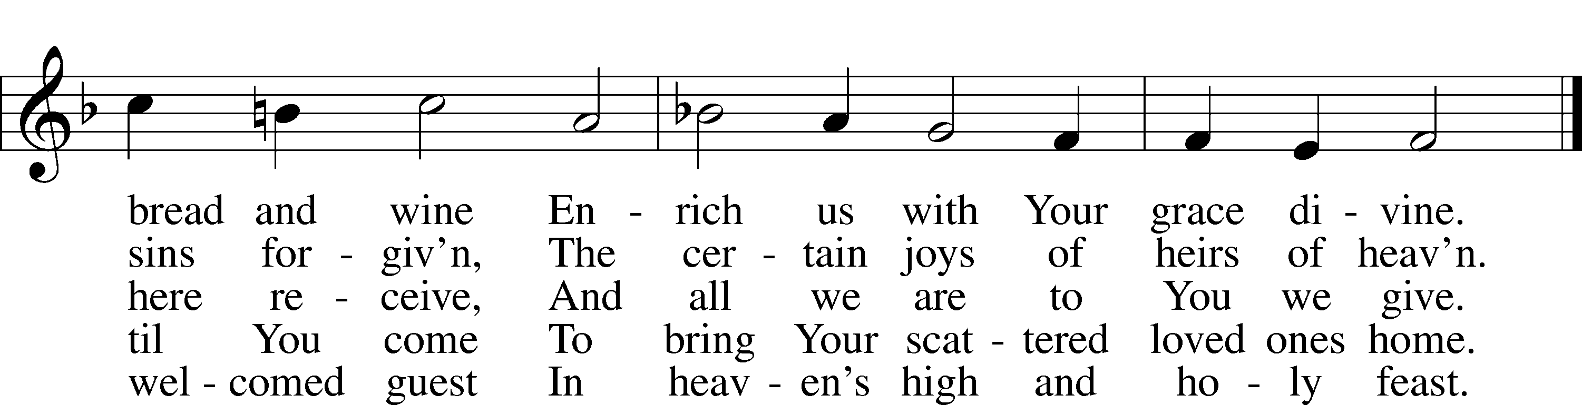
Text: Henry E. Jacobs, 1844–1932, alt. Tune: Cantionale Germanicum, 1628, Gochsheim Text and tune: Public domain

579 The Law of God Is Good and Wise
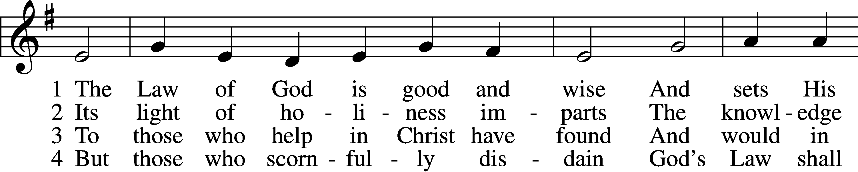
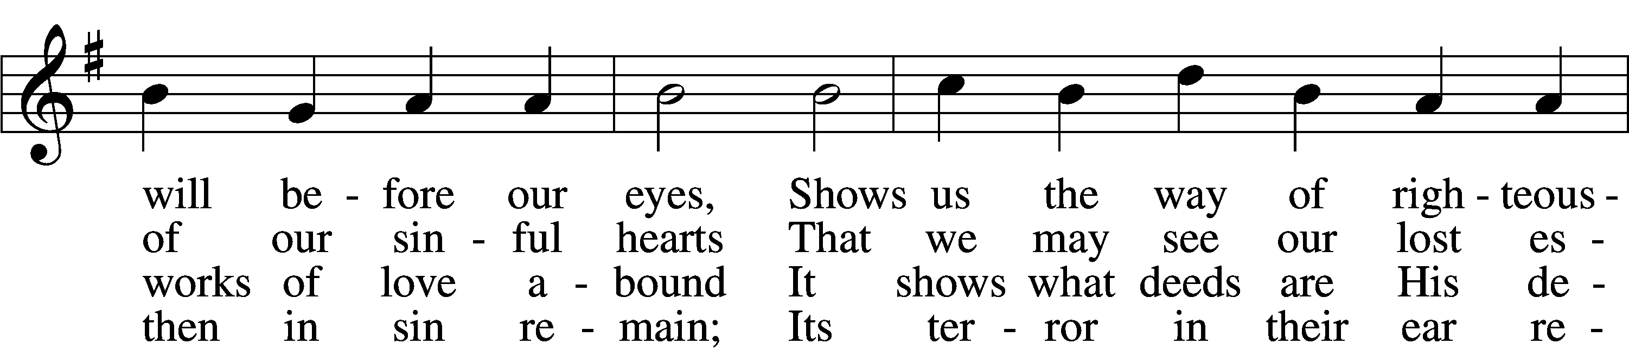
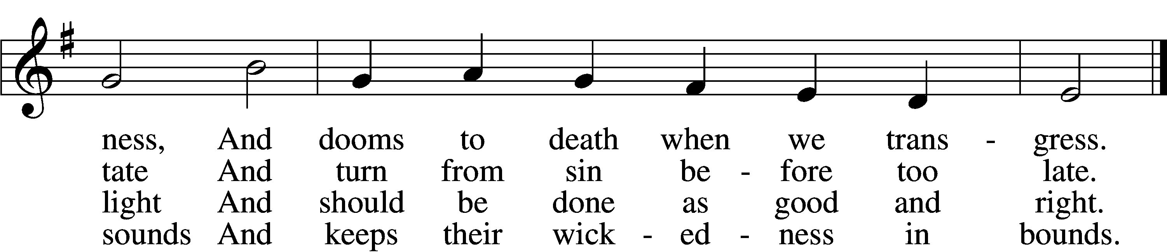

5 The Law is good; but since the fall
Its holiness condemns us all;
It dooms us for our sin to die
And has no pow’r to justify.

6 To Jesus we for refuge flee,
Who from the curse has set us free,
And humbly worship at His throne,
Saved by His grace through faith alone.
Text: Matthias Loy, 1828–1915, alt. Tune: Geistliche Lieder auffs new gebessert, 1543, Wittenberg, ed. Joseph Klug Text and tune: Public domain

680 Thine the Amen, Thine the Praise
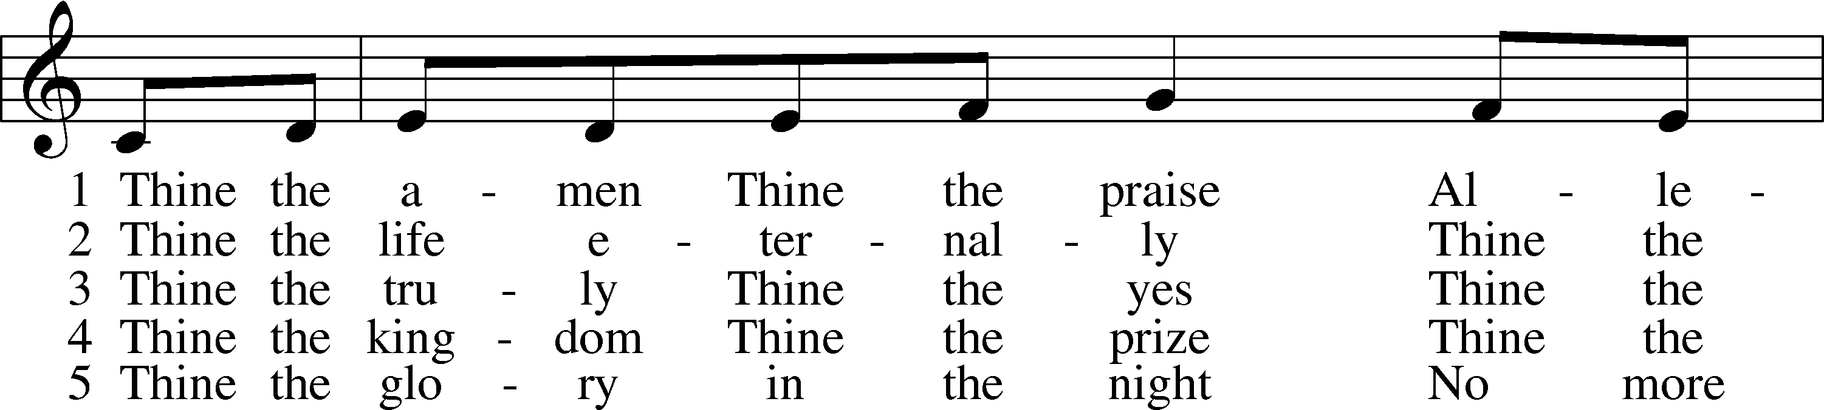
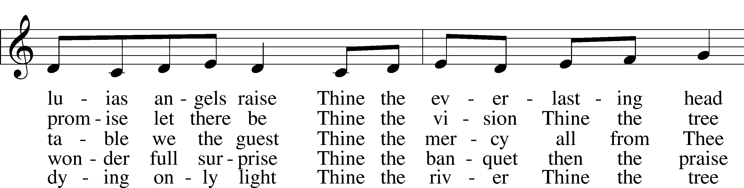
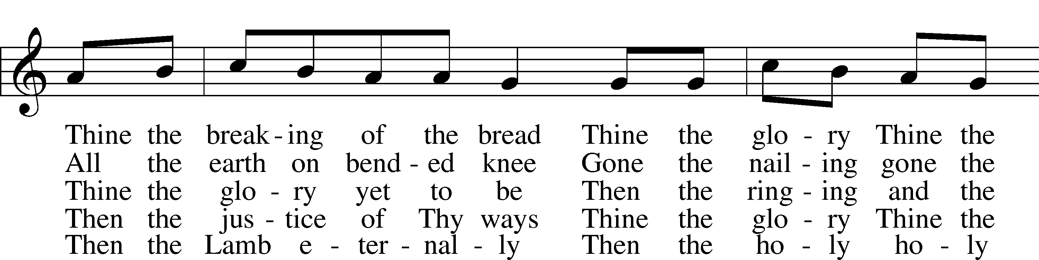
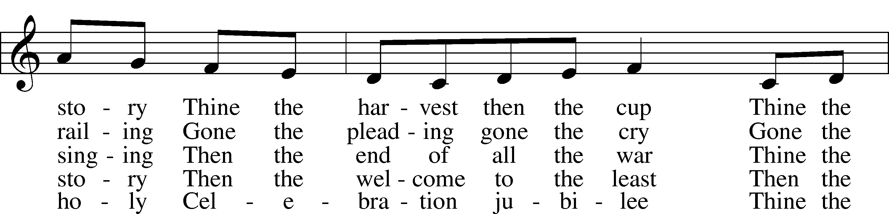
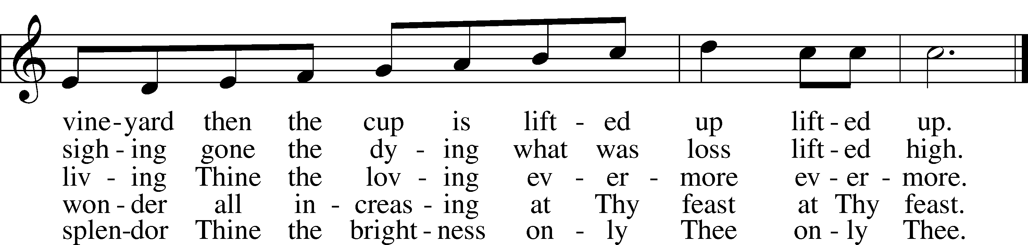
Text: Herbert F. Brokering, 1926–2009
Tune: Carl F. Schalk, 1929
Text and tune: © 1983 Augsburg Publishing House. Used by permission: LSB Hymn License no. 110004822

Nunc Dimittis
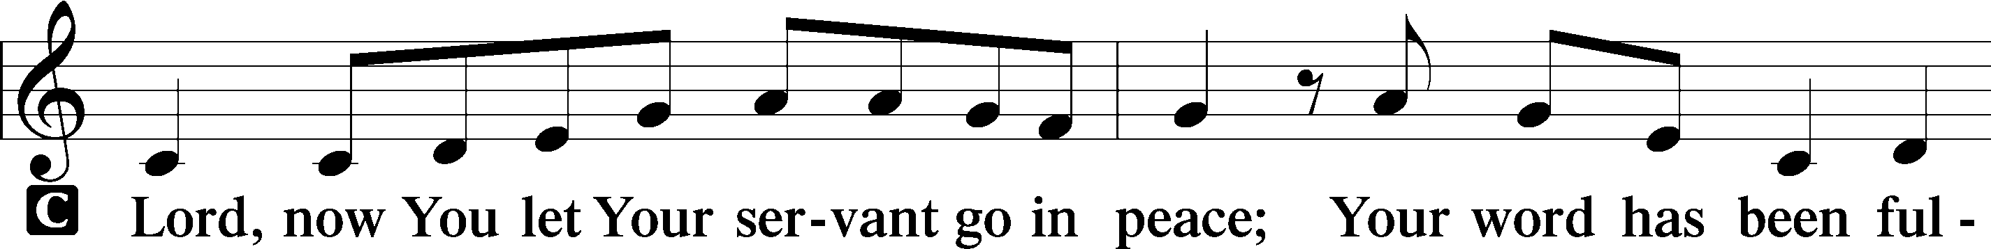
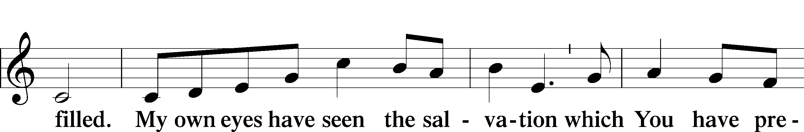
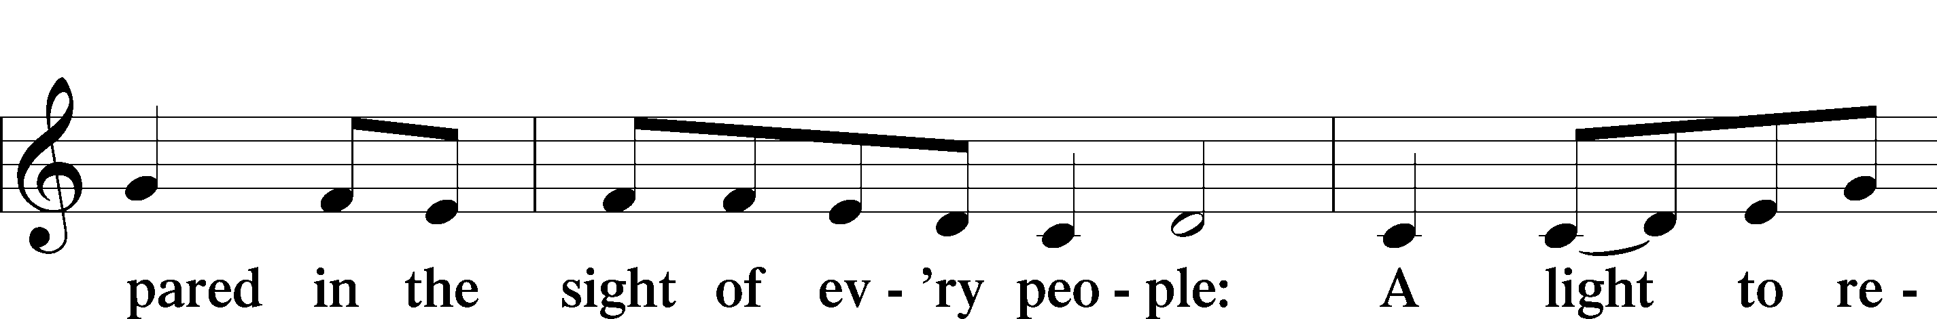
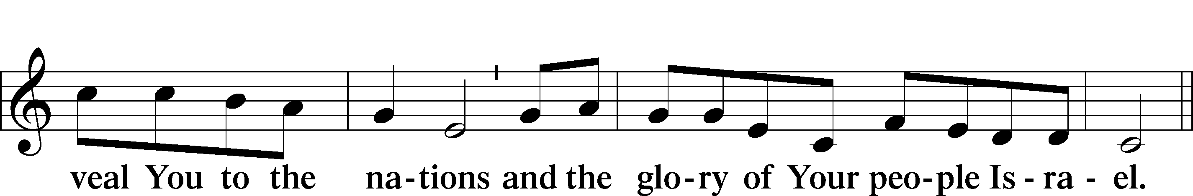
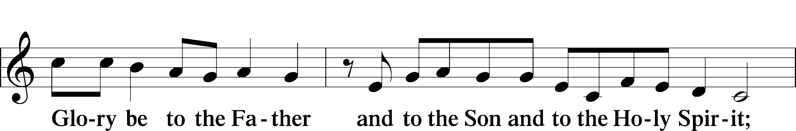
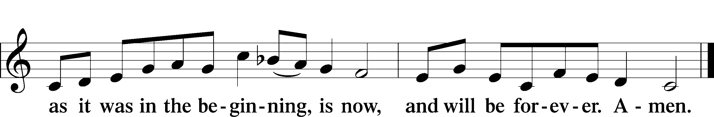

Post-Communion Collect
A Let us pray.
We give thanks to You, almighty God, that You have refreshed us through this salutary gift, and we implore You that of Your mercy You would strengthen us through the same in faith toward You and in fervent love toward one another; through Jesus Christ, Your Son, our Lord, who lives and reigns with You and the Holy Spirit, one God, now and forever.
C Amen.

Benediction
P The Lord bless you and keep you.
The Lord make His face shine on you and be gracious to you.
The Lord look upon you with favor and + give you peace.
C Amen.

Hymn on the back page

847 Christ, Our Human Likeness Sharing
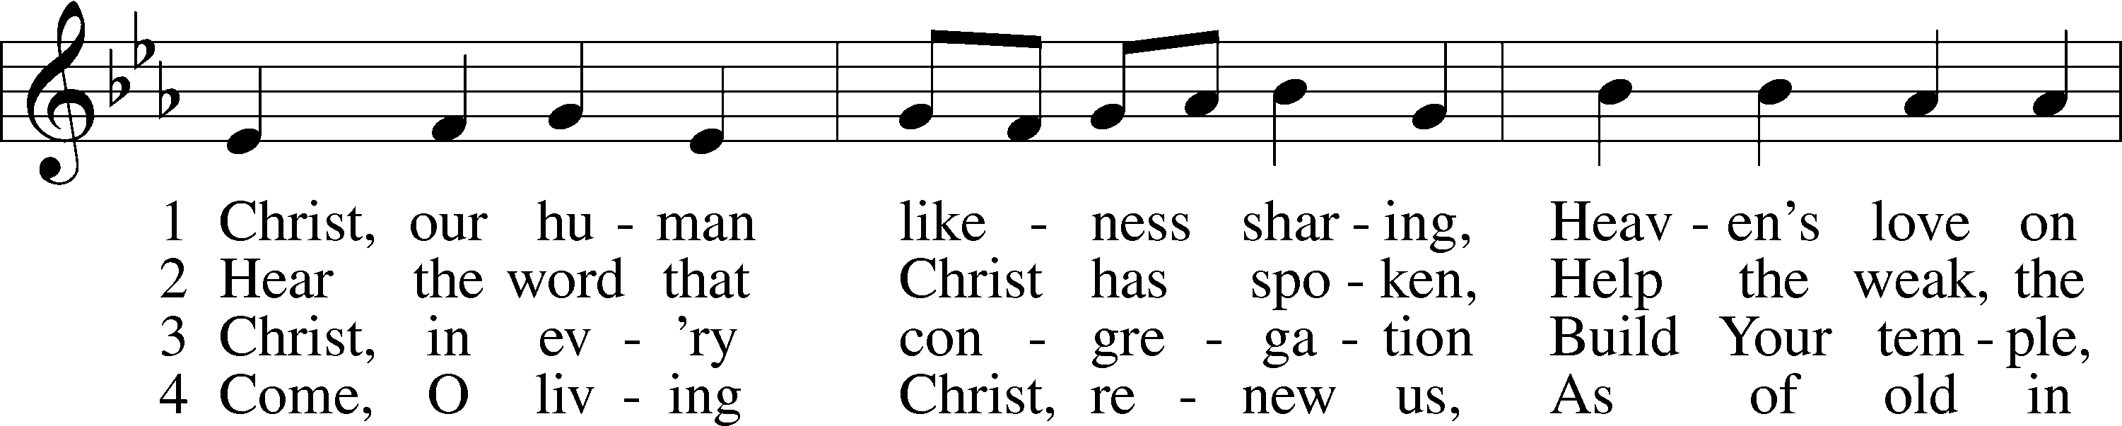
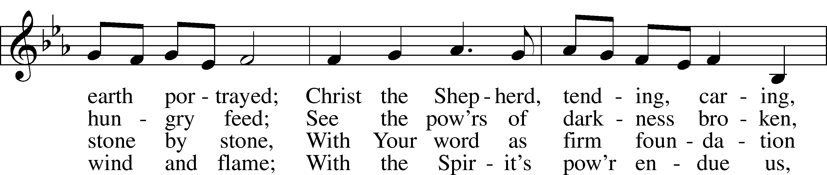
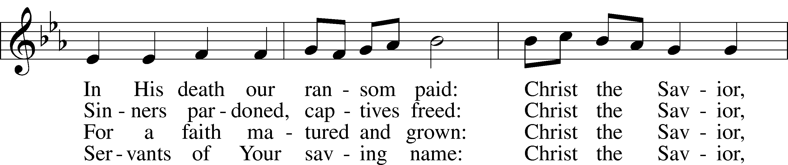
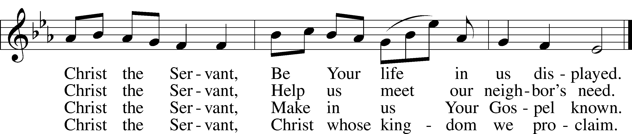
Text: Timothy Dudley-Smith, 1926
Tune: Chants ordinaires de l’Office Divin, Paris, 1881
Text: © 2003 Hope Publishing Co. Used by permission: LSB Hymn License no. 110004822
Tune: Public domain

