Ninth Sunday after Trinity
Sunday, July 28th, 2024
Divine Service 4, Page 203

Divine Shepherd Lutheran Church & School

7308 Wedgewood Drive
Black Hawk, SD 57718

Pastor Randy Sturzenbecher
Pastor Dennis Mercer
“We are baptized children of God, forgiven and redeemed by Jesus. We are His family, called together to receive His gifts and serve others.”
Office 605-787-6438, Pastor S. Cell 605-391-0428, Pastor M. Cell 443-980-7338,
ECC 605-791-1131
Email: DSLCpsturz@divineshep.org
DSLCpmercer@divineshep.org
DSLCSecretary@divineshep.org
Greetings to all in the Name of the Risen Lord!
May our worship this glorious morning celebrate the joy and hope, peace and presence, of our Lord Jesus Christ, raised to life for us. We welcome all, especially our guests. If you do not have a church home please consider Divine Shepherd. We would love to have you as part of our family. Please take a minute and sign our guest book.

A prayer before Worship
This is the day you have made, O Lord Jesus, a day of new life and eternal celebration! The stone is moved; death is defeated; heaven is open. As Your disciples first saw and believed Your victory over the tomb, so give us joy in the promise You made and keep for us: because You live, we live also! Amen.

The Lord’s Supper
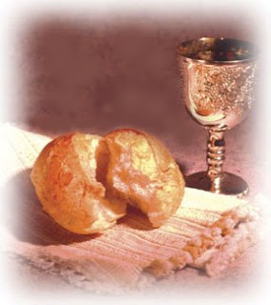
The Lord’s Supper is celebrated by us this morning in the confession and gladness that, as our Lord says, He gives into our mouth not only bread and wine but His very body and blood to eat and drink for the forgiveness of sins and to strengthen our union with Him and with one another. Our Lord Jesus invites to His table those who trust His Words, repent of all sin, and set aside any refusal to forgive and love as He forgives and loves us, that they may show forth His death until He comes.

Whoever, therefore, eats the bread or drinks the blood of the Lord in an unworthy manner will be guilty concerning the body and blood of the Lord.
(1 Cor 11:28 ESV) Holy Communion is a confession of the faith which is confessed at this altar. Any who are not yet instructed, in doubt, or hold a confession differing from that of the Holy Scriptures, this congregation, and the Lutheran Church~Missouri Synod, and yet desire to receive the sacrament, are asked to speak with Pastor Sturzenbecher.

644 The Church’s One Foundation sts. 1–5
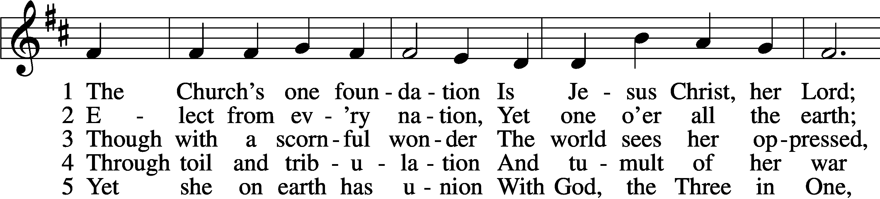
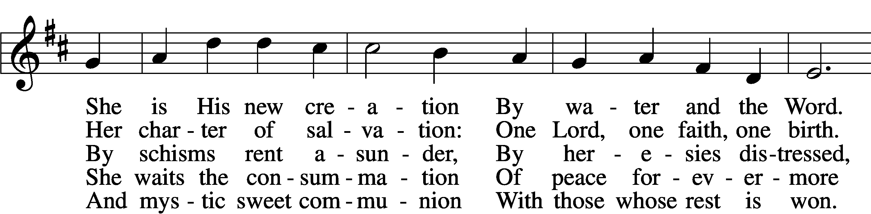
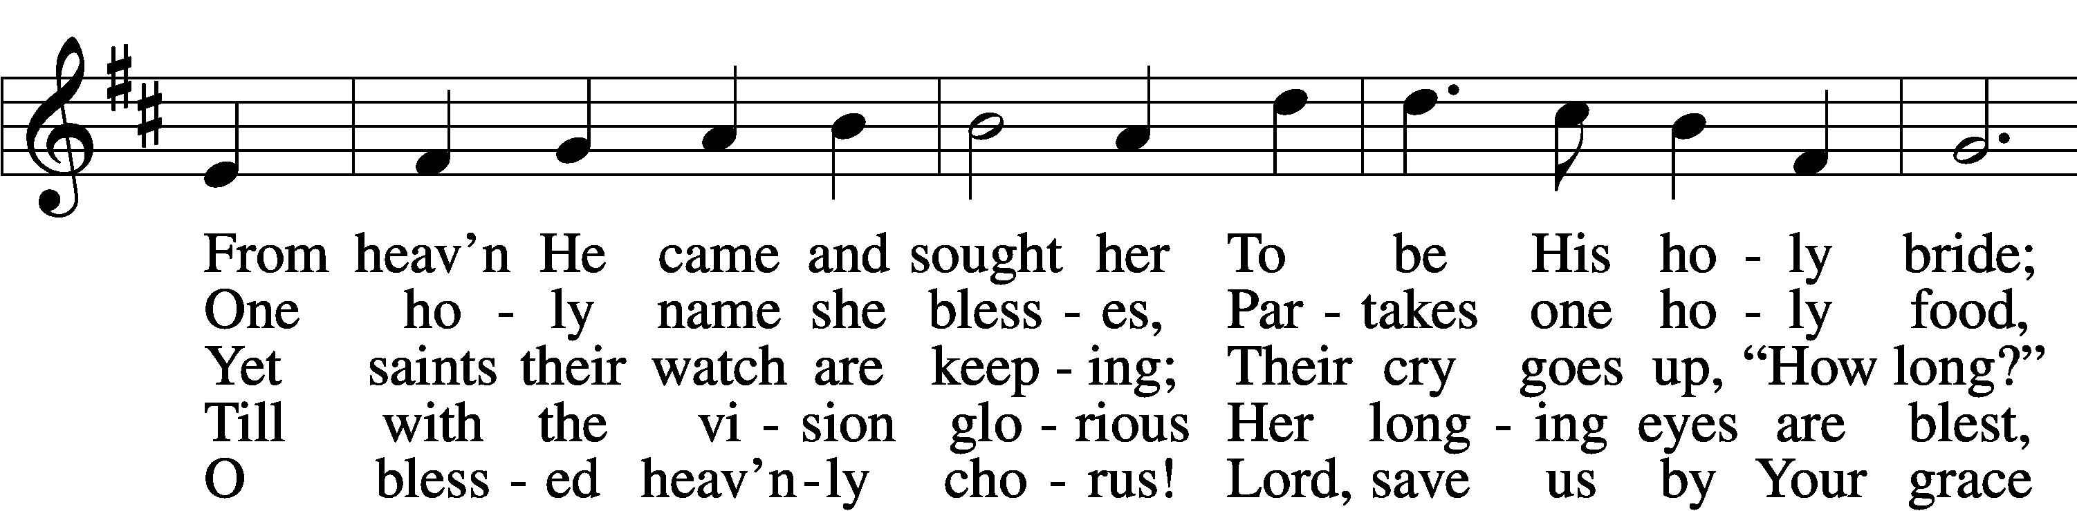
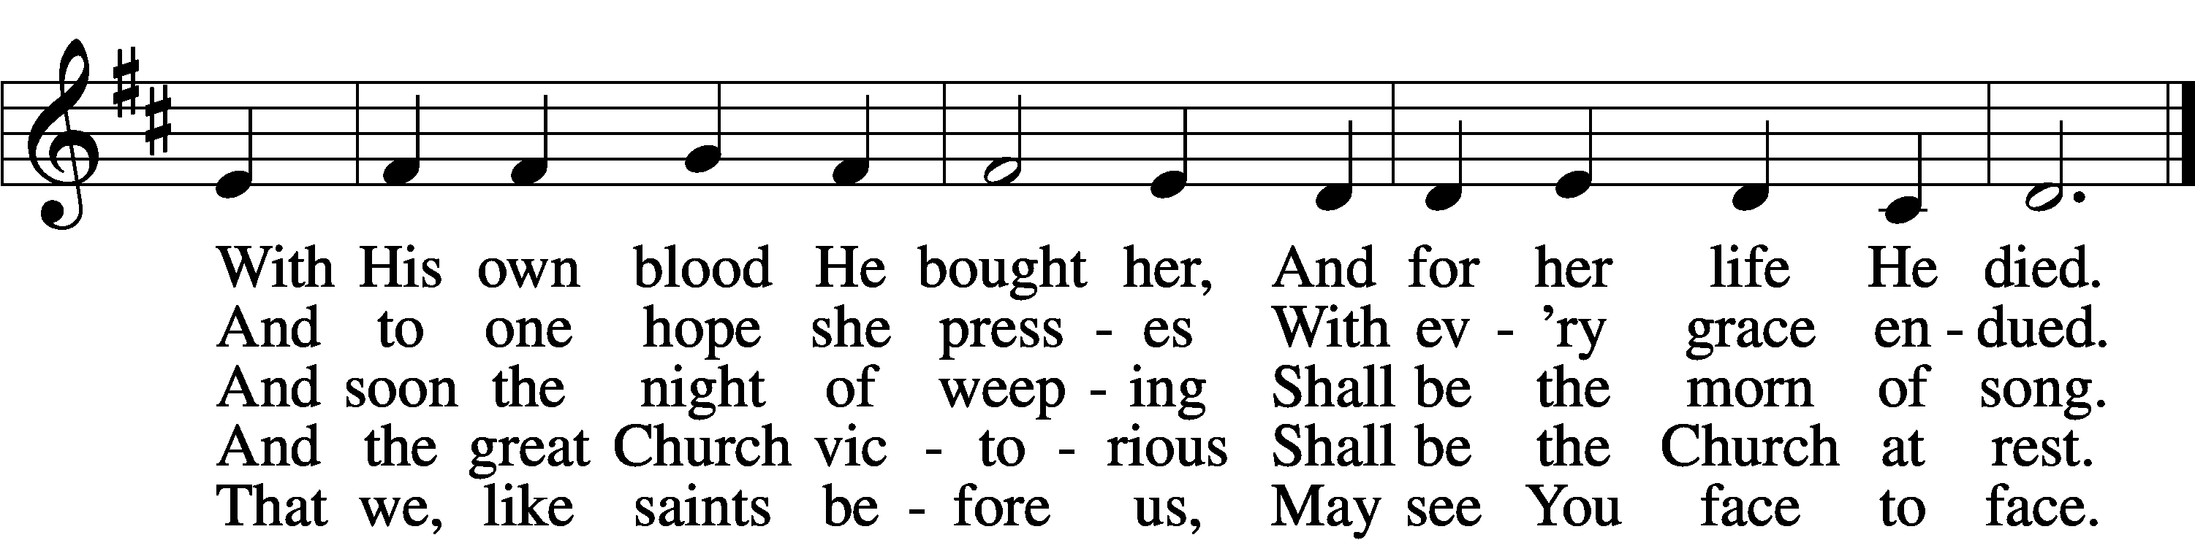
Text: Samuel J. Stone, 1839–1900, alt.
Tune: Samuel S. Wesley, 1810–76
Text and tune: Public domain

Confession & Absolution
P In the name of the Father and of the + Son and of the Holy Spirit.
C Amen.
P Our help is in the name of the Lord,
C who made heaven and earth.
P If You, O Lord, kept a record of sins, O Lord, who could stand?
C But with You there is forgiveness; therefore You are feared.
P Since we are gathered to hear God’s Word, call upon Him in prayer and praise, and receive the body and blood of our Lord Jesus Christ in the fellowship of this altar, let us first consider our unworthiness and confess before God and one another that we have sinned in thought, word, and deed, and that we cannot free ourselves from our sinful condition. Together as His people let us take refuge in the infinite mercy of God, our heavenly Father, seeking His grace for the sake of Christ, and saying: God, be merciful to me, a sinner.
C Almighty God, have mercy upon us, forgive us our sins, and lead us to everlasting life. Amen.
P Almighty God in His mercy has given His Son to die for you and for His sake forgives you all your sins. As a called and ordained servant of Christ, and by His authority, I therefore forgive you all your sins in the name of the Father and of the + Son and of the Holy Spirit.
C Amen.

Introit Psalm 54:1–3, 7
Behold, God is my | helper;*
the Lord is the upholder | of my life.
He will return the evil to my | enemies;*
in your faithfulness put an | end to them.
O God, save me, | by your name,*
and vindicate me | by your might.
O God, | hear my prayer;*
give ear to the words | of my mouth.
For strangers have risen against me; ruthless men | seek my life;*
they do not set God be- | fore themselves.
For he has delivered me from every | trouble,*
and my eye has looked in triumph on my | enemies.
Glory be to the Father and | to the Son*
and to the Holy | Spirit;
as it was in the be- | ginning,*
is now, and will be forever. | Amen.
Behold, God is my | helper;*
the Lord is the upholder | of my life.
He will return the evil to my | enemies;*
in your faithfulness put an | end to them.
Kyrie
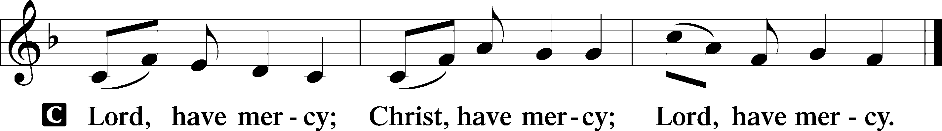

Gloria in Excelsis
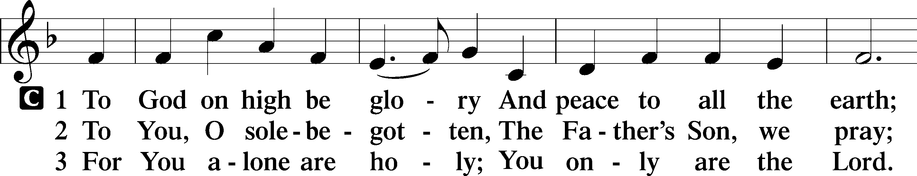
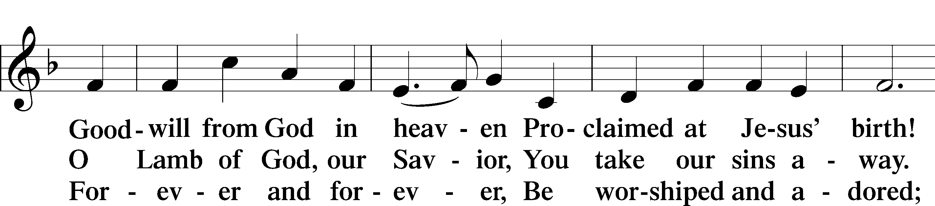
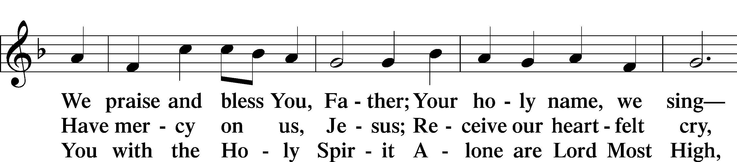
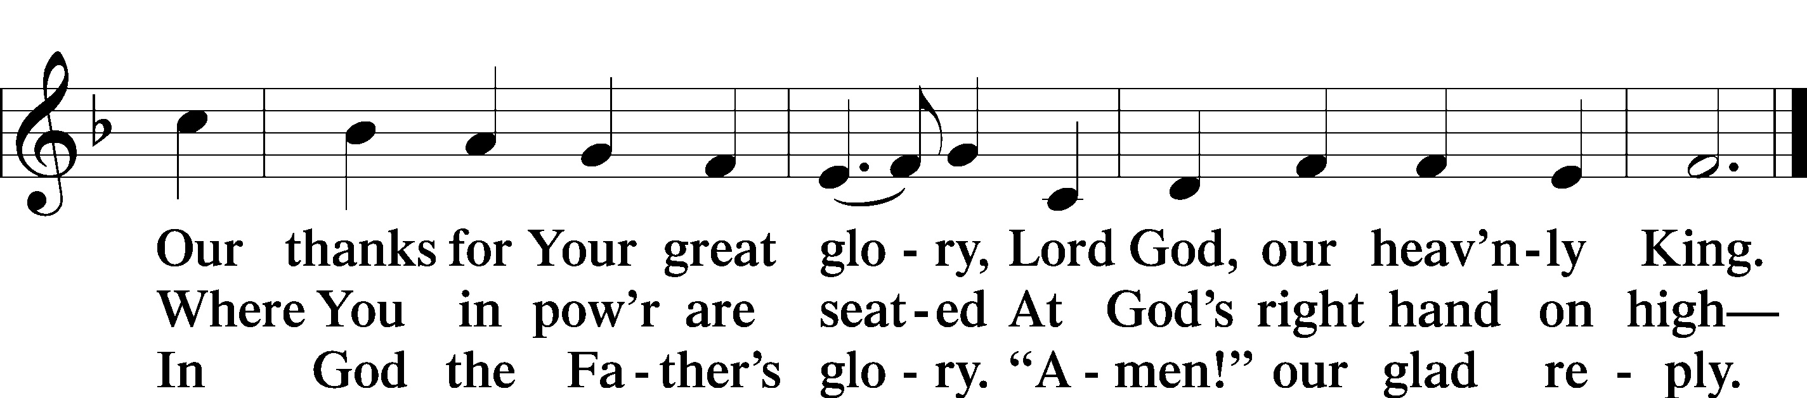
Salutation and Collect of the Day
P The Lord be with you.
C And also with you.
P Let us pray.
Let Your merciful ears, O Lord, be open to the prayers of Your humble servants; and that they may obtain their petitions, make them to ask such things as shall please You; through Jesus Christ, Your Son, our Lord, who lives and reigns with You and the Holy Spirit, one God, now and forever.
C Amen.

Old Testament Reading 2 Samuel 22:26–34
²⁶“With the merciful you show yourself merciful; with the blameless man you show yourself blameless; ²⁷with the purified you deal purely, and with the crooked you make yourself seem tortuous. ²⁸You save a humble people, but your eyes are on the haughty to bring them down. ²⁹For you are my lamp, O Lord, and my God lightens my darkness. ³⁰For by you I can run against a troop, and by my God I can leap over a wall. ³¹This God—his way is perfect; the word of the Lord proves true; he is a shield for all those who take refuge in him. ³²“For who is God, but the Lord? And who is a rock, except our God? ³³This God is my strong refuge and has made my way blameless. ³⁴He made my feet like the feet of a deer and set me secure on the heights.”

Catechetical Review
The Sixth Petition of the Lord’s Prayer
And lead us not into temptation.

What does this mean?
God tempts no one. We pray in this petition that God would guard and keep us so that the devil, the world, and our sinful nature may not deceive us or mislead us into false belief, despair, and other great shame and vice. Although we are attacked by these things, we pray that we may finally overcome them and win the victory.

The Seventh Petition of the Lord’s Prayer
But deliver us from evil.

What does this mean?
We pray in this petition, in summary, that our Father in heaven would rescue us from every evil of body and soul, possessions and reputation, and finally, when our last hour comes, give us a blessed end, and graciously take us from this valley of sorrow to Himself in heaven.

Epistle 1 Corinthians 10:6–13
⁶Now these things took place as examples for us, that we might not desire evil as they did. ⁷Do not be idolaters as some of them were; as it is written, “The people sat down to eat and drink and rose up to play.” ⁸We must not indulge in sexual immorality as some of them did, and twenty-three thousand fell in a single day. ⁹We must not put Christ to the test, as some of them did and were destroyed by serpents, ¹⁰nor grumble, as some of them did and were destroyed by the Destroyer. ¹¹Now these things happened to them as an example, but they were written down for our instruction, on whom the end of the ages has come. ¹²Therefore let anyone who thinks that he stands take heed lest he fall. ¹³No temptation has overtaken you that is not common to man. God is faithful, and he will not let you be tempted beyond your ability, but with the temptation he will also provide the way of escape, that you may be able to endure it.

Alleluia and Verse
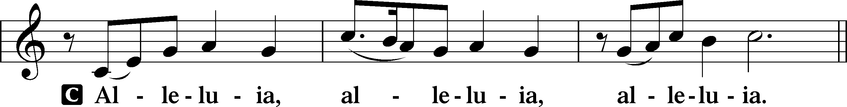
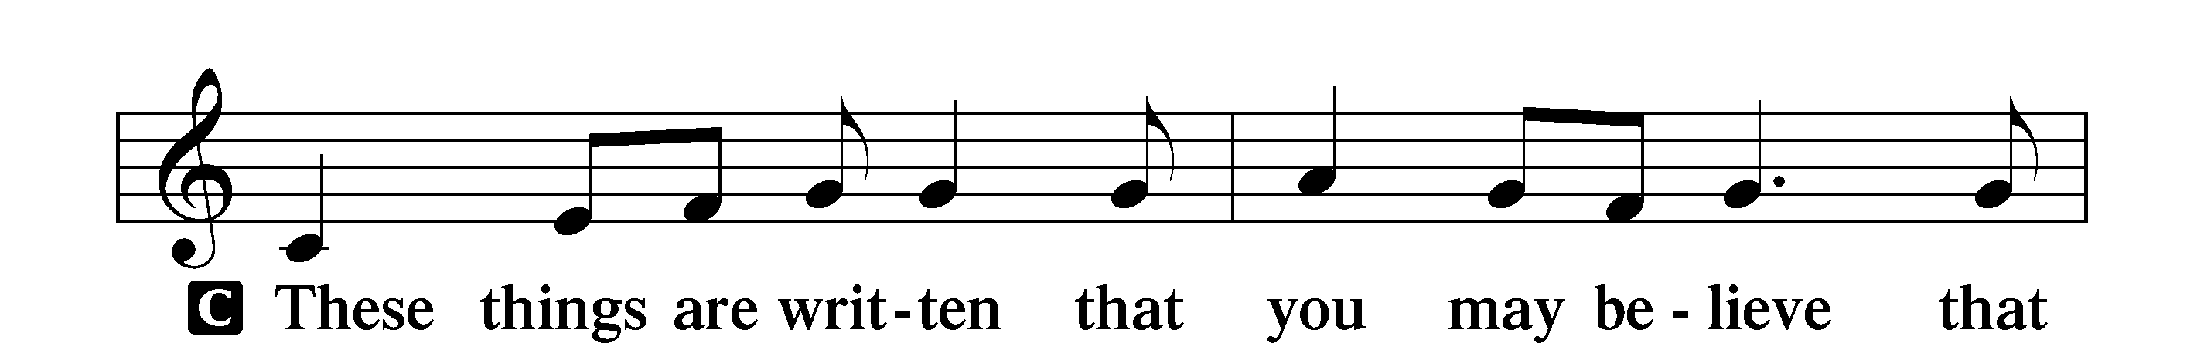
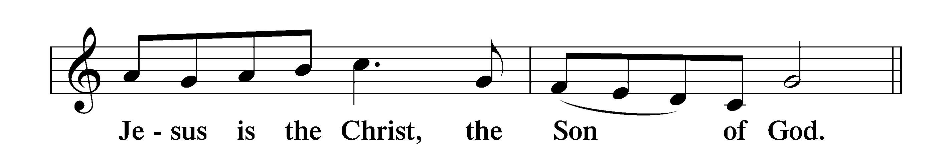
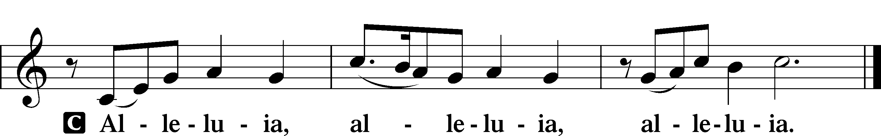

Holy Gospel Luke 16:1–13
P The Holy Gospel according to St. Luke, the sixteenth chapter.
C Glory to You, O Lord.
¹[Jesus] also said to the disciples, “There was a rich man who had a manager, and charges were brought to him that this man was wasting his possessions. ²And he called him and said to him, ‘What is this that I hear about you? Turn in the account of your management, for you can no longer be manager.’ ³And the manager said to himself, ‘What shall I do, since my master is taking the management away from me? I am not strong enough to dig, and I am ashamed to beg. ⁴I have decided what to do, so that when I am removed from management, people may receive me into their houses.’ ⁵So, summoning his master’s debtors one by one, he said to the first, ‘How much do you owe my master?’ ⁶He said, ‘A hundred measures of oil.’ He said to him, ‘Take your bill, and sit down quickly and write fifty.’ ⁷Then he said to another, ‘And how much do you owe?’ He said, ‘A hundred measures of wheat.’ He said to him, ‘Take your bill, and write eighty.’ ⁸The master commended the dishonest manager for his shrewdness. For the sons of this world are more shrewd in dealing with their own generation than the sons of light. ⁹And I tell you, make friends for yourselves by means of unrighteous wealth, so that when it fails they may receive you into the eternal dwellings. ¹⁰“One who is faithful in a very little is also faithful in much, and one who is dishonest in a very little is also dishonest in much. ¹¹If then you have not been faithful in the unrighteous wealth, who will entrust to you the true riches? ¹²And if you have not been faithful in that which is another’s, who will give you that which is your own? ¹³No servant can serve two masters, for either he will hate the one and love the other, or he will be devoted to the one and despise the other. You cannot serve God and money.”
P This is the Gospel of the Lord.
C Praise to You, O Christ.

Apostles’ Creed
C I believe in God, the Father Almighty, maker of heaven and earth. And in Jesus Christ, His only Son, our Lord, who was conceived by the Holy Spirit, born of the virgin Mary, suffered under Pontius Pilate, was crucified, died and was buried. He descended into hell. The third day He rose again from the dead. He ascended into heaven and sits at the right hand of God the Father Almighty. From thence He will come to judge the living and the dead. I believe in the Holy Spirit, the holy Christian Church, the communion of saints, the forgiveness of sins, the resurrection of the body, and the life + everlasting. Amen.

Childrens Message

730 What Is the World to Me
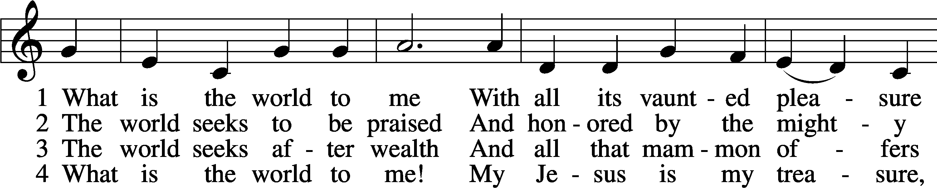
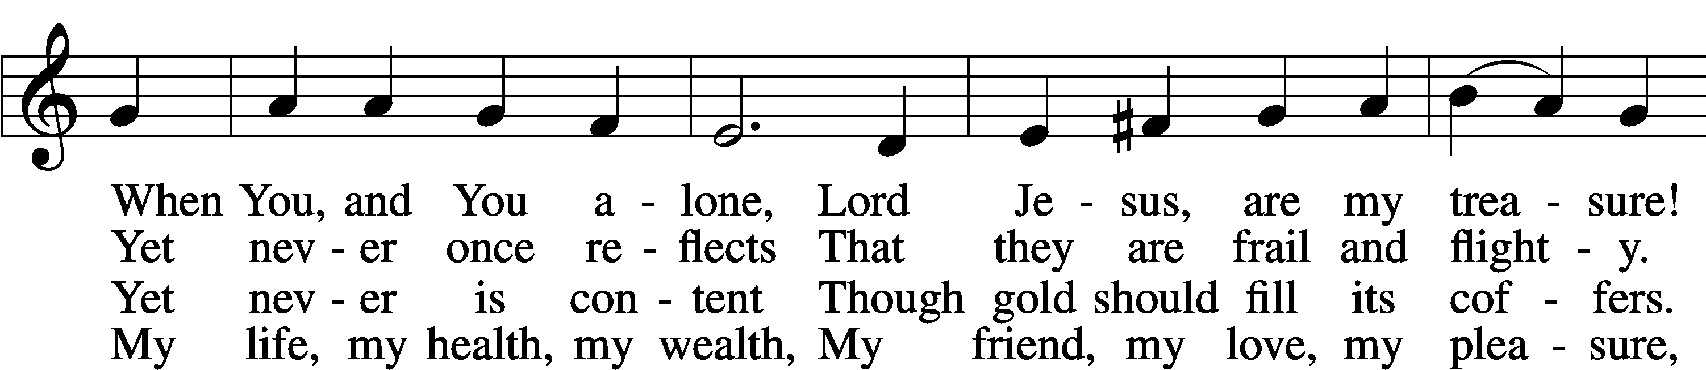
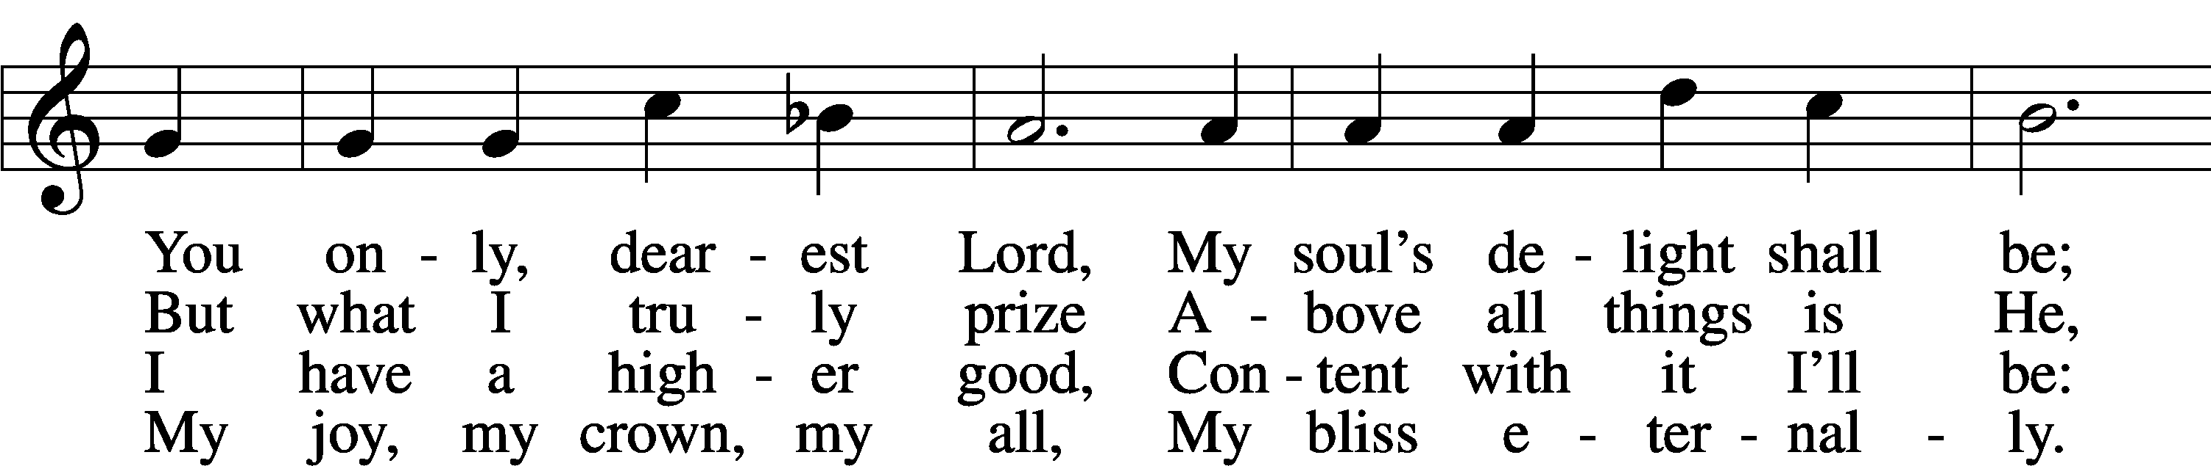
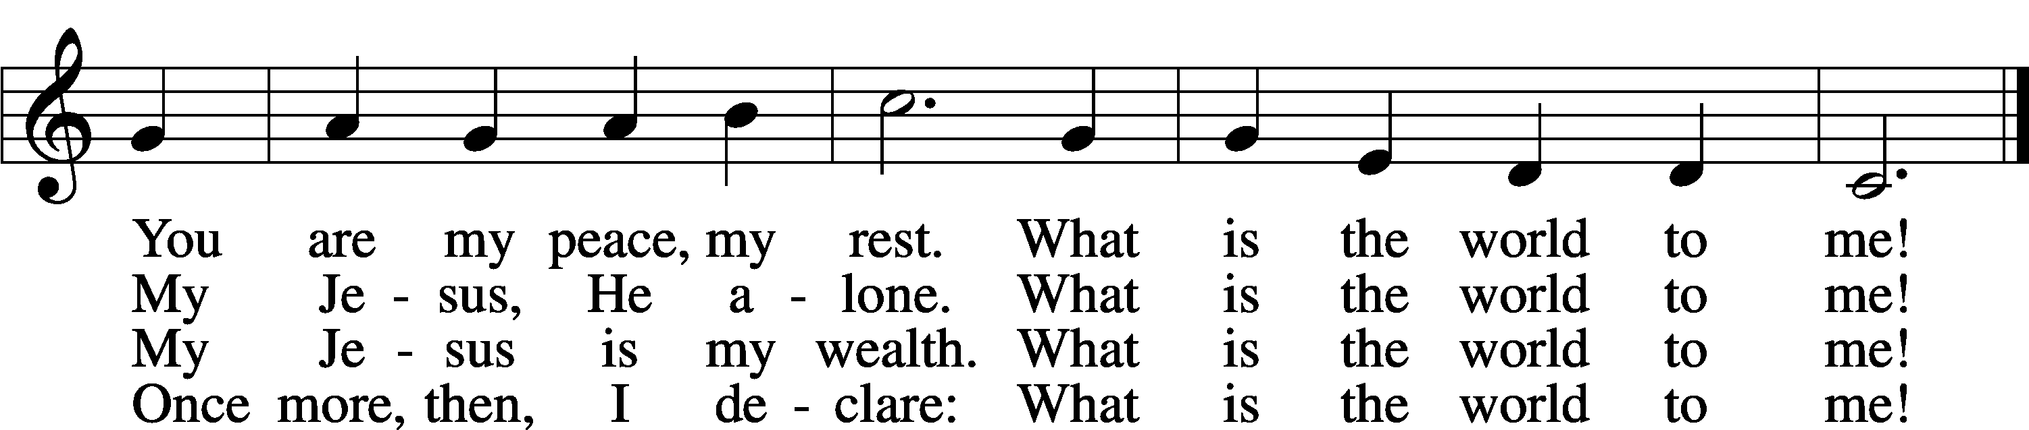
Text: Georg Michael Pfefferkorn, 1645–1732; tr. August Crull, 1845–1923, alt.
Tune: Ahasverus Fritsch, 1629–1701
Text and tune: Public domain

Sermon
Prayer of the Church “Hear Our Prayer”
Offering

Service of the Sacrament
Preface LSB 208
P The Lord be with you.
C And also with you.
P Lift up your hearts.
C We lift them to the Lord.
P Let us give thanks to the Lord our God.
C It is right to give Him thanks and praise.

Sanctus
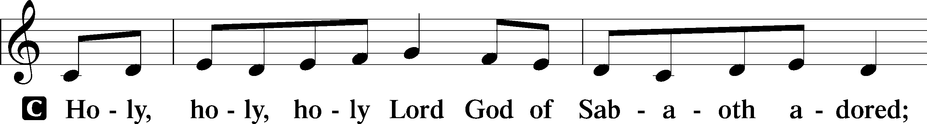
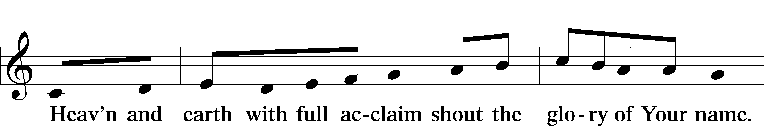
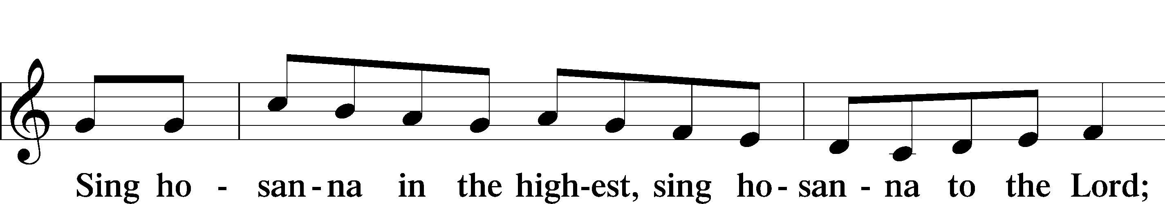
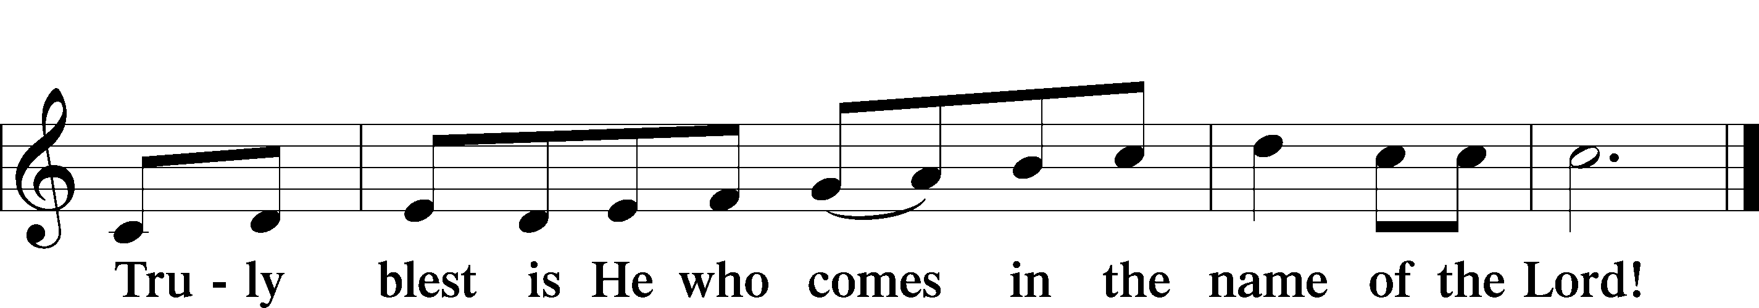

Prayer of Thanksgiving
P Blessed are You, O Lord our God, king of all creation, for You have had mercy on us and given Your only-begotten Son that whoever believes in Him should not perish but have eternal life. As the glory of Your presence once filled Your ancient temple, so in the incarnation of Your Son, Jesus Christ, You manifested the fullness of Your glory in human flesh.
We give You thanks that in His most Holy Supper You reveal Your glory to us. Grant us faithfully to eat His body and drink His blood so that we may one day behold Your glory face to face.
Hear us as we pray in His name and as He has taught us:

Lord’s Prayer
Our Father who art in heaven, hallowed be Thy name, Thy kingdom come, Thy will be done on earth as it is in heaven; give us this day our daily bread; and forgive us our trespasses as we forgive those who trespass against us; and lead us not into temptation, but deliver us from evil. For Thine is the kingdom and the power and the glory forever and ever. Amen

The Words of Our Lord
P Our Lord Jesus Christ, on the night when He was betrayed, took bread, and when He had given thanks, He broke it and gave it to the disciples and said: “Take, eat; this is My + body, which is given for you. This do in remembrance of Me.” In the same way also He took the cup after supper, and when He had given thanks, He gave it to them, saying: “Drink of it, all of you; this cup is the new testament in My + blood, which is shed for you for the forgiveness of sins. This do, as often as you drink it, in remembrance of Me.”

Pax Domini
P The peace of the Lord be with you always.
C Amen.

Agnus Dei
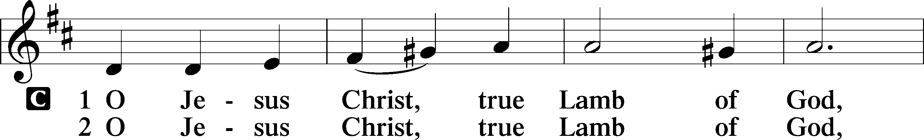
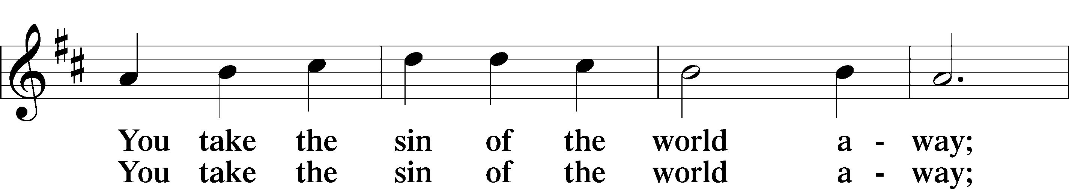
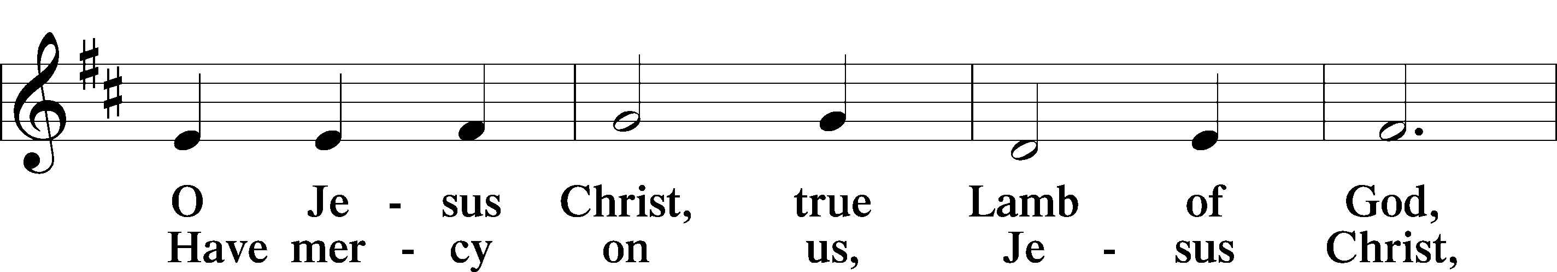
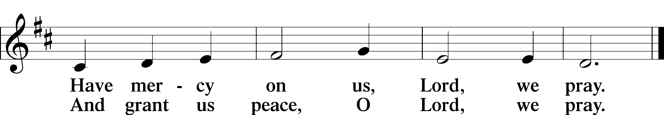

Distribution Hymns
809 Great Is Thy Faithfulness
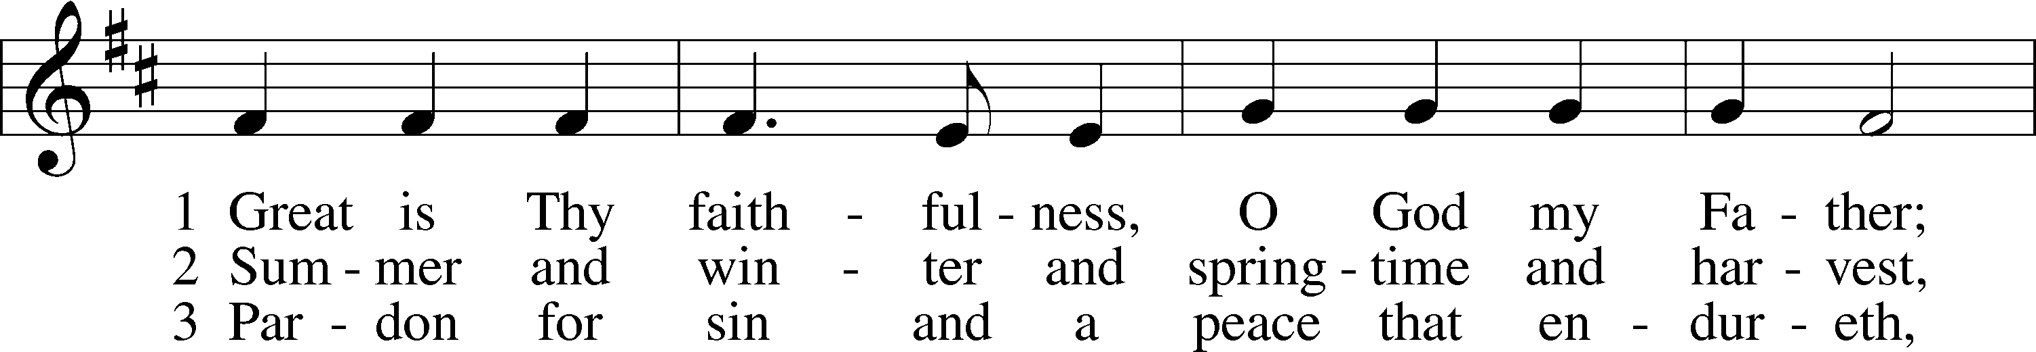
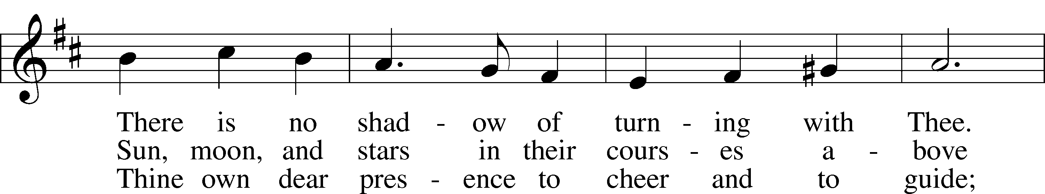
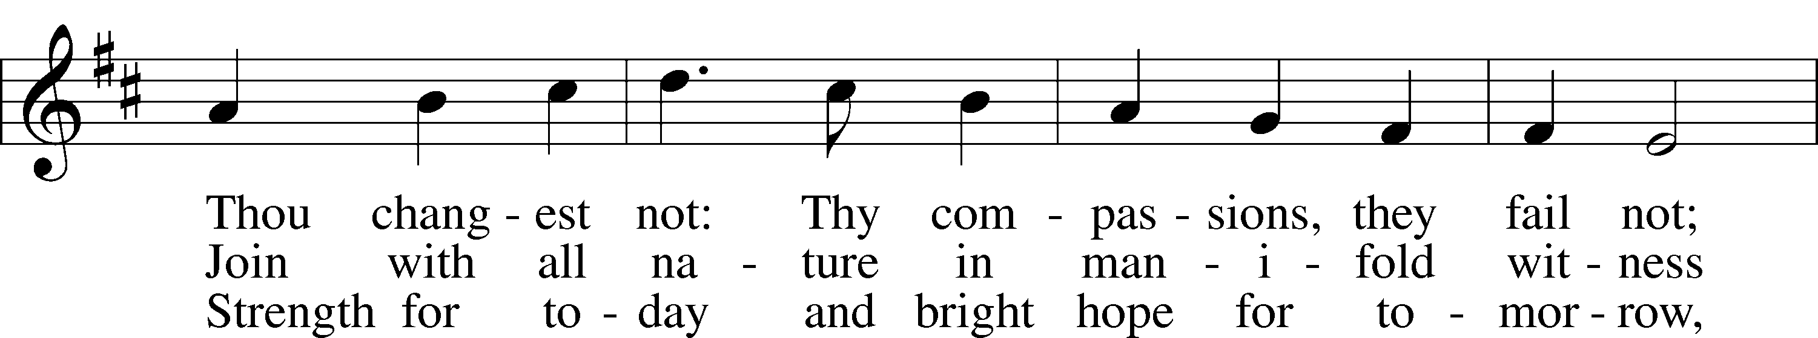
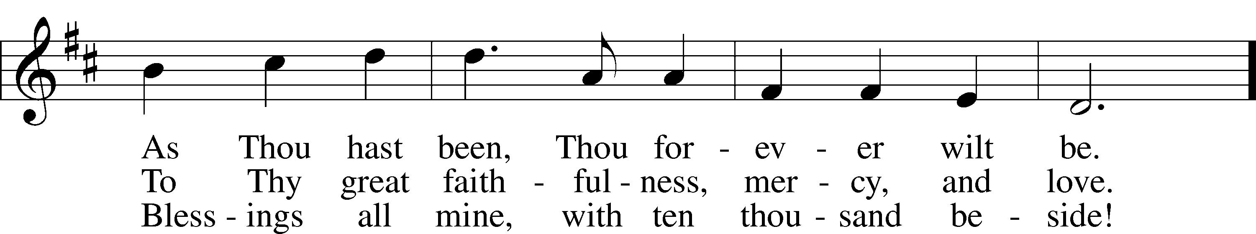
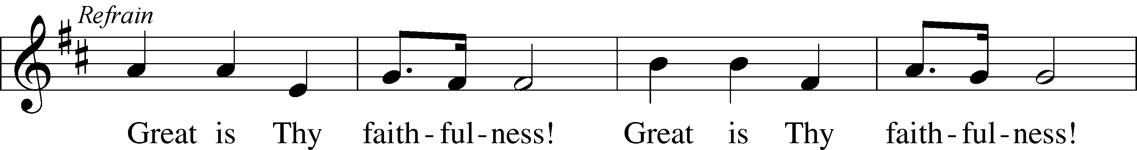
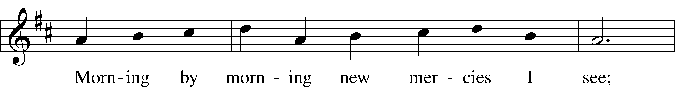
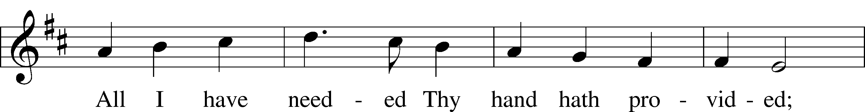
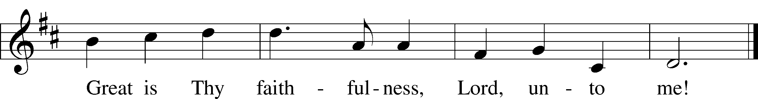
Text: Thomas O. Chisholm, 1866–1960
Tune: William M. Runyan, 1870–1957
Text: Public domain
743 Jesus, Priceless Treasure
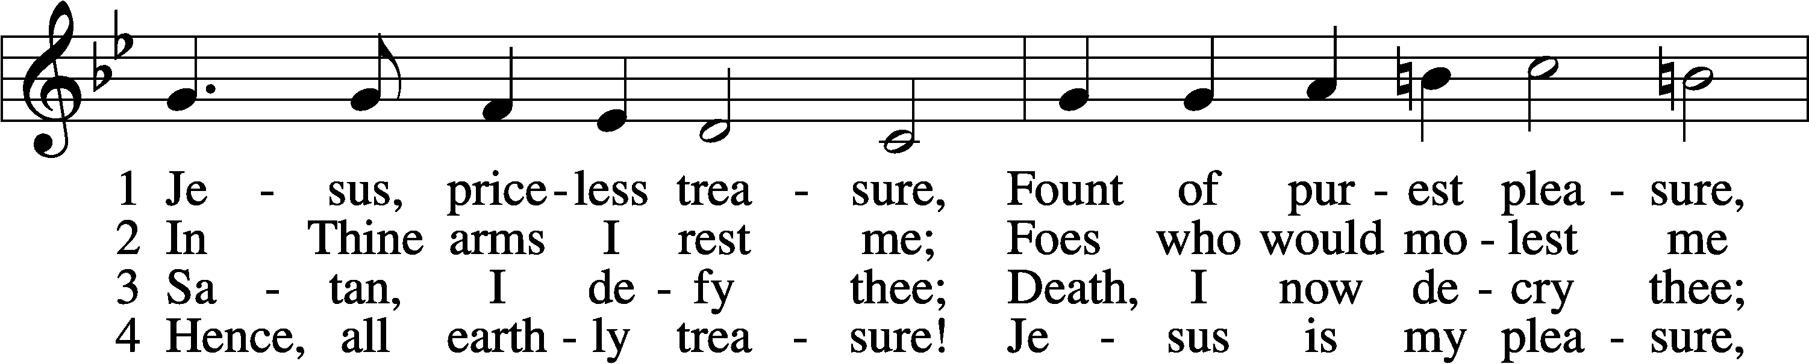
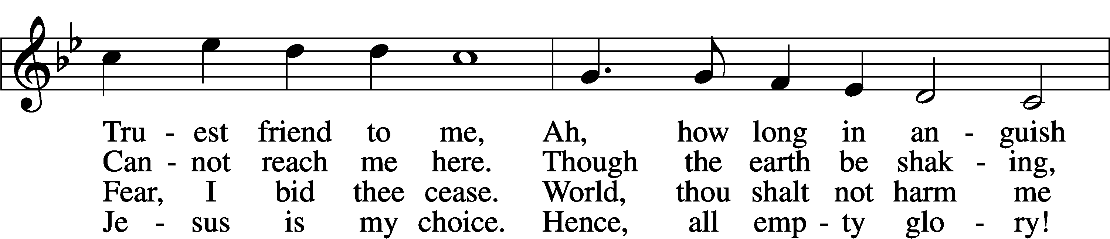
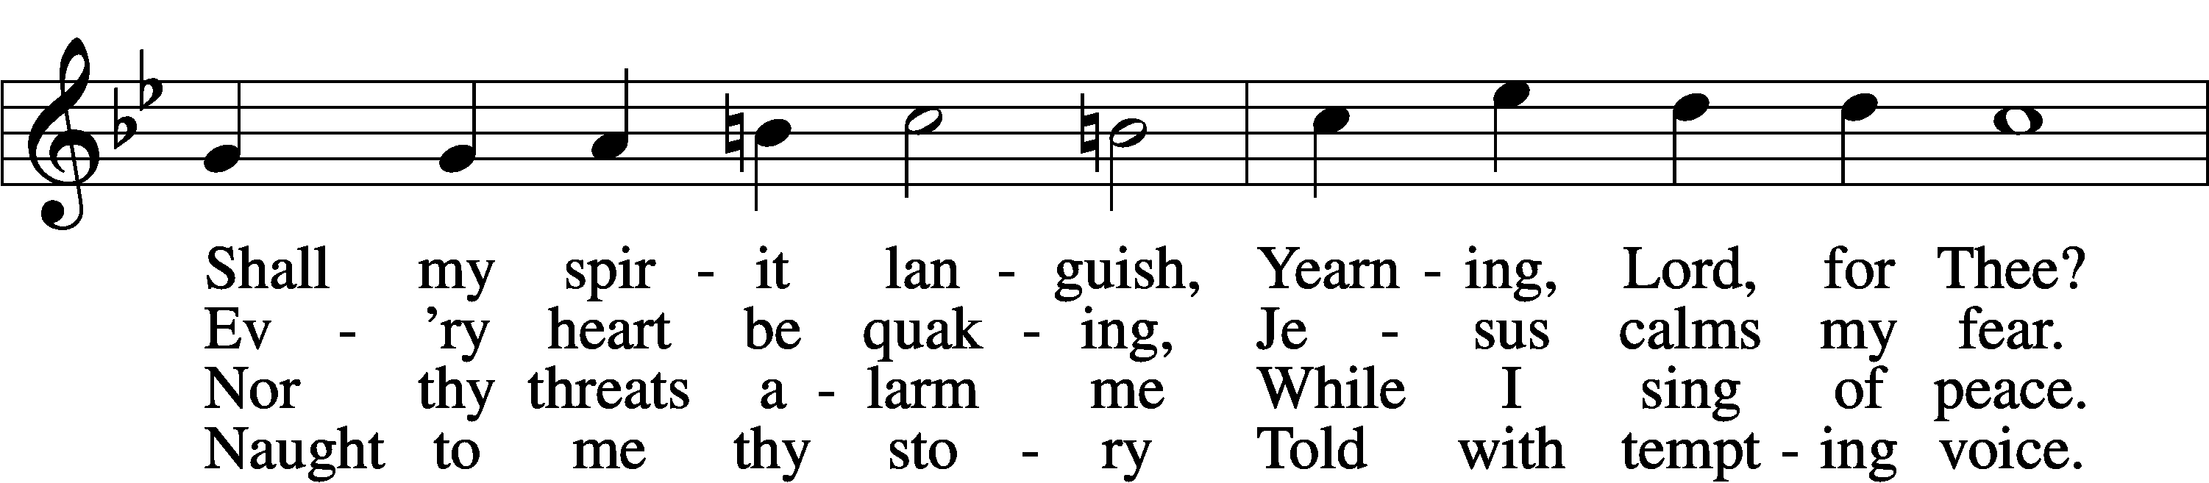
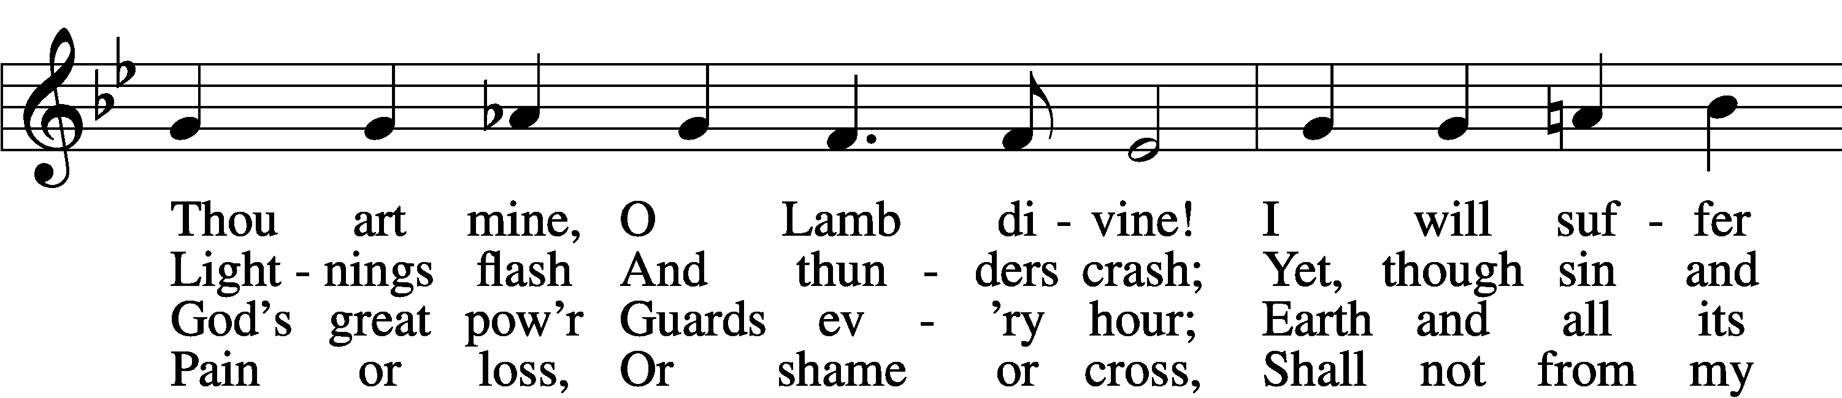
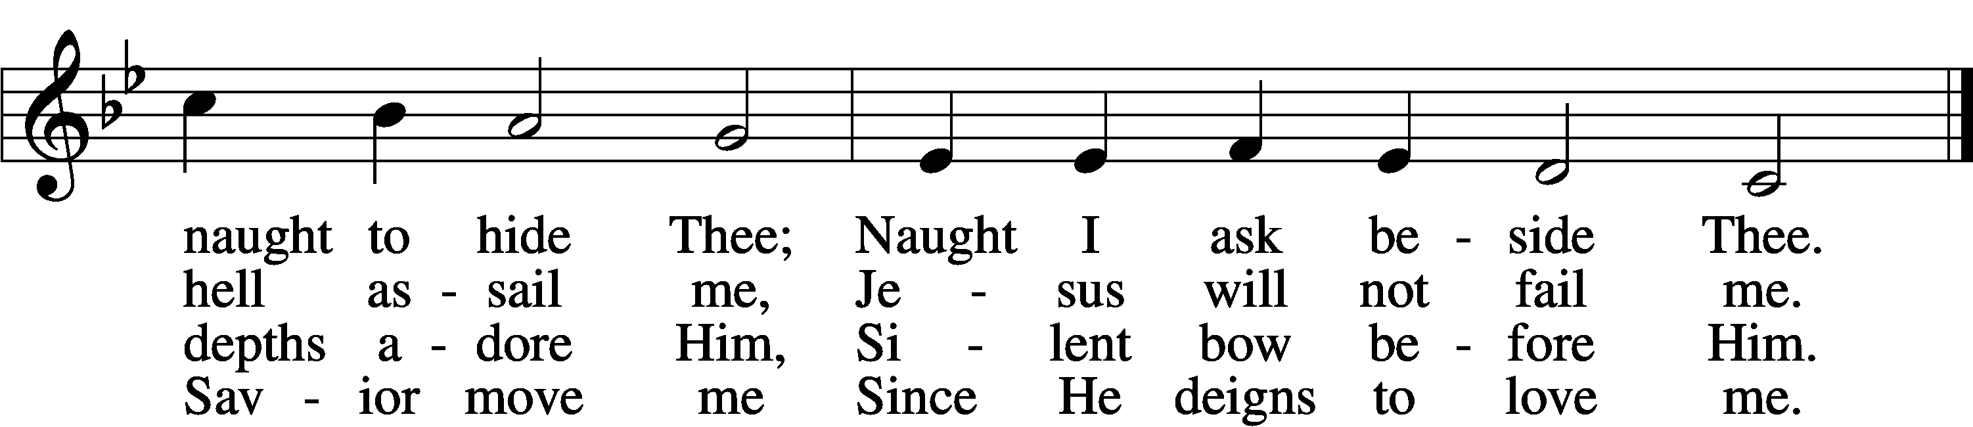

5 Evil world, I leave thee;
Thou canst not deceive me,
Thine appeal is vain.
Sin that once did blind me,
Get thee far behind me,
Come not forth again.
Past thy hour,
O pride and pow’r;
Sinful life, thy bonds I sever,
Leave thee now forever.

6 Hence, all fear and sadness!
For the Lord of gladness,
Jesus, enters in.
Those who love the Father,
Though the storms may gather,
Still have peace within.
Yea, whate’er
I here must bear,
Thou art still my purest pleasure,
Jesus, priceless treasure!
Text: Johann Franck, 1618–77; tr. Catherine Winkworth, 1827–78, alt.
Tune: Johann Crüger, 1598–1662
Text and tune: Public domain

524 How Sweet the Name of Jesus Sounds
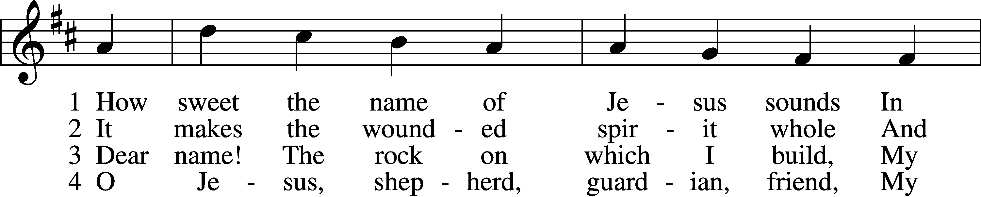
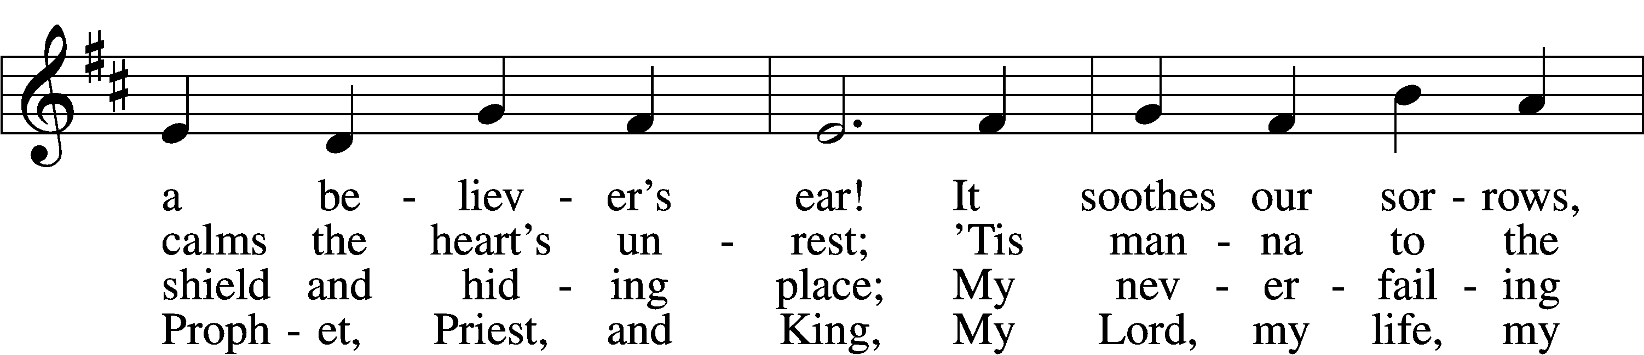
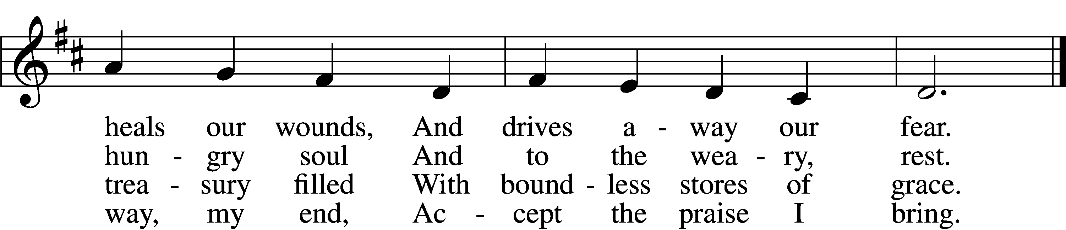

5 How weak the effort of my heart,
How cold my warmest thought!
But when I see Thee as Thou art,
I’ll praise Thee as I ought.

6 Till then I would Thy love proclaim
With ev’ry fleeting breath;
And may the music of Thy name
Refresh my soul in death!
Text: John Newton, 1725–1807, alt.
Tune: Alexander R. Reinagle, 1799–1877
Text and tune: Public domain

Nunc Dimittis
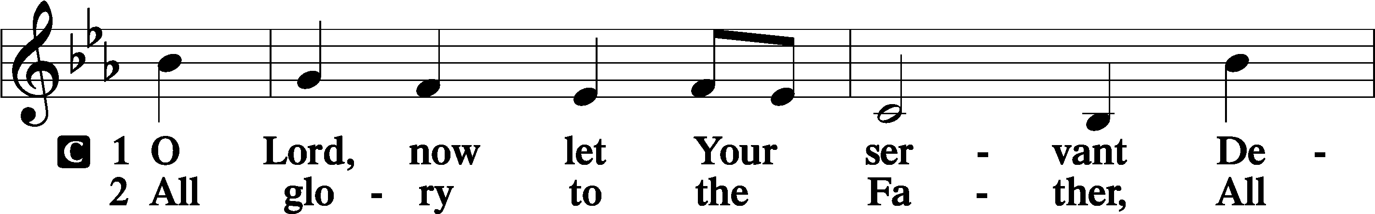
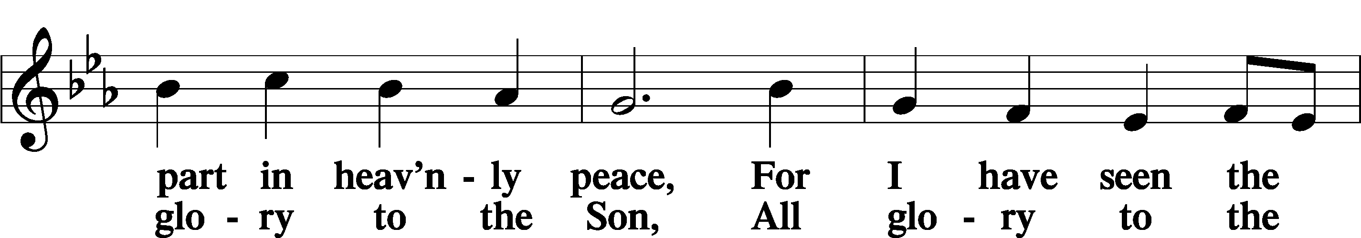
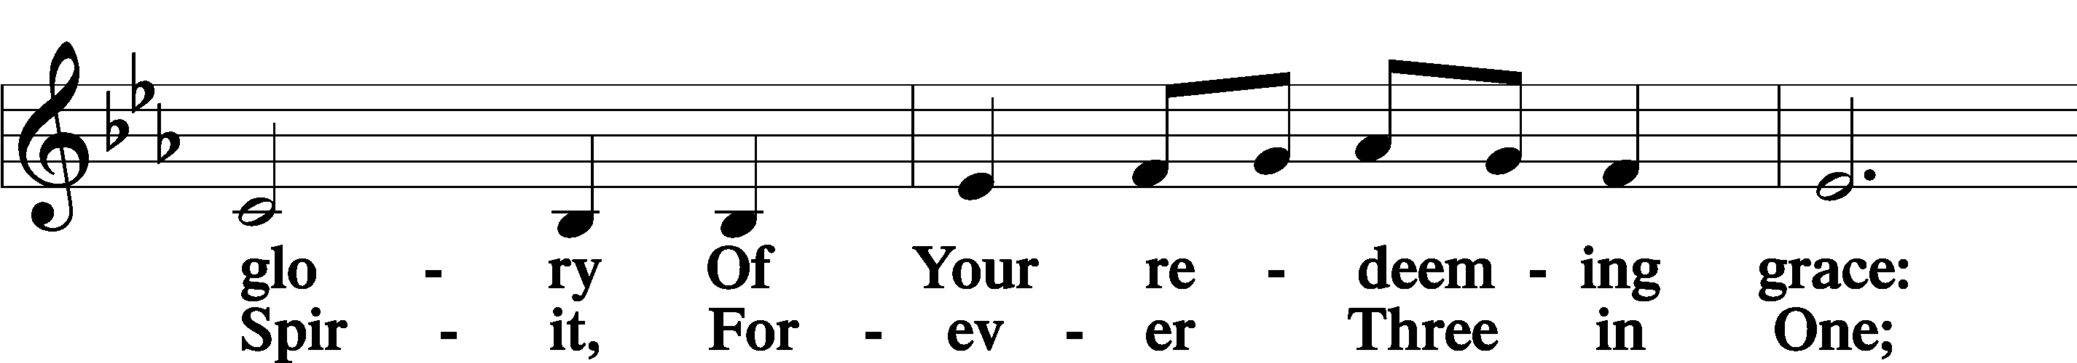
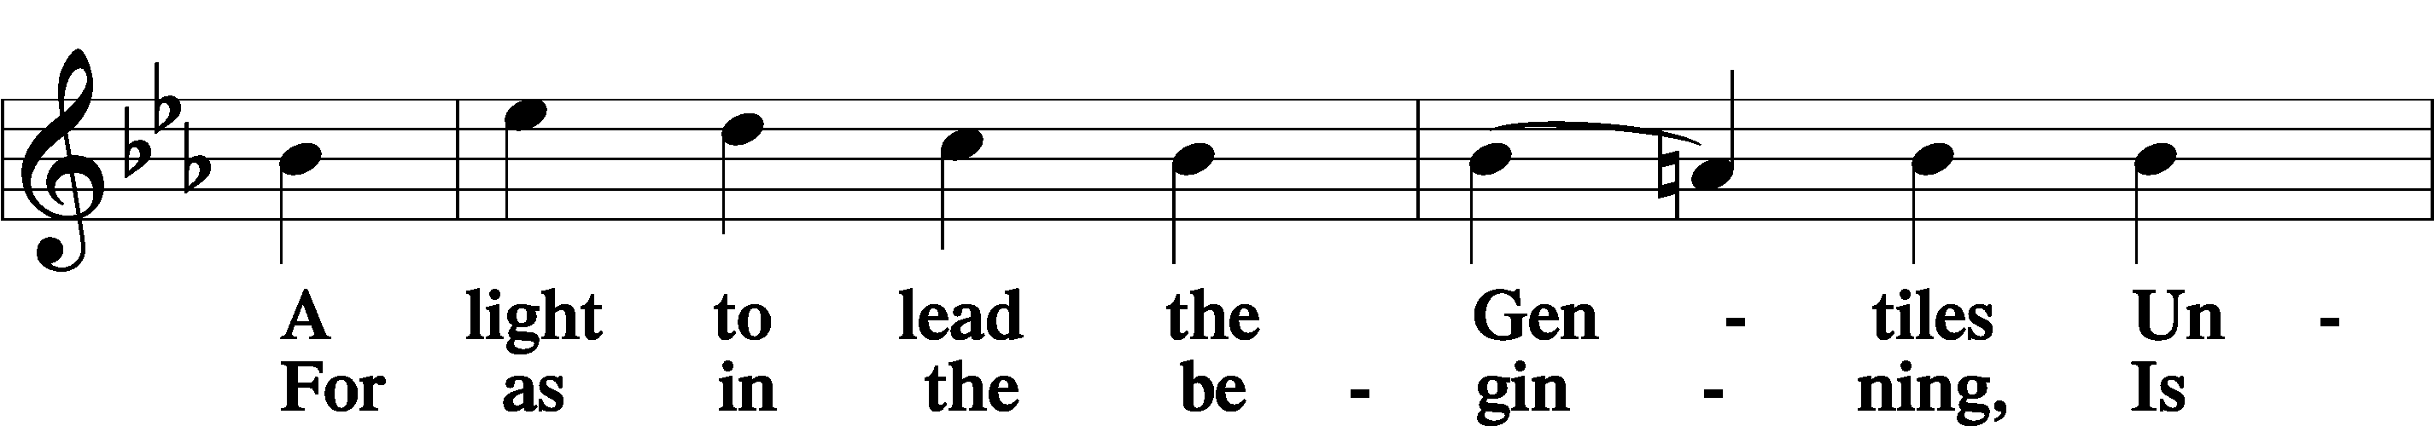
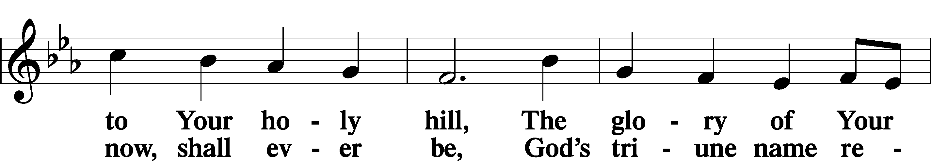
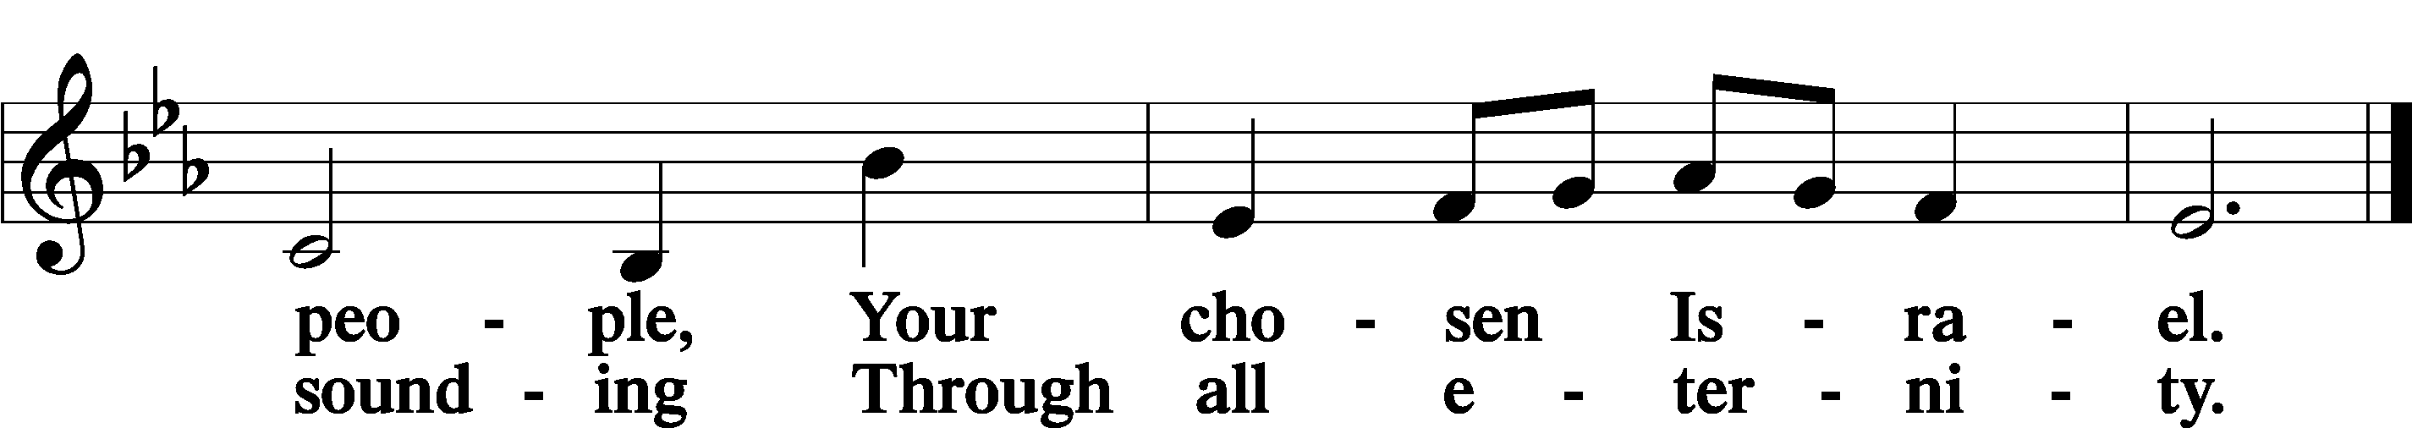

Post-Communion Collect
A Let us pray.
We give thanks to You, almighty God, that You have refreshed us through this salutary gift, and we implore You that of Your mercy You would strengthen us through the same in faith toward You and in fervent love toward one another; through Jesus Christ, Your Son, our Lord, who lives and reigns with You and the Holy Spirit, one God, now and forever.
C Amen.
Benedicamus
A Let us bless the Lord.
C Thanks be to God.

Benediction
P The Lord bless you and keep you.
The Lord make His face shine on you and be gracious to you.
The Lord look upon you with favor and + give you peace.
C Amen.

718 Jesus, Lead Thou On
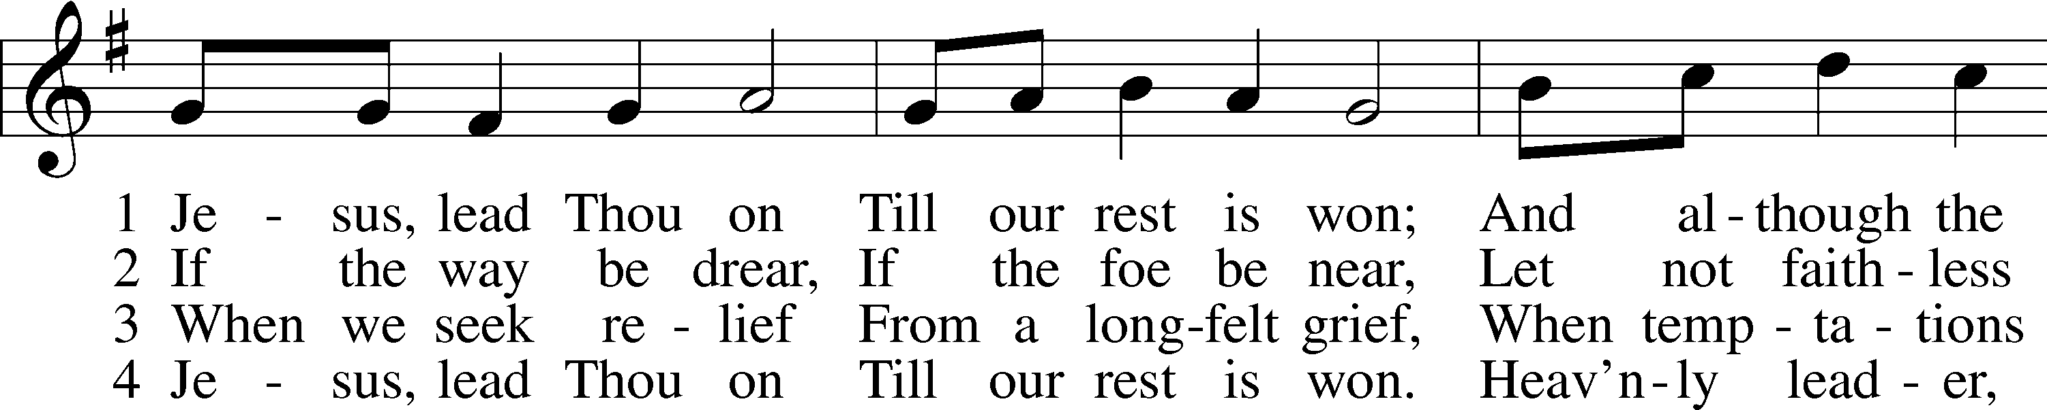
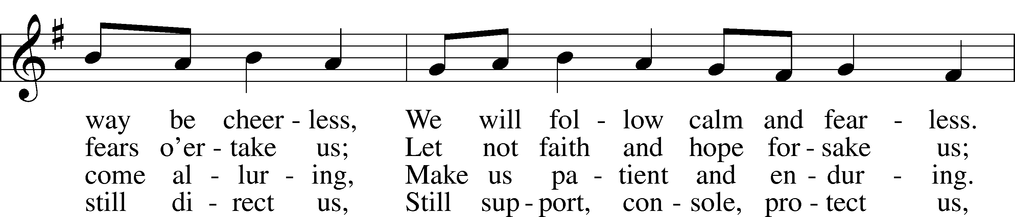
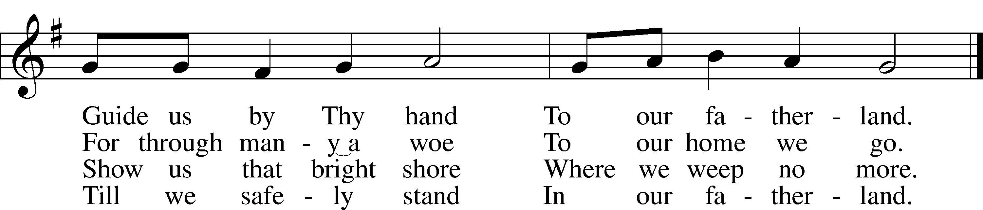
Text: Nicolaus Ludwig von Zinzendorf, 1700–60; tr. Jane L. Borthwick, 1813–97, alt.
Tune: Adam Drese, 1620–1701
Text and tune: Public domain

Divine Shepherd Calendar
Sunday, July 28th
8:00 am Divine Worship Service
9:15 am Coffee & Cookies
9:30 am Adult Bible Study & Sunday School
9:30 am Prayer Walk Committee Meeting
10:30 am Divine Worship Service
Wednesday, July 31st
5:30 pm Family Dinner
6:00 pm Vespers Service
Thursday, August 1st
9:30 am Ladies Bible Study
Sunday, August 4th
8:00 am Divine Worship Service
9:15 am Coffee & Cookies
9:30 am Adult Bible Study & Sunday School
10:30 am Divine Worship Service

The church calendar may also be found on our website at divineshep.org! Go to our website and scroll to the bottom.

Need to use the church for a special event? Reach out to the church secretary to fill out an event form! All events need to be approved by the Pastors and office beforehand.

Important Dates
Sunday, August 11th, there will be one service at 9:30 am. We will be having a potluck afterwards to congratulate Pastor Dennis on completing his SMP program at Concordia Seminary-Ft. Wayne! The Elders will be cooking the meat. Please bring a side to share!

The Christian Life Workshop will be hosted at Divine Shepherd on September 7th at 9:00 am. All women from the congregation are invited to attend! If you are able to donate a salad for the luncheon, please let the church office or Kathy Roling know.

Divine Shepherd Prayer Walk-September 2024!
The Prayer Walk Committee will be meeting today between the services. Please attend if you are interested in being a part of the prayer walk planning and process! If you would like to donate to this project, please reach out to the church office.
