Eighth Sunday after Trinity

Sunday, July 21st, 2024
Divine Service 3, Page 184
LARGE PRINT

Divine Shepherd Lutheran Church & School

7308 Wedgewood Drive
Black Hawk, SD 57718
“We are baptized children of God, forgiven and redeemed by Jesus. We are His family, called together to receive His gifts and serve others.”
Guest Preacher- Vicar Jonah Clausen
Pastor Randy Sturzenbecher
Pastor Dennis Mercer
Office (605) 787-6438 Pastor S. Cell (605) 391-0428
Pastor M. Cell (443) 980-7338 ECC (605) 791-1131

Email: DSLCpsturz@divineshep.org
DSLCpmercer@divineshep.org
DSLCsecretary@divineshep.org
Greetings to all in the Name of the Risen Lord!
May our worship celebrate the joy and hope, peace and presence, of our Lord Jesus Christ, raised to life for us. We welcome all, especially our guests. If you do not have a church home please consider Divine Shepherd. We would love to have you as part of our family. Please take a minute and sign our guest book.

A prayer before Worship
This is the day you have made, O Lord Jesus, a day of new life and eternal celebration! The stone is moved; death is defeated; heaven is open. As Your disciples first saw and believed Your victory over the tomb, so give us joy in the promise You made and keep for us: because You live, we live also! Amen.

The Lord’s Supper
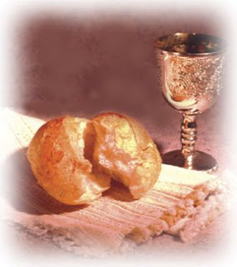
The Lord’s Supper is celebrated in the confession and gladness that, as our Lord says, He gives into our mouth not only bread and wine but His very body and blood to eat and drink for the forgiveness of sins and to strengthen our union with Him and with one another. Our Lord Jesus invites to His table those who trust His Words, repent of all sin, and set aside any refusal to forgive and love as He forgives and loves us, that they may show forth His death until He comes.

Whoever, therefore, eats the bread or drinks the blood of the Lord in an unworthy manner will be guilty concerning the body and blood of the Lord.
(1 Cor 11:28 ESV) Holy Communion is a confession of the faith which is confessed at this altar. Any who holds a confession differing from that of the Holy Scriptures, or are not a member in good standing with the LC-MS, are asked to speak with Pastor Sturzenbecher or Pastor Mercer.

Members and guests of DSLC and School we stream our services through Facebook Live. With this stream we do publish this to our Facebook page which means your face may end up on our Facebook page. If you are not comfortable with this please talk to Pastor to address this concern. -Thank you, The AV Team.

578 Thy Strong Word
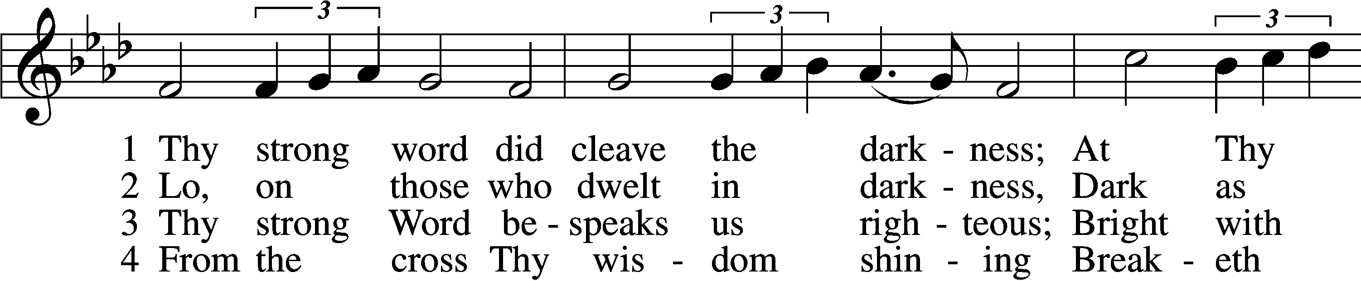
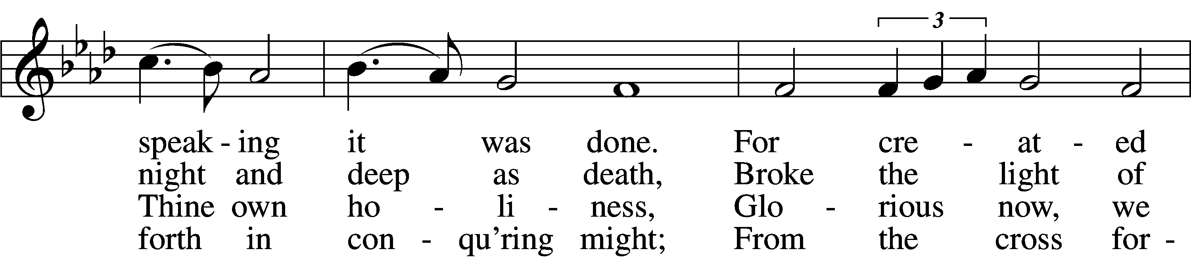
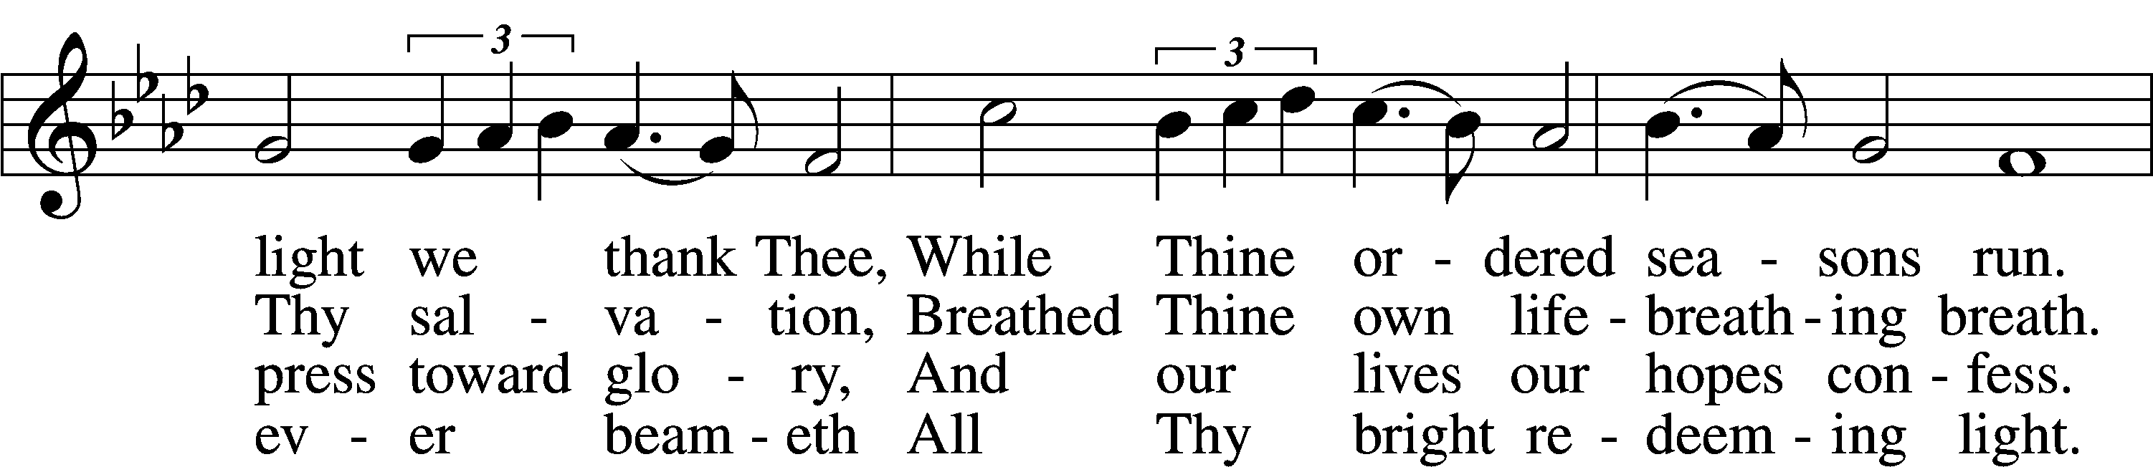
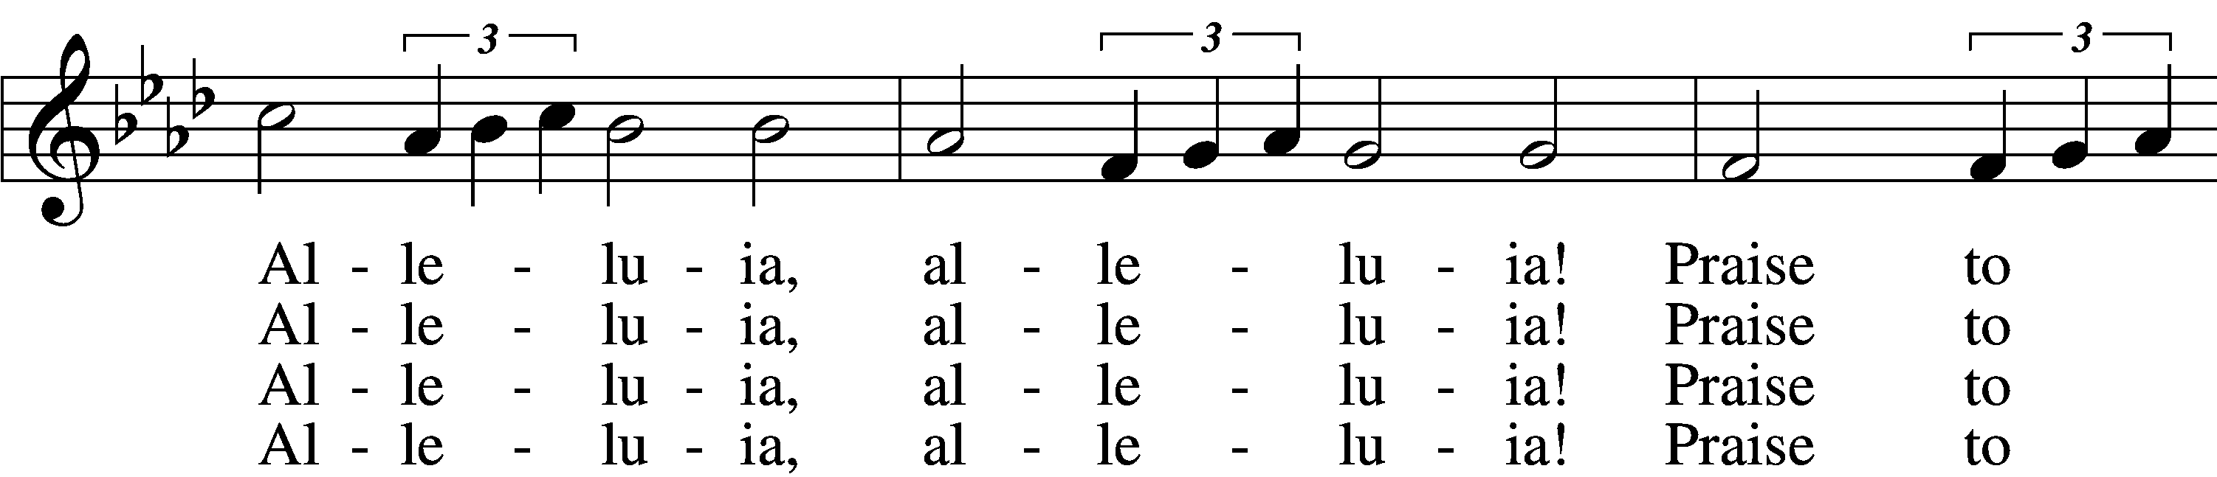
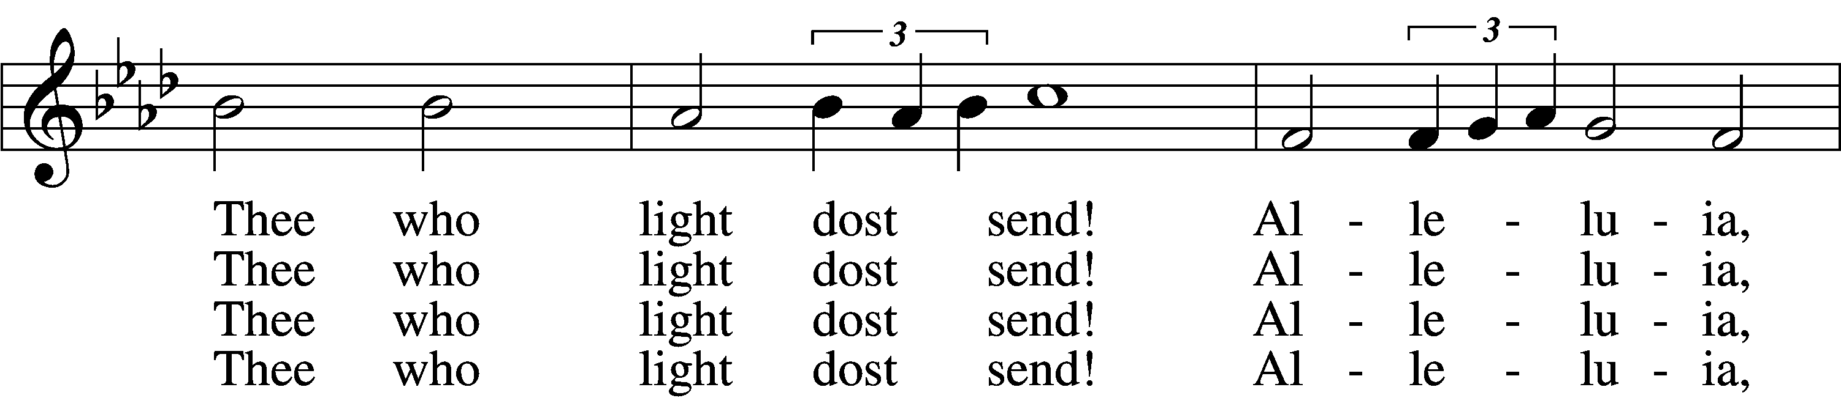
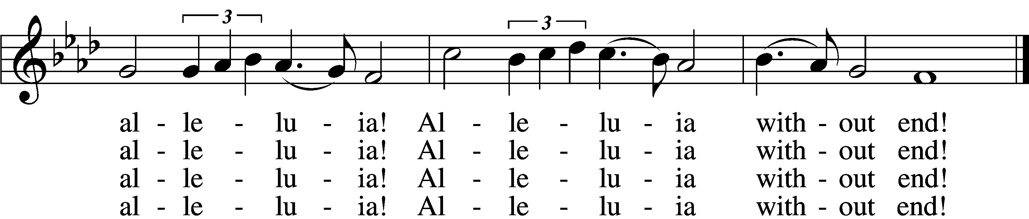

5 Give us lips to sing Thy glory,
Tongues Thy mercy to proclaim,
Throats that shout the hope that fills us,
Mouths to speak Thy holy name.
Alleluia, alleluia!
May the light which Thou dost send
Fill our songs with alleluias,
Alleluias without end!

D6 God the Father, light-creator,
To Thee laud and honor be.
To Thee, Light of Light begotten,
Praise be sung eternally.
Holy Spirit, light-revealer,
Glory, glory be to Thee.
Mortals, angels, now and ever
Praise the holy Trinity!
Text: Martin H. Franzmann, 1907–76
Tune: Thomas J. Williams, 1869–1944
Text: © 1969 Concordia Publishing House. Used by permission: LSB Hymn License no. 110004822
Tune: Public domain

Invocation & Exhortation
P In the name of the Father and of the + Son and of the Holy Spirit.
C Amen.
P Beloved in the Lord! Let us draw near with a true heart and confess our sins unto God our Father, beseeching Him in the name of our Lord Jesus Christ to grant us forgiveness.
P Our help is in the name of the Lord,
C who made heaven and earth.
P I said, I will confess my transgressions unto the Lord,
C and You forgave the iniquity of my sin.

Confession and Absolution
P O almighty God, merciful Father,
C I, a poor, miserable sinner, confess unto You all my sins and iniquities with which I have ever offended You and justly deserved Your temporal and eternal punishment.
But I am heartily sorry for them and sincerely repent of them, and I pray You of Your boundless mercy and for the sake of the holy, innocent, bitter sufferings and death of Your beloved Son, Jesus Christ, to be gracious and merciful to me, a poor, sinful being.
P Upon this your confession, I, by virtue of my office, as a called and ordained servant of the Word, announce the grace of God unto all of you, and in the stead and by the command of my Lord Jesus Christ I forgive you all your sins in the name of the Father and of the + Son and of the Holy Spirit.
C Amen.

Introit Psalm 48:1, 3, 11, 14
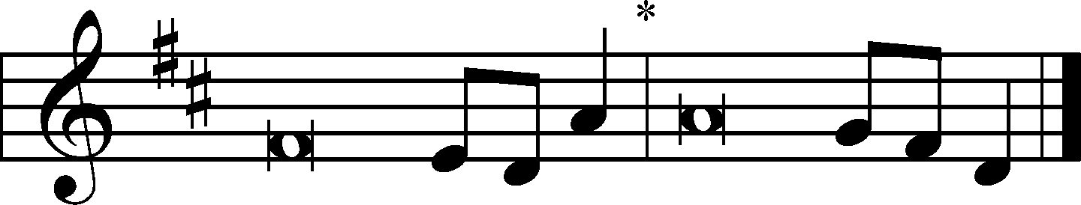
We have thought on your steadfast love, | O God,*
in the midst of your | temple.
As your name, O God, so your praise reaches to the ends | of the earth.*
Your right hand is filled with | righteousness.
Great is the Lord and greatly | to be praised*
in the city of our God, his holy | mountain.
Within her | citadels*
God has made himself known as a | fortress.
Let Mount Zion | be glad!*
Let the daughters of Judah rejoice because of your | judgments!
This is God, our God forever and | ever.*
He will guide us for- | ever.
Glory be to the Father and | to the Son*
and to the Holy | Spirit;
as it was in the be- | ginning,*
is now, and will be forever. | Amen.
We have thought on your steadfast love, | O God,*
in the midst of your | temple.
As your name, O God, so your praise reaches to the ends | of the earth.*
Your right hand is filled with | righteousness.

Kyrie
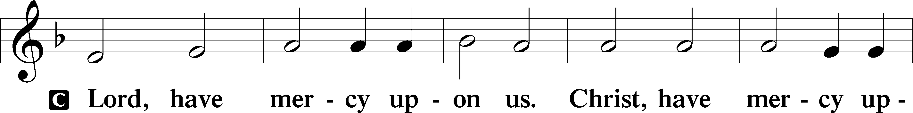
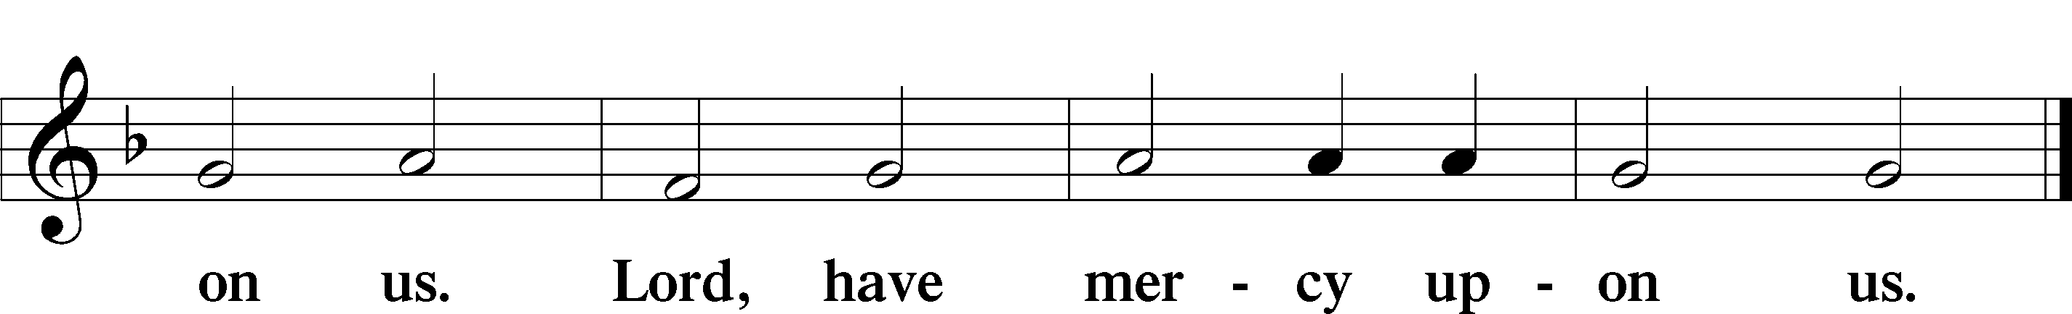

Gloria in Excelsis
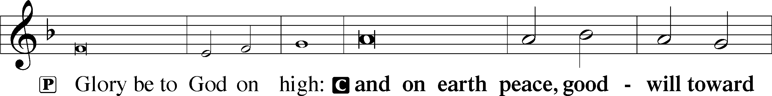
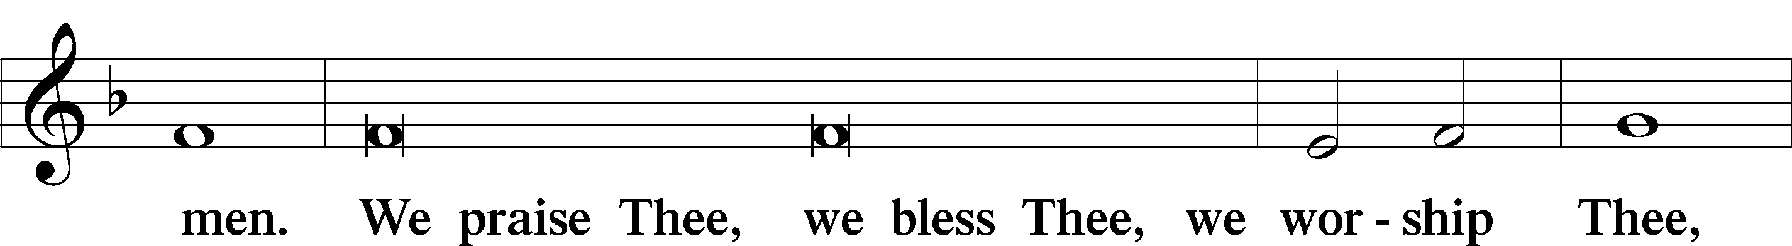
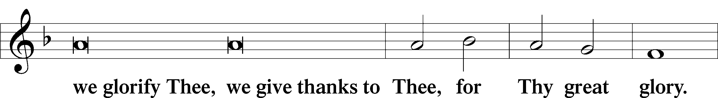
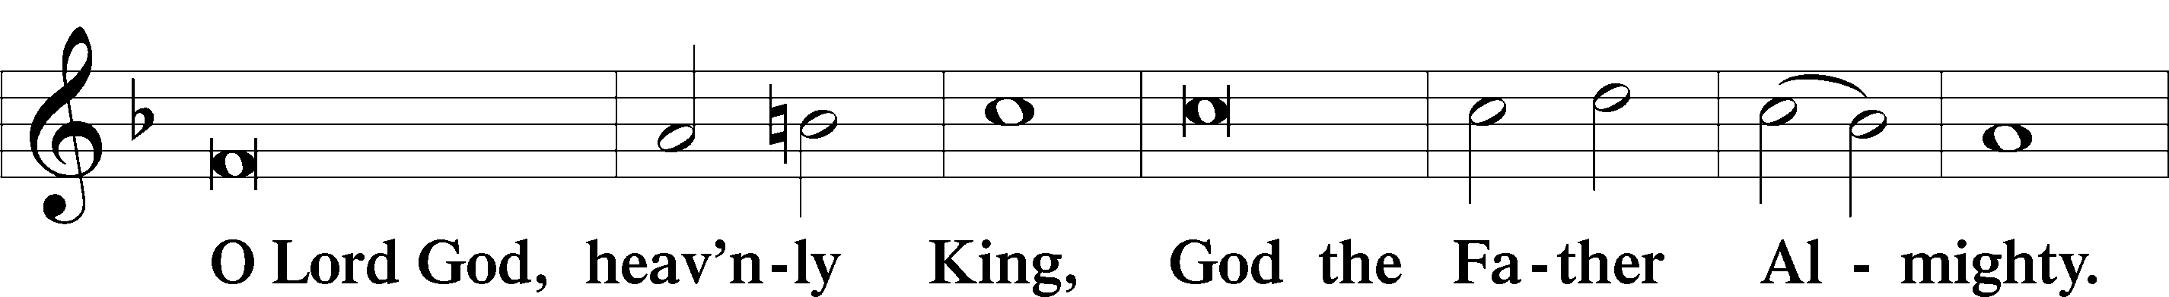
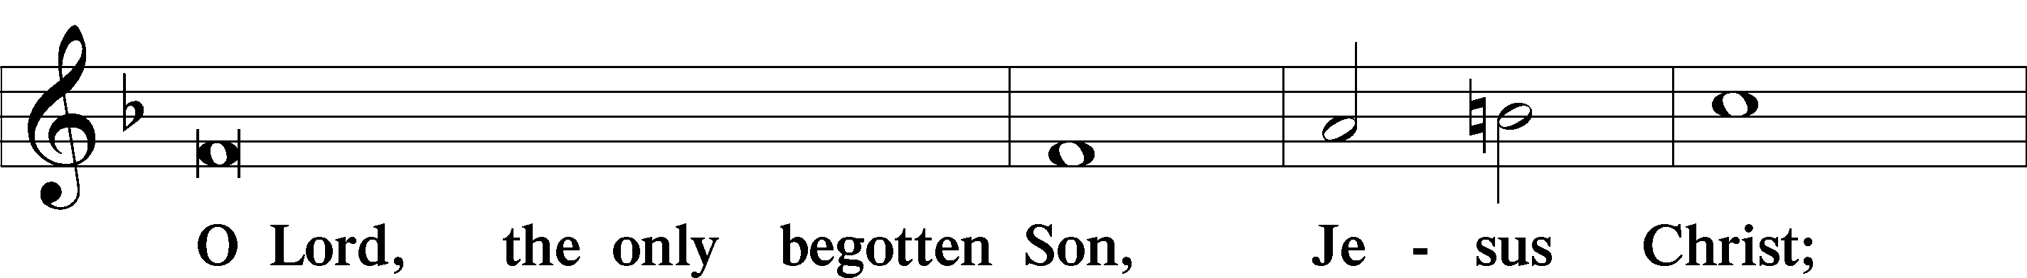
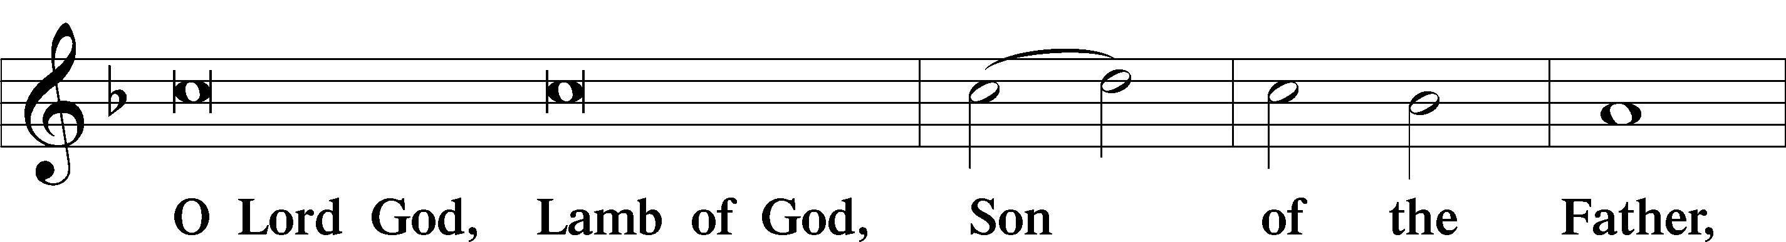
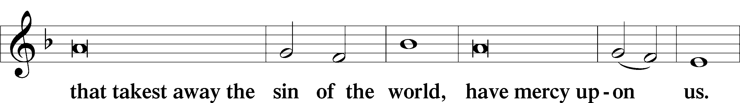
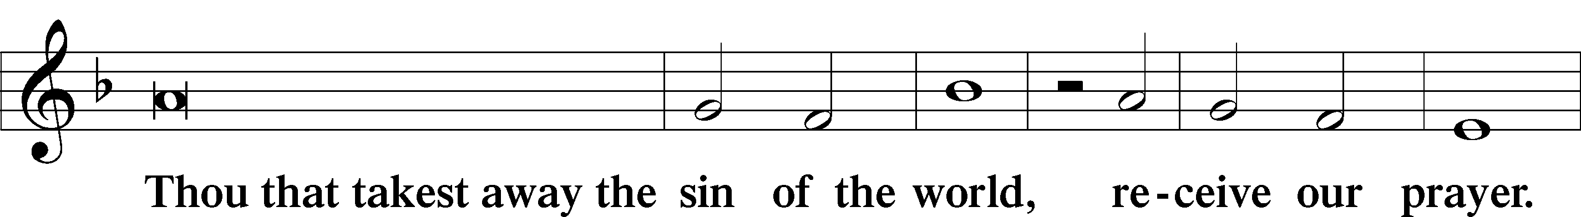
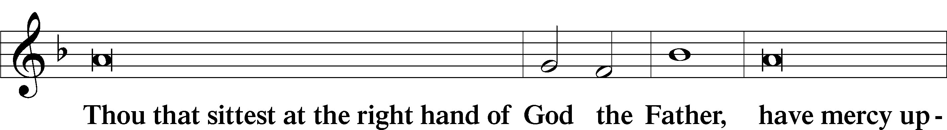
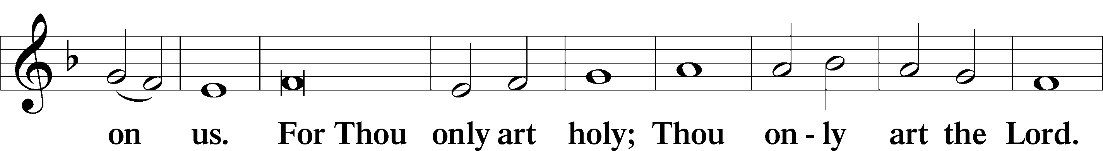
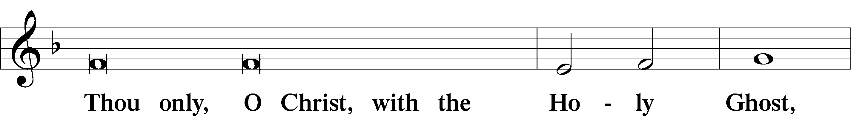
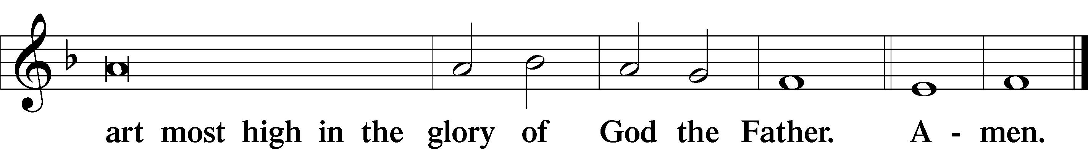

Salutation and Collect of the Day
P The Lord be with you.
C And with thy spirit.
P Let us pray.
Grant to us, Lord, the Spirit to think and do always such things as are right, that we, who cannot do anything that is good without You, may be enabled by You to live according to Your will; through Jesus Christ, Your Son, our Lord, who lives and reigns with You and the Holy Spirit, one God, now and forever.
C Amen.

Old Testament Reading Jeremiah 23:16–29
¹⁶Thus says the Lord of hosts: “Do not listen to the words of the prophets who prophesy to you, filling you with vain hopes. They speak visions of their own minds, not from the mouth of the Lord. ¹⁷They say continually to those who despise the word of the Lord, ‘It shall be well with you’; and to everyone who stubbornly follows his own heart, they say, ‘No disaster shall come upon you.’” ¹⁸For who among them has stood in the council of the Lord to see and to hear his word, or who has paid attention to his word and listened? ¹⁹Behold, the storm of the Lord! Wrath has gone forth, a whirling tempest; it will burst upon the head of the wicked. ²⁰The anger of the Lord will not turn back until he has executed and accomplished the intents of his heart. In the latter days you will understand it clearly. ²¹“I did not send the prophets, yet they ran; I did not speak to them, yet they prophesied. ²²But if they had stood in my council, then they would have proclaimed my words to my people, and they would have turned them from their evil way, and from the evil of their deeds. ²³“Am I a God at hand, declares the Lord, and not a God afar off? ²⁴Can a man hide himself in secret places so that I cannot see him? declares the Lord. Do I not fill heaven and earth? declares the Lord. ²⁵I have heard what the prophets have said who prophesy lies in my name, saying, ‘I have dreamed, I have dreamed!’ ²⁶How long shall there be lies in the heart of the prophets who prophesy lies, and who prophesy the deceit of their own heart, ²⁷who think to make my people forget my name by their dreams that they tell one another, even as their fathers forgot my name for Baal? ²⁸Let the prophet who has a dream tell the dream, but let him who has my word speak my word faithfully. What has straw in common with wheat? declares the Lord. ²⁹Is not my word like fire, declares the Lord, and like a hammer that breaks the rock in pieces?”

Catechetical Review
The Second Article of the Apostles Creed
Redemption
And in Jesus Christ, His only Son, our Lord, who was conceived by the Holy Spirit, born of the virgin Mary, suffered under Pontius Pilate, was crucified, died and was buried. He descended into hell. The third day He rose again from the dead. He ascended into heaven and sits at the right hand of God the Father Almighty. From thence He will come to judge the living and the dead.

What does this mean?
I believe that Jesus Christ, true God, begotten of the Father from eternity, and also true man, born of the virgin Mary, is my Lord, who has redeemed me, a lost and condemned person, purchased and won me from all sins, from death, and from the power of the devil; not with gold or silver, but with His holy, precious blood and with His innocent suffering and death, that I may be His own and live under Him in His kingdom and serve Him in everlasting righteousness, innocence, and blessedness, just as He is risen from the dead, lives and reigns to all eternity. This is most certainly true.
Epistle Romans 8:12–17
¹²So then, brothers, we are debtors, not to the flesh, to live according to the flesh. ¹³For if you live according to the flesh you will die, but if by the Spirit you put to death the deeds of the body, you will live. ¹⁴For all who are led by the Spirit of God are sons of God. ¹⁵For you did not receive the spirit of slavery to fall back into fear, but you have received the Spirit of adoption as sons, by whom we cry, “Abba! Father!” ¹⁶The Spirit himself bears witness with our spirit that we are children of God, ¹⁷and if children, then heirs—heirs of God and fellow heirs with Christ, provided we suffer with him in order that we may also be glorified with him.

Alleluia
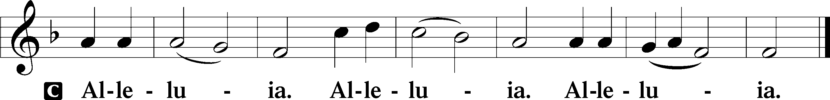

Holy Gospel Matthew 7:15–23
P The Holy Gospel according to St. Matthew, the seventh chapter.
C Glory be to Thee, O Lord.
¹⁵[Jesus said:] “Beware of false prophets, who come to you in sheep’s clothing but inwardly are ravenous wolves. ¹⁶You will recognize them by their fruits. Are grapes gathered from thornbushes, or figs from thistles? ¹⁷So, every healthy tree bears good fruit, but the diseased tree bears bad fruit. ¹⁸A healthy tree cannot bear bad fruit, nor can a diseased tree bear good fruit. ¹⁹Every tree that does not bear good fruit is cut down and thrown into the fire. ²⁰Thus you will recognize them by their fruits. ²¹“Not everyone who says to me, ‘Lord, Lord,’ will enter the kingdom of heaven, but the one who does the will of my Father who is in heaven. ²²On that day many will say to me, ‘Lord, Lord, did we not prophesy in your name, and cast out demons in your name, and do many mighty works in your name?’ ²³And then will I declare to them, ‘I never knew you; depart from me, you workers of lawlessness.’”
P This is the Gospel of the Lord.
C Praise be to Thee, O Christ.

Nicene Creed
C I believe in one God, the Father Almighty, maker of heaven and earth and of all things visible and invisible. And in one Lord Jesus Christ, the only-begotten Son of God, begotten of His Father before all worlds, God of God, Light of Light, very God of very God, begotten, not made, being of one substance with the Father, by whom all things were made; who for us men and for our salvation came down from heaven and was incarnate by the Holy Spirit of the virgin Mary and was made man; and was crucified also for us under Pontius Pilate. He suffered and was buried. And the third day He rose again according to the Scriptures and ascended into heaven and sits at the right hand of the Father. And He will come again with glory to judge both the living and the dead, whose kingdom will have no end. And I believe in the Holy Spirit, the Lord and giver of life, who proceeds from the Father and the Son, who with the Father and the Son together is worshiped and glorified, who spoke by the prophets. And I believe in one holy Christian and apostolic Church, I acknowledge one Baptism for the remission of sins, and I look for the resurrection of the dead and the life + of the world to come. Amen.

Children’s Sermon

586 Preach You the Word
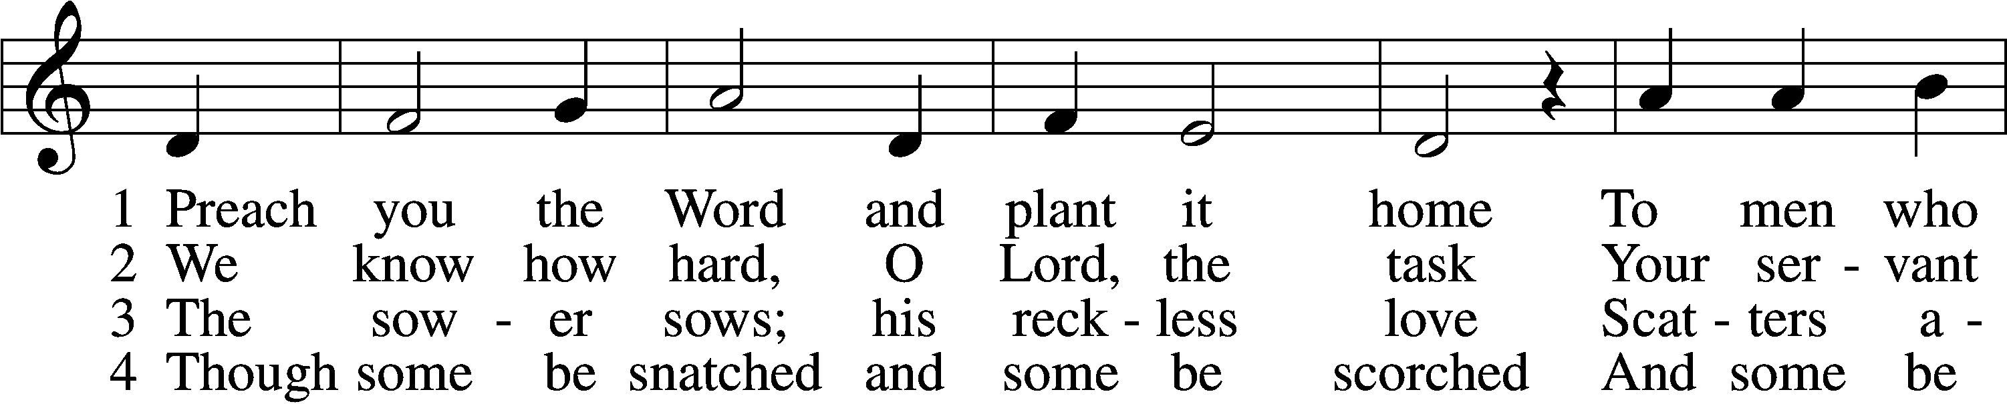
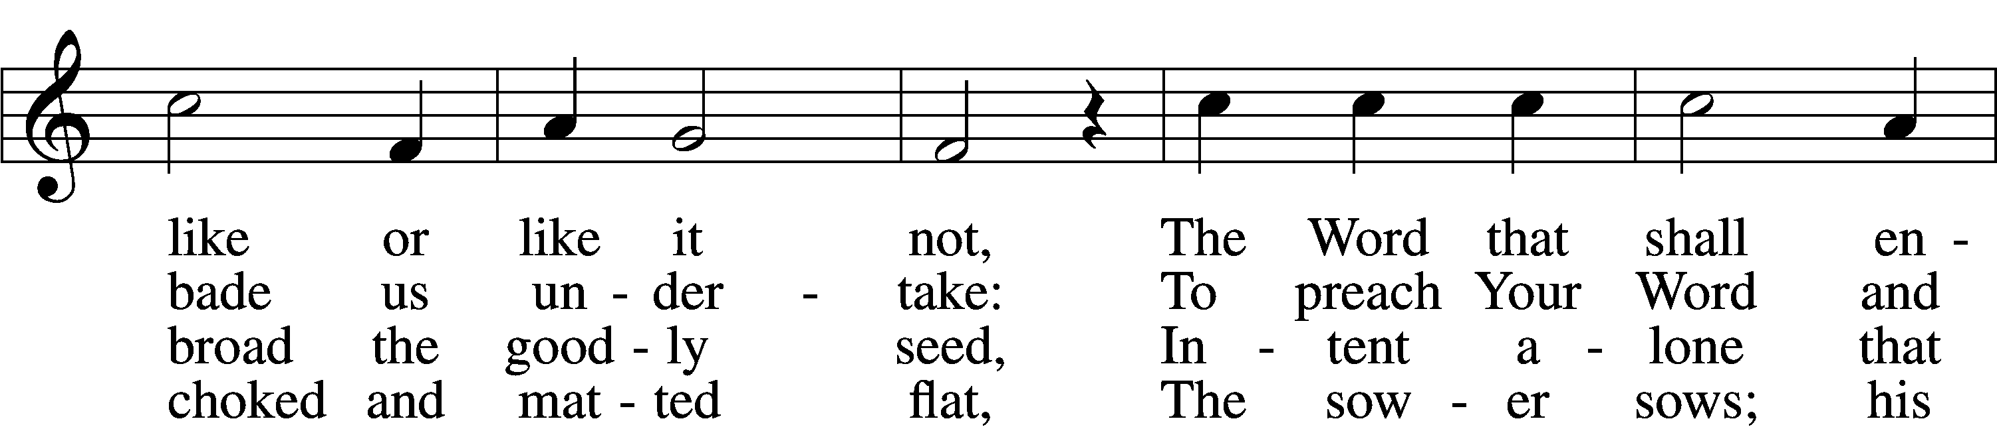
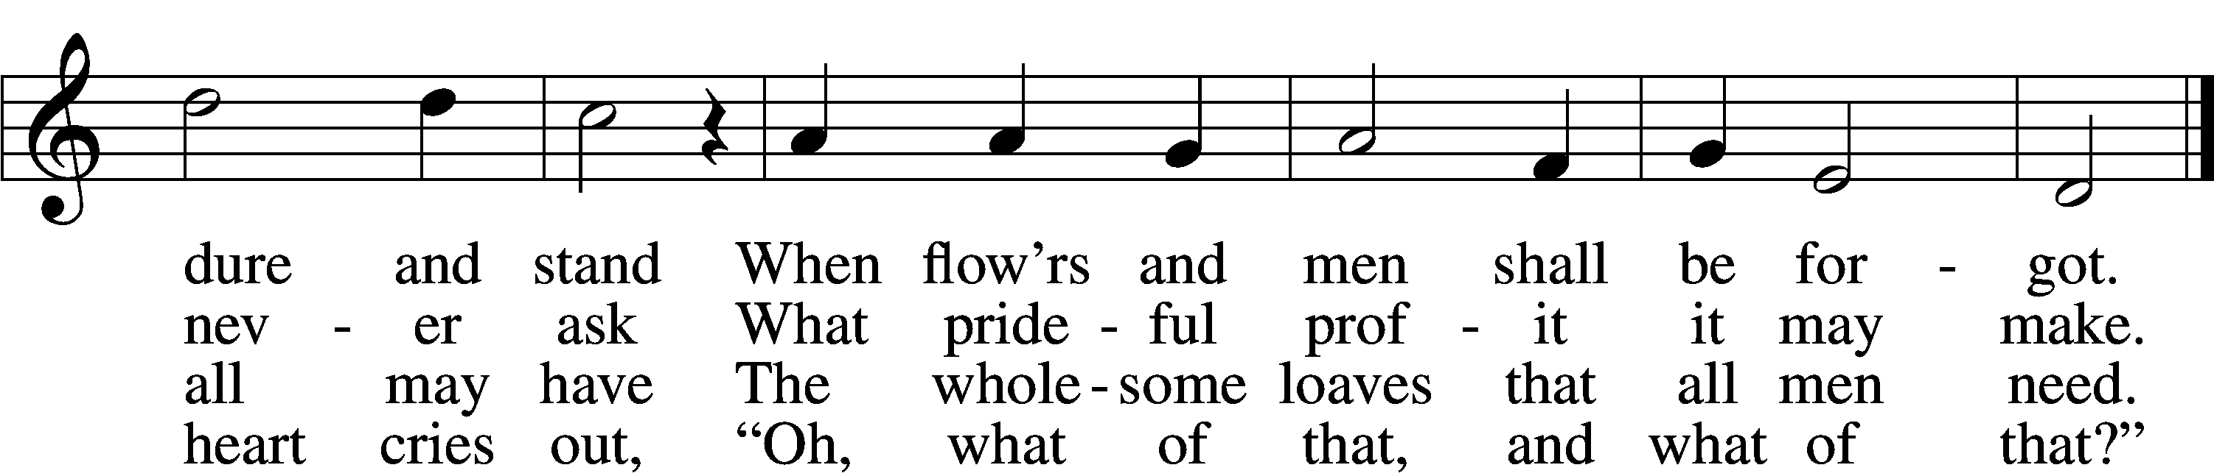

5 Of all his scattered plenteousness
One-fourth waves ripe on hill and flat,
And bears a harvest hundredfold:
“Ah, what of that, Lord, what of that!”

6 Preach you the Word and plant it home
And never faint; the Harvest Lord
Who gave the sower seed to sow
Will watch and tend His planted Word.
Text: Martin H. Franzmann, 1907–76, alt.
Tune: Rheinfelssisch Deutsches Catholisches Gesangbuch, 1666, Augsburg
Text: © 1971 The Franzmann Family. Used by permission: LSB Hymn License no. 110004822
Tune: Public domain

Sermon

Offertory
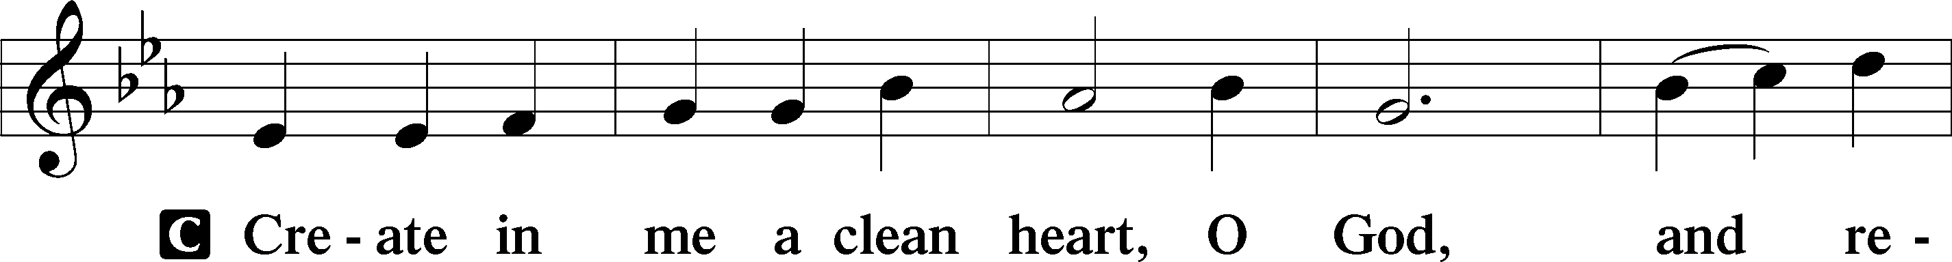
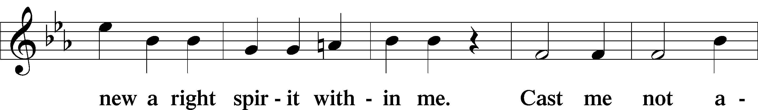
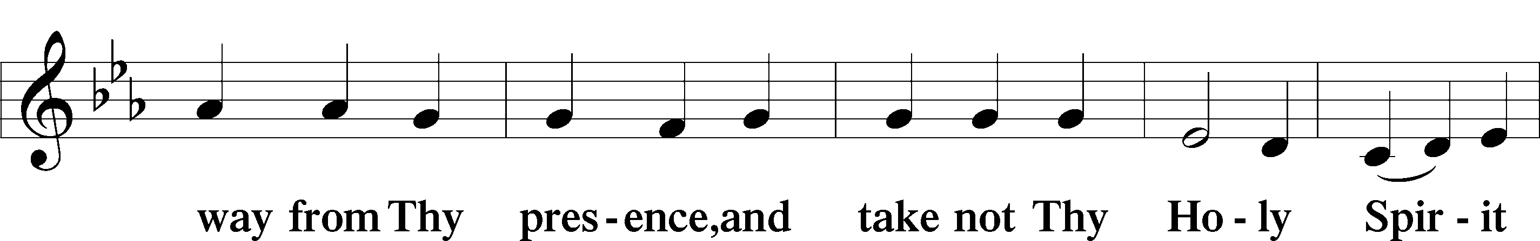
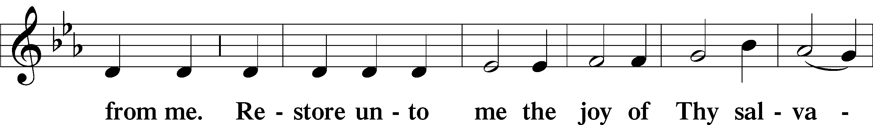
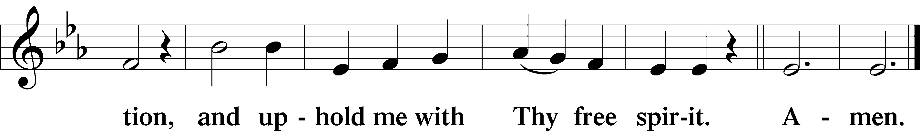

Offering
Prayer of the Church “Hear Our Prayer“

Preface
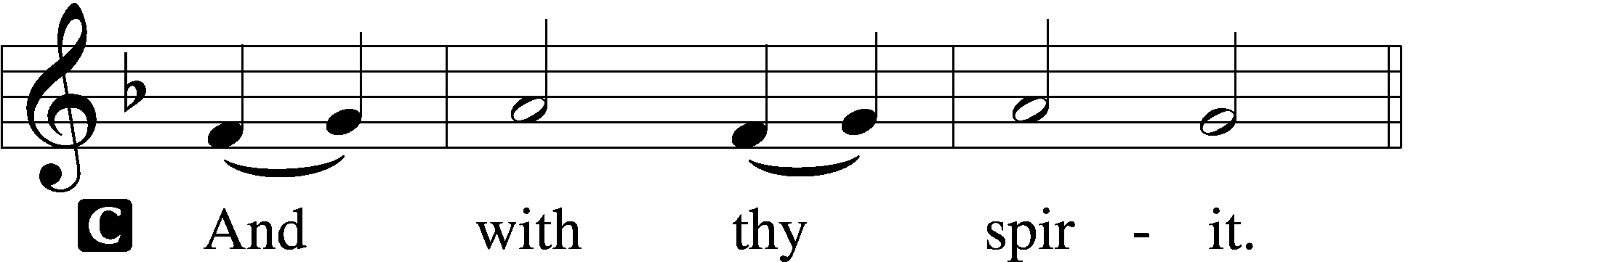

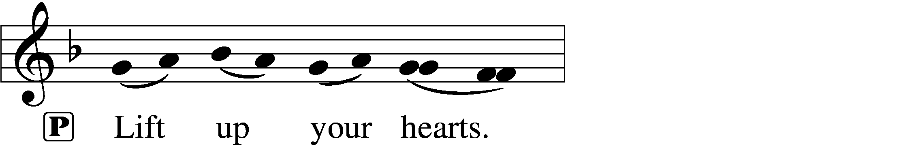
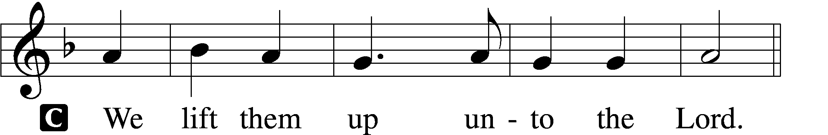

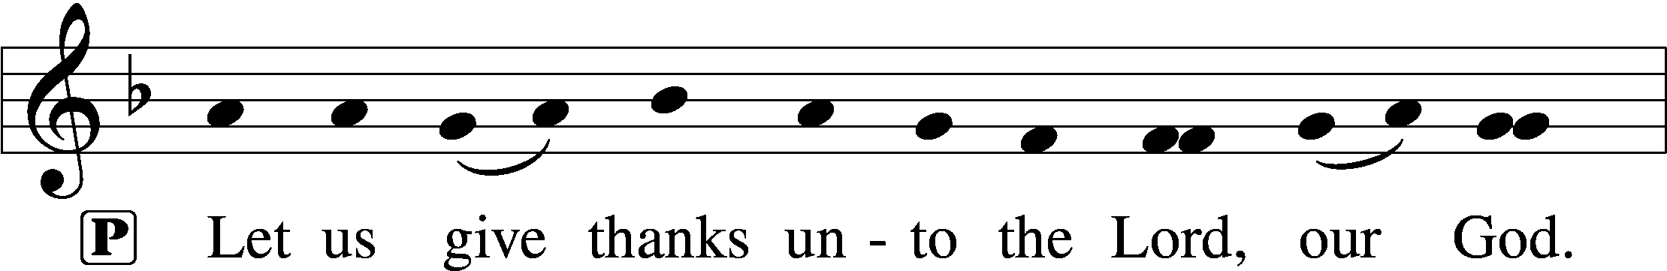
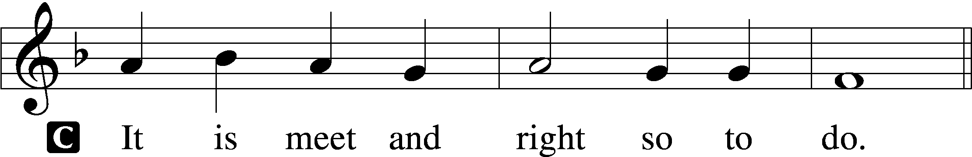

Sanctus
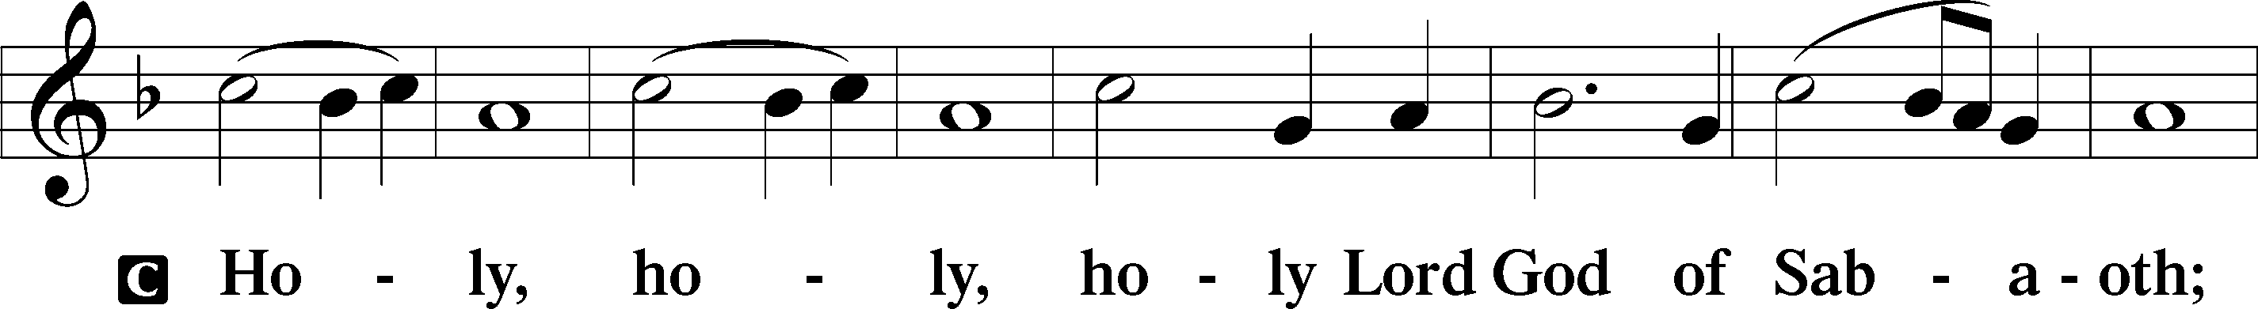
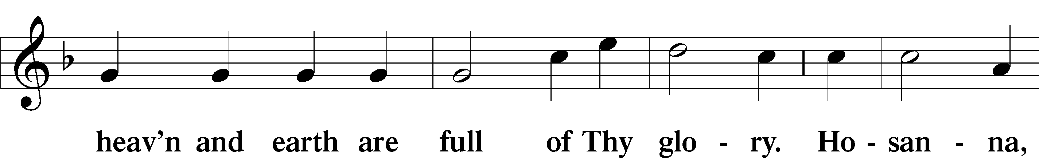
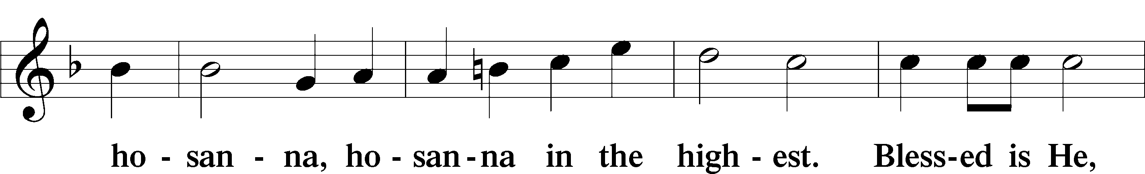
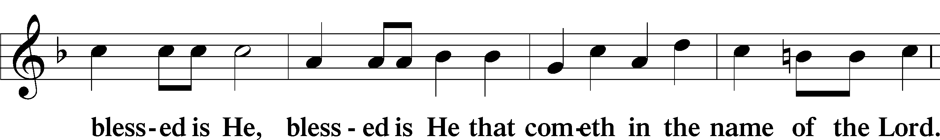
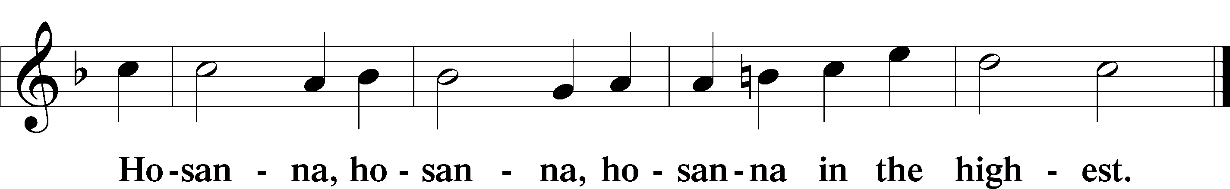

Lord’s Prayer
Our Father who art in heaven, hallowed be Thy name, Thy kingdom come, Thy will be done on earth as it is in heaven; give us this day our daily bread; and forgive us our trespasses as we forgive those who trespass against us; and lead us not into temptation, but deliver us from evil. For Thine is the kingdom and the power and the glory forever and ever. Amen.

The Words of Our Lord
P Our Lord Jesus Christ, on the night when He was betrayed, took bread, and when He had given thanks, He broke it and gave it to the disciples and said: “Take, eat; this is My + body, which is given for you. This do in remembrance of Me.” In the same way also He took the cup after supper, and when He had given thanks, He gave it to them, saying: “Drink of it, all of you; this cup is the new testament in My + blood, which is shed for you for the forgiveness of sins. This do, as often as you drink it, in remembrance of Me.”

Pax Domini
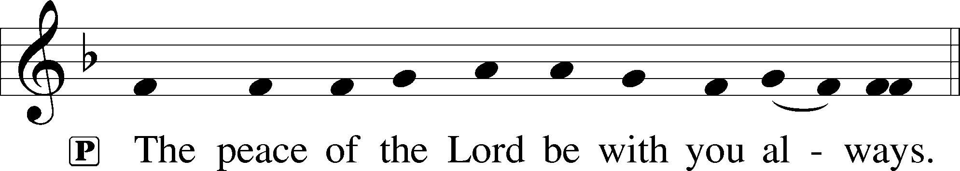

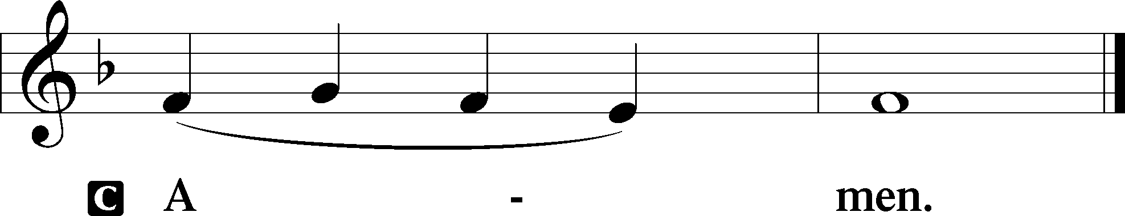

Agnus Dei
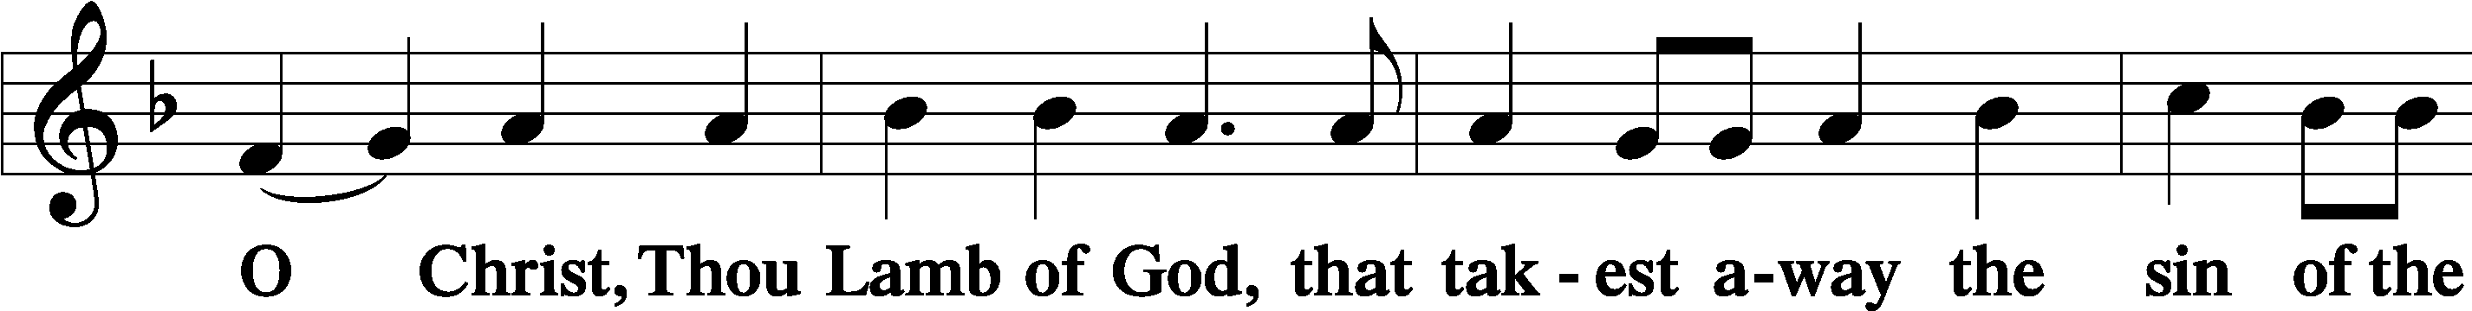
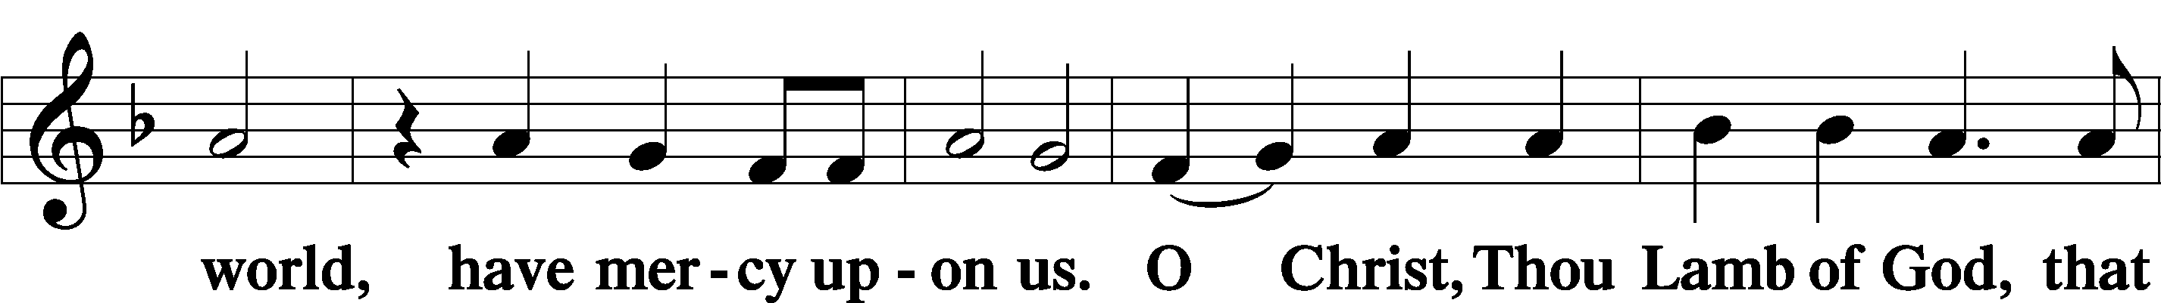
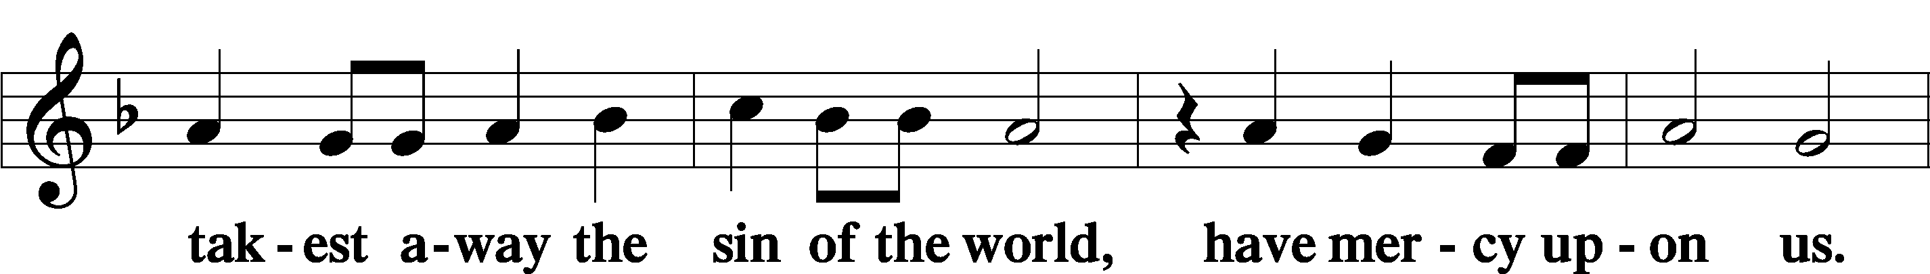
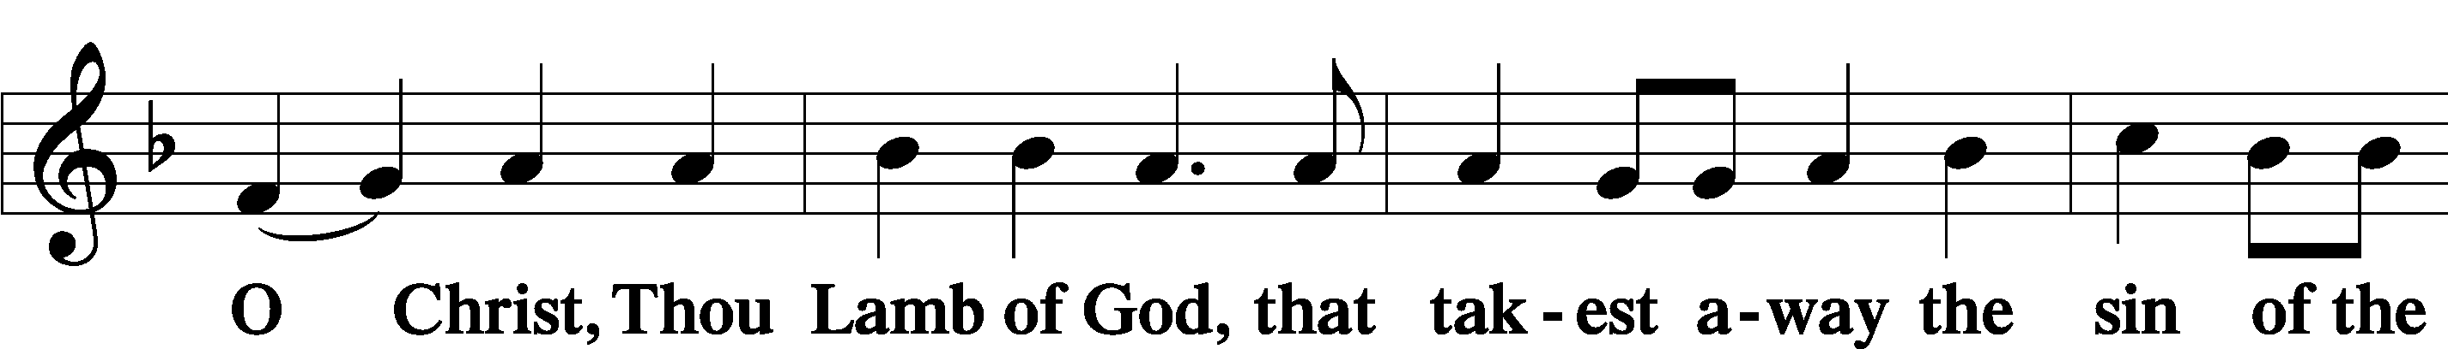
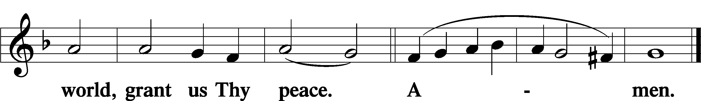

Distribution Hymn
588 Jesus Loves Me sts. 1, ref, 2
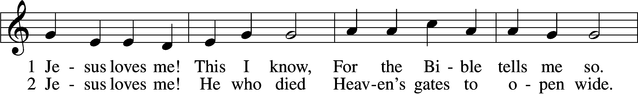
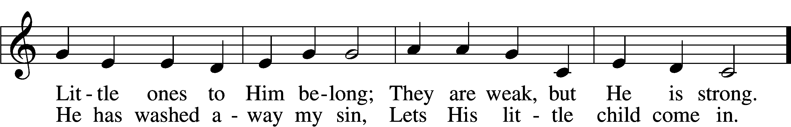
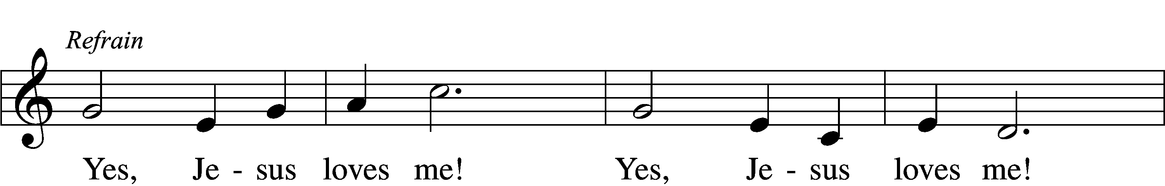
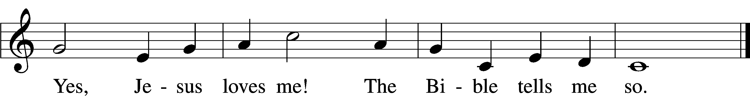
Text: Anna B. Warner, 1820–1915, alt.
Tune: William B. Bradbury, 1816–68
Text and tune: Public domain

851 Lord of Glory, You Have Bought Us
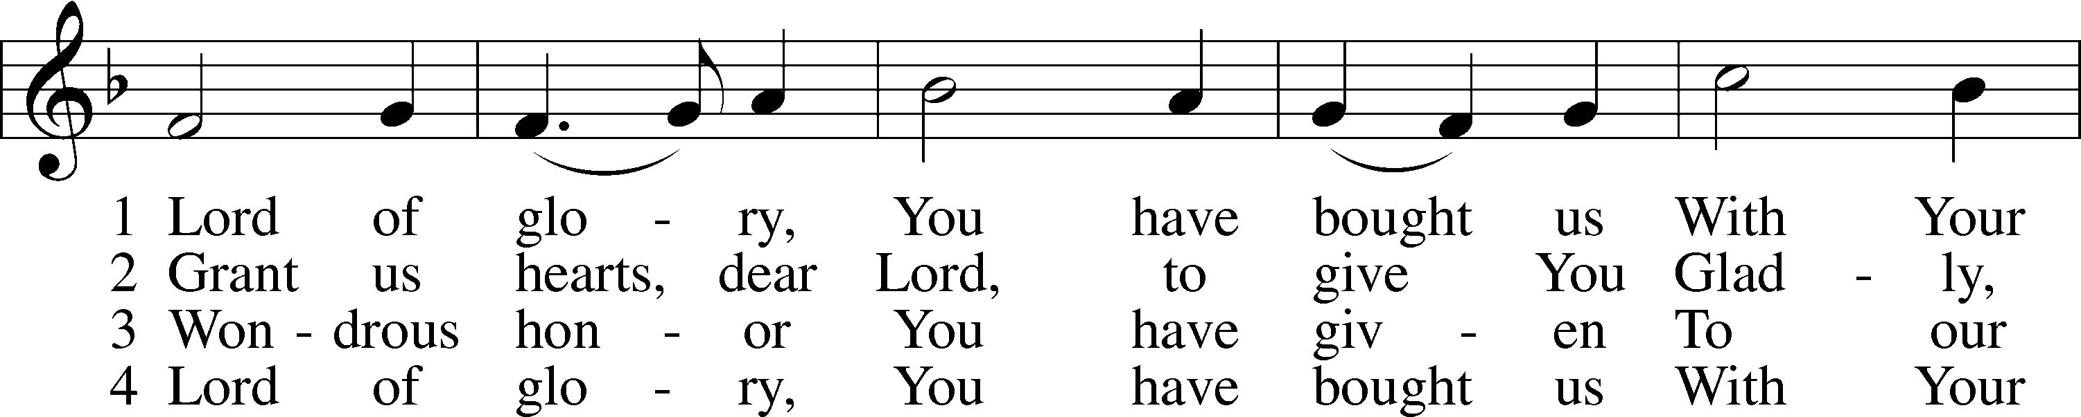
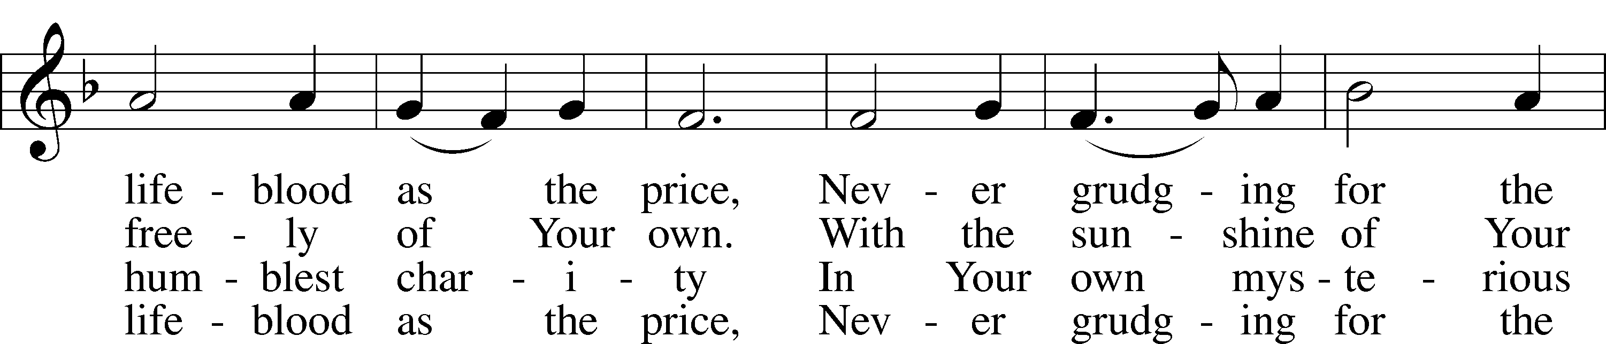
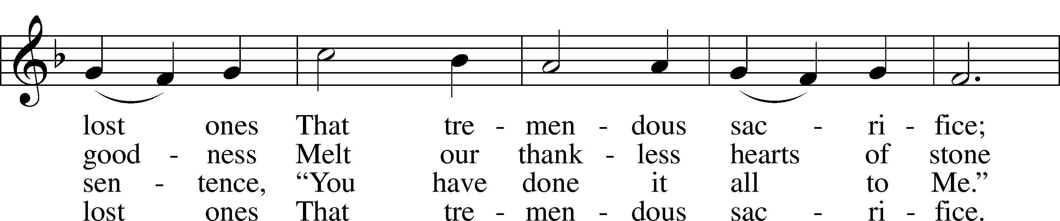
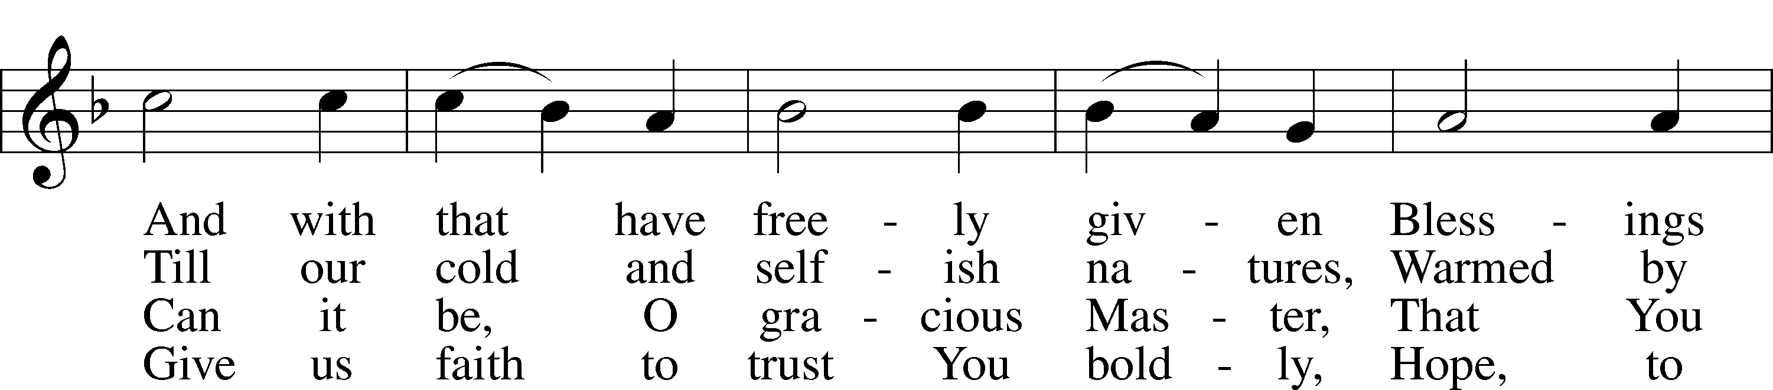
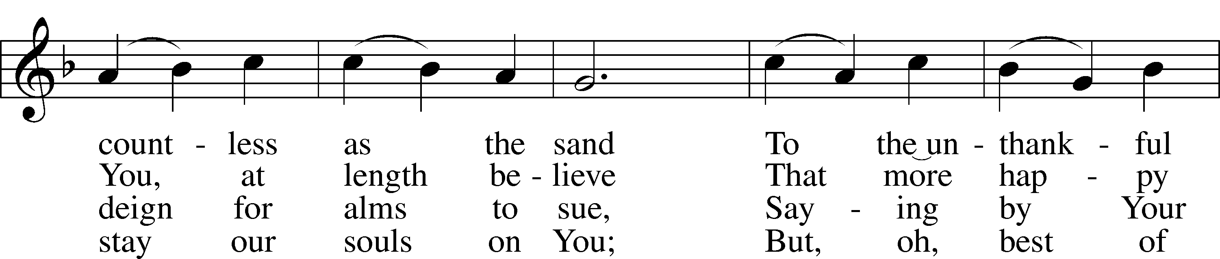
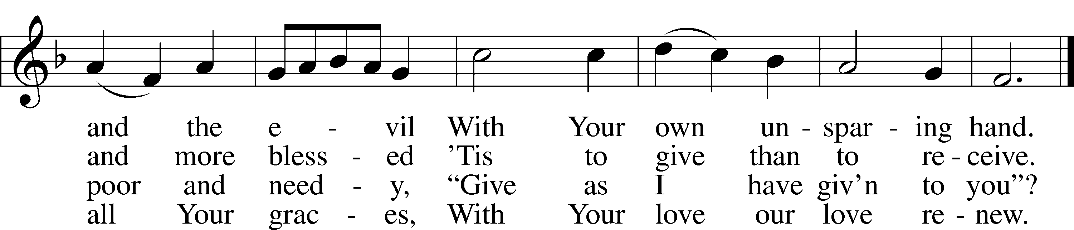
Text: Eliza S. Alderson, 1818–89, alt. Tune: Rowland H. Prichard, 1811–87 Text and tune: Public domain

596 All Christians Who Have Been Baptized
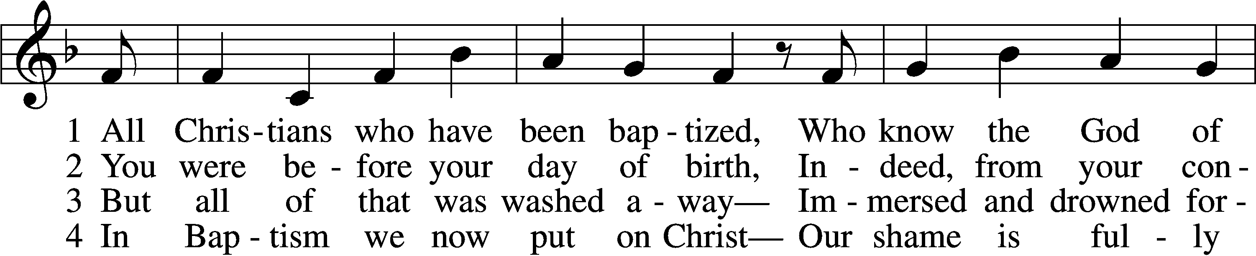
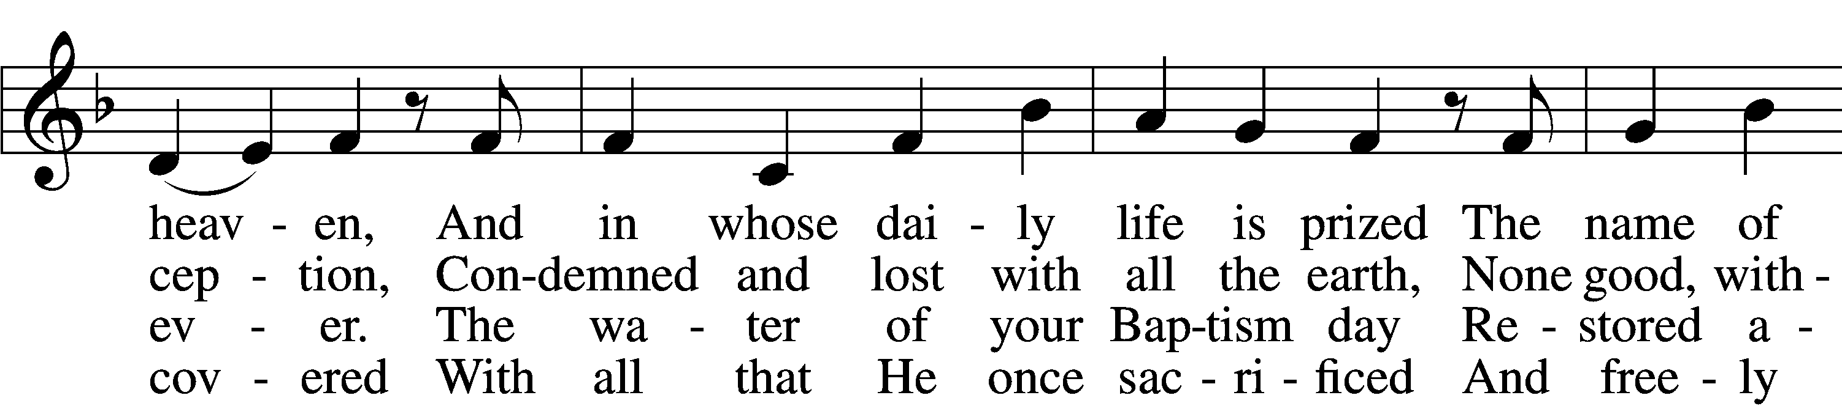
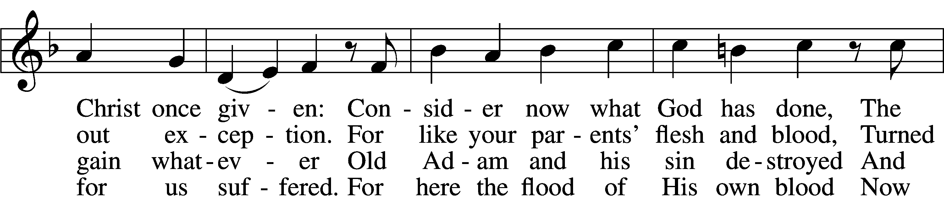
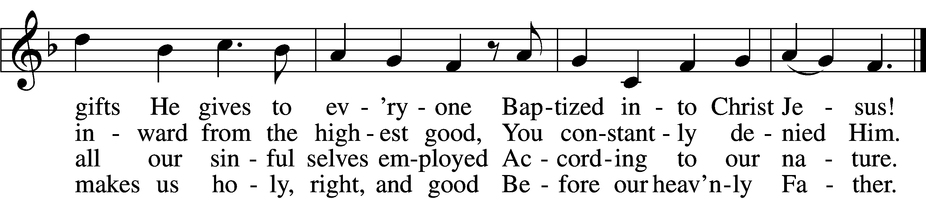
6 So use it well! You are made new—
In Christ a new creation!
As faithful Christians, live and do
Within your own vocation,
Until that day when you possess
His glorious robe of righteousness
Bestowed on you forever!
Text: Paul Gerhardt, 1607–76; tr. Jon D. Vieker, 1961
Tune: Etlich Cristlich lider, 1524, Wittenberg
Text: © 2004 Concordia Publishing House. Used by permission: LSB Hymn License no. 110004822
Tune: Public domain

5 O Christian, firmly hold this gift
And give God thanks forever!
It gives the power to uplift
In all that you endeavor.
When nothing else revives your soul,
Your Baptism stands and makes you whole
And then in death completes you.

Nunc Dimittis
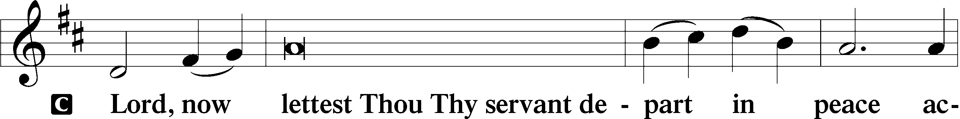
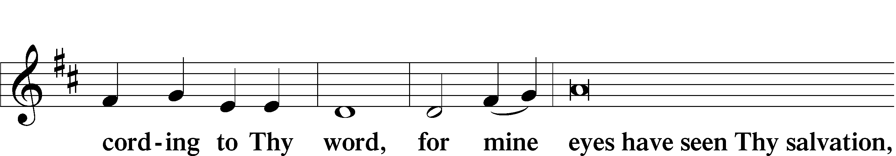
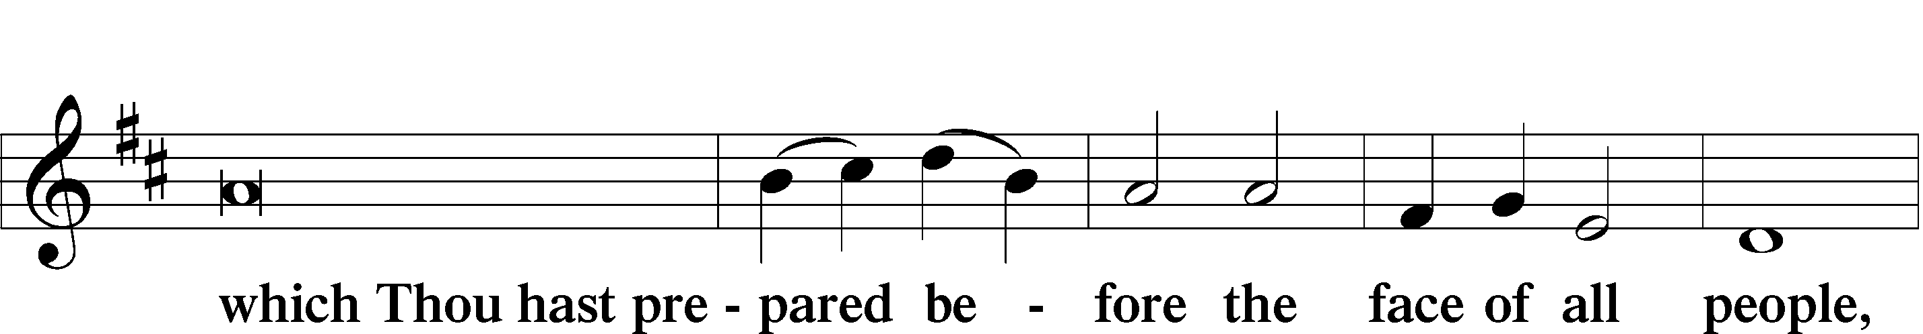
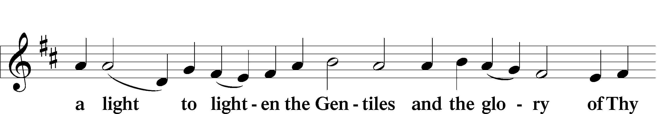
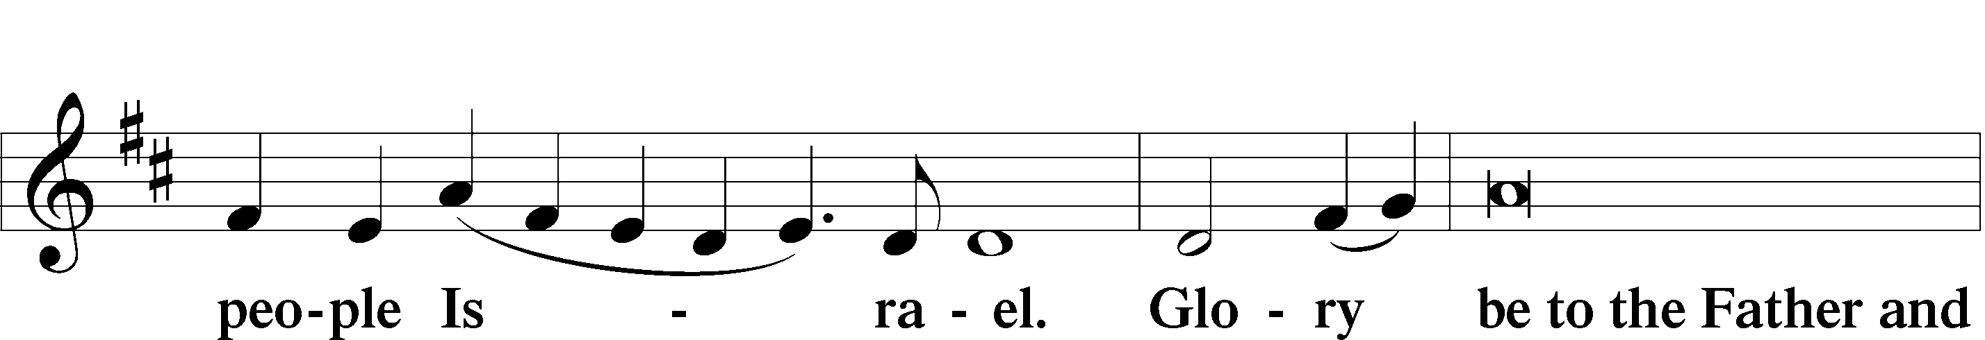
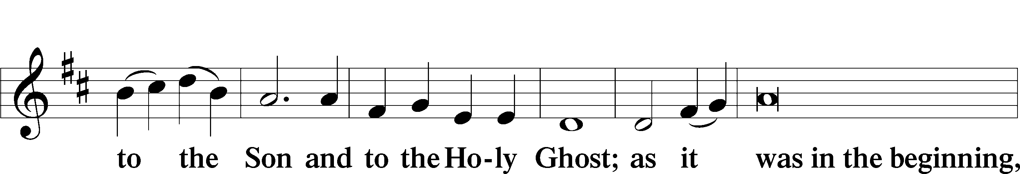
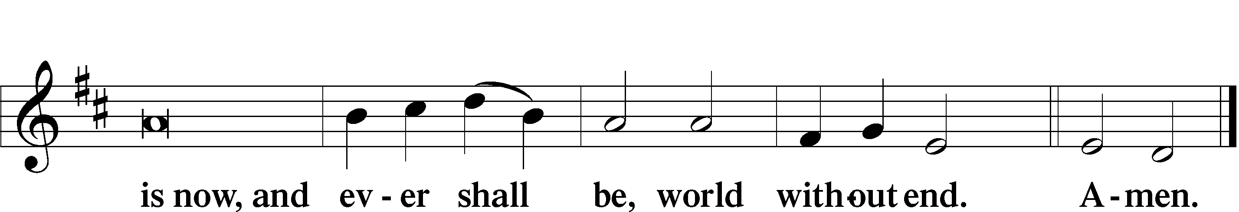

Thanksgiving
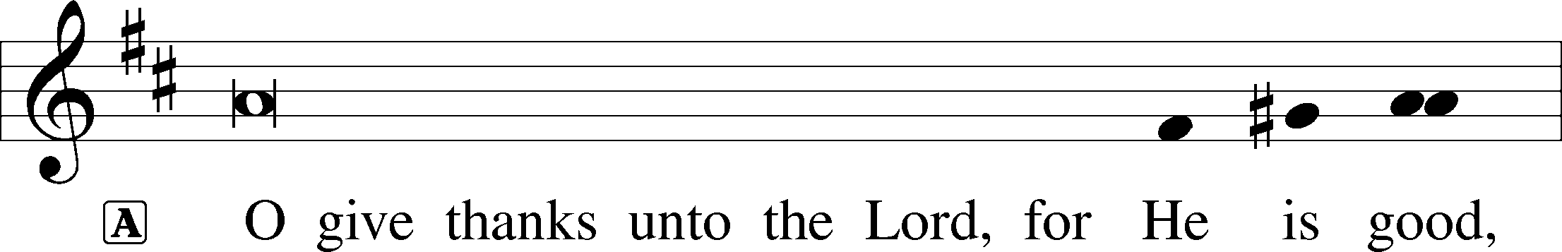

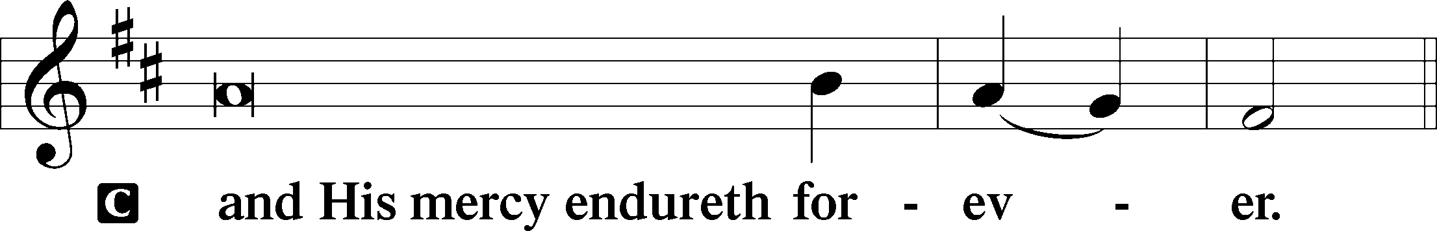

P Let us pray.
We give thanks to You, almighty God, that You have refreshed us through this salutary gift, and we implore You that of Your mercy You would strengthen us through the same in faith toward You and in fervent love toward one another; through Jesus Christ, Your Son, our Lord, who lives and reigns with You and the Holy Spirit, one God, now and forever.

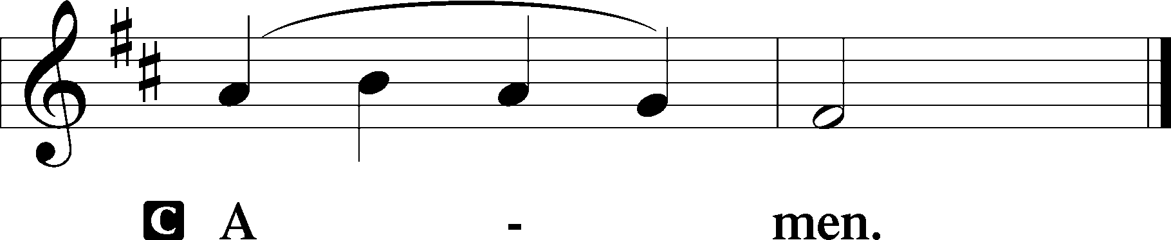

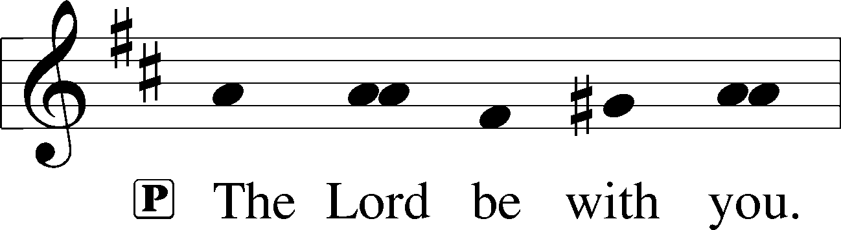

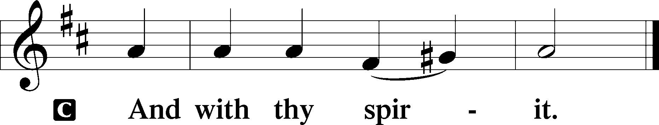

Benedicamus
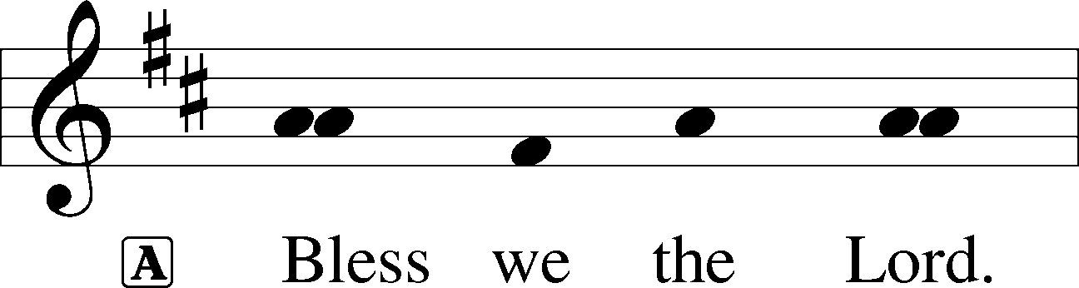

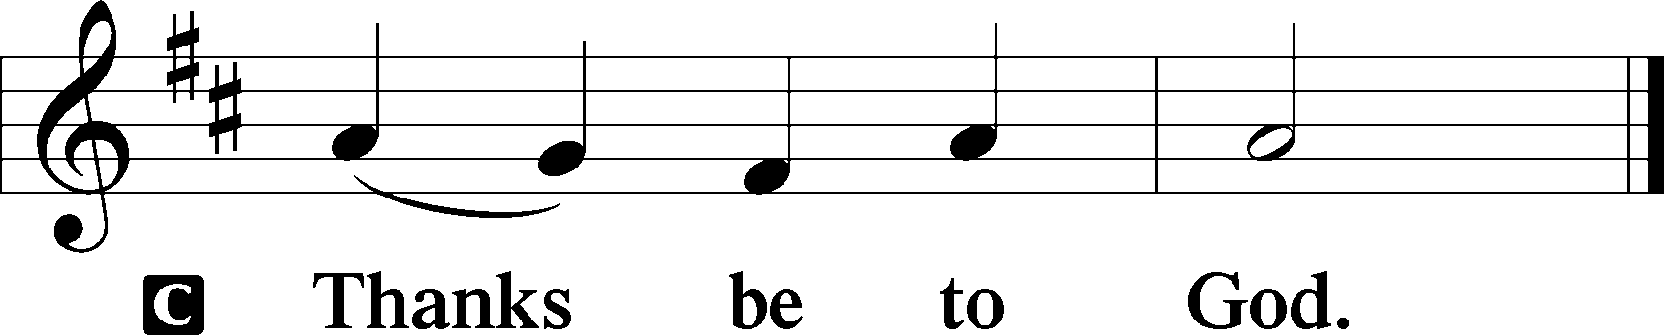

Benediction

669 Come, We That Love the Lord
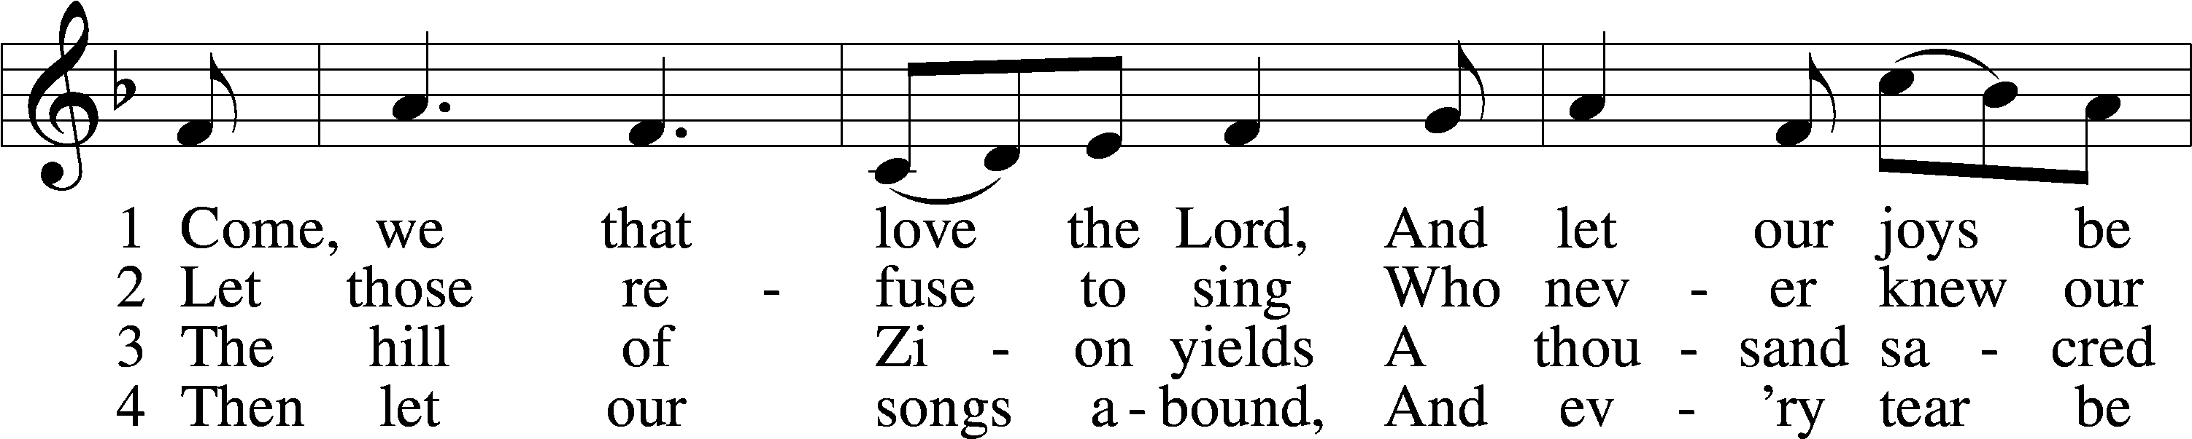
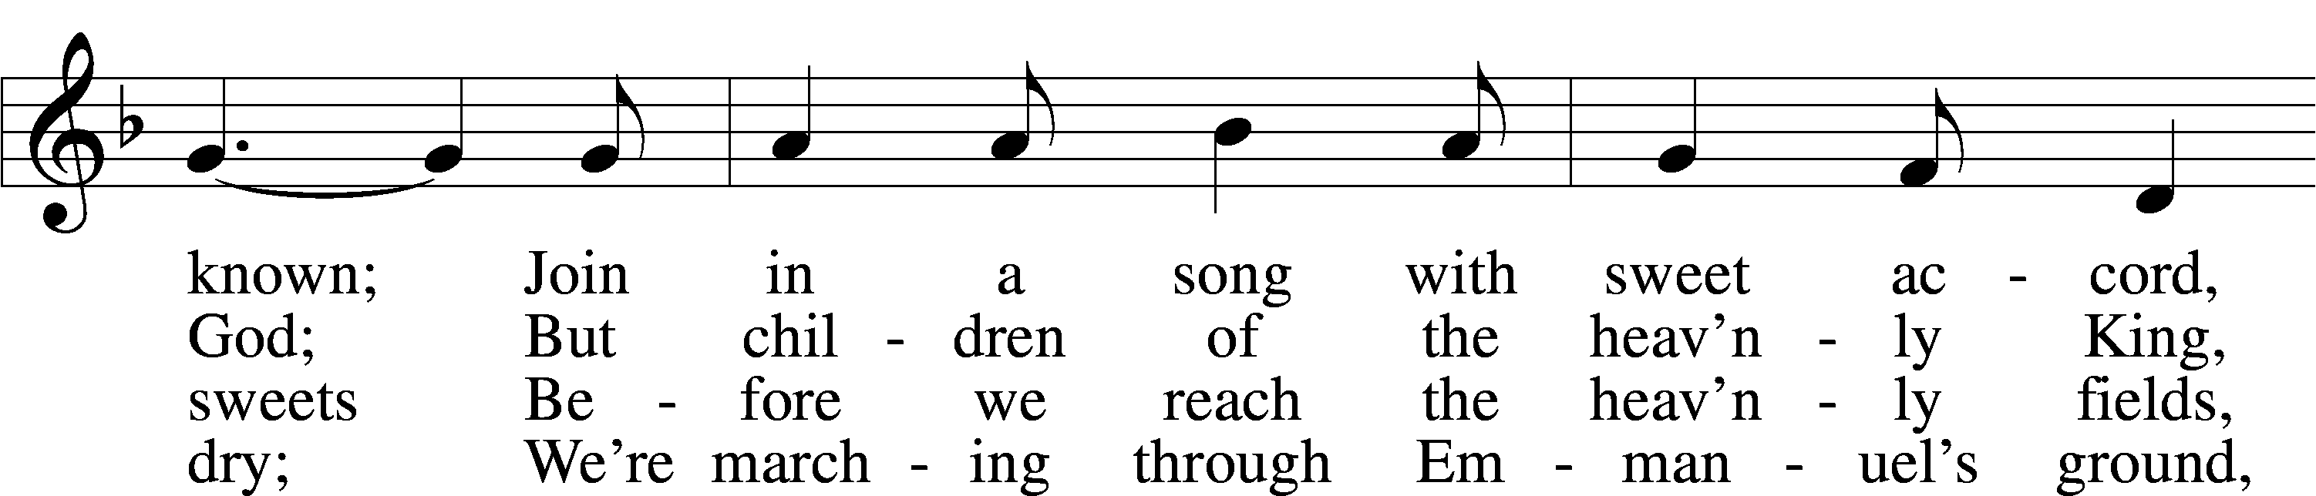
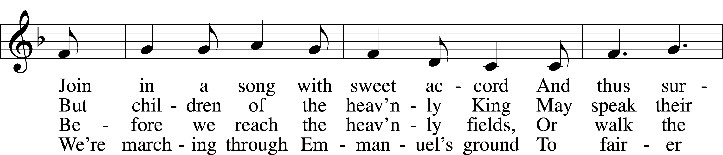
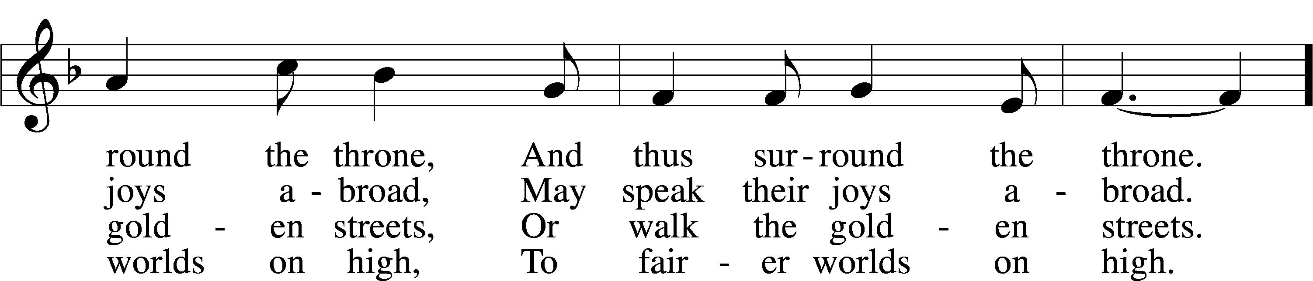
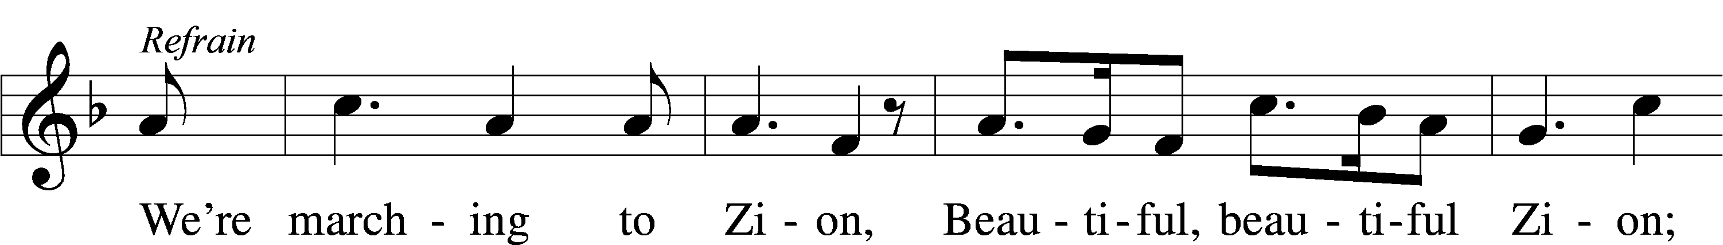
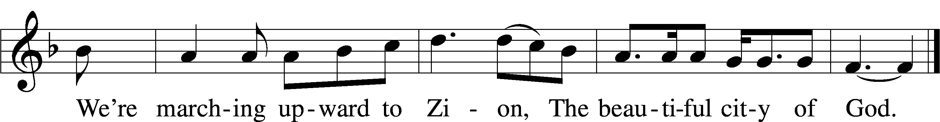
Text (sts. 1–4): Isaac Watts, 1674–1748
Text (ref) and tune: Robert Lowry, 1826–99
Text and tune: Public domain

Welcome and thank you to Vicar Jonah Clausen for preaching today!
Divine Shepherd Calendar
Sunday, 21st
8:00 am Divine Worship Service
9:15 am Coffee & Cookies
9:30 am Adult Bible Study & Sunday School
10:30 am Divine Worship Service
Wednesday, July 24th
No Dinner or Service
Thursday, July 25th
No Ladies Bible Study
Saturday, July 27th
6:30 am Rusty Restorations
Sunday, July 28th
8:00 am Divine Worship Service
9:15 am Coffee & Cookies
9:30 am Adult Bible Study & Sunday School
10:30 am Divine Worship Service

The church calendar may also be found on our website at divineshep.org! Go to our website and scroll to the bottom.

Need to use the church for a special event? Reach out to the church secretary to fill out an event form! All events need to be approved by the Pastors and office beforehand.

Important Dates
Please note that there will be no dinner or service on Wednesday, July 24th, and there will be no Ladies Bible Study on Thursday, July 25th.

Sunday, August 11th, there will be one service at 9:30 am. We will be having a potluck afterwards to congratulate Pastor Dennis on completing his SMP program at Concordia Seminary-Ft. Wayne! The Elders will be cooking the meat. Please bring a side to share!

Divine Shepherd Prayer Walk-September 2024!
The Prayer Walk Committee will be meeting July 28th between the services. Please attend if you are interested in being a part of the prayer walk planning and process! Please check page 7 to learn how to donate to this ongoing project.

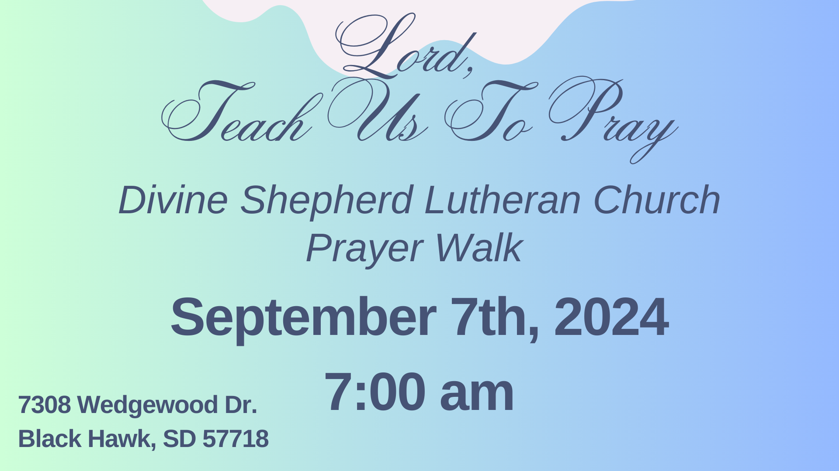

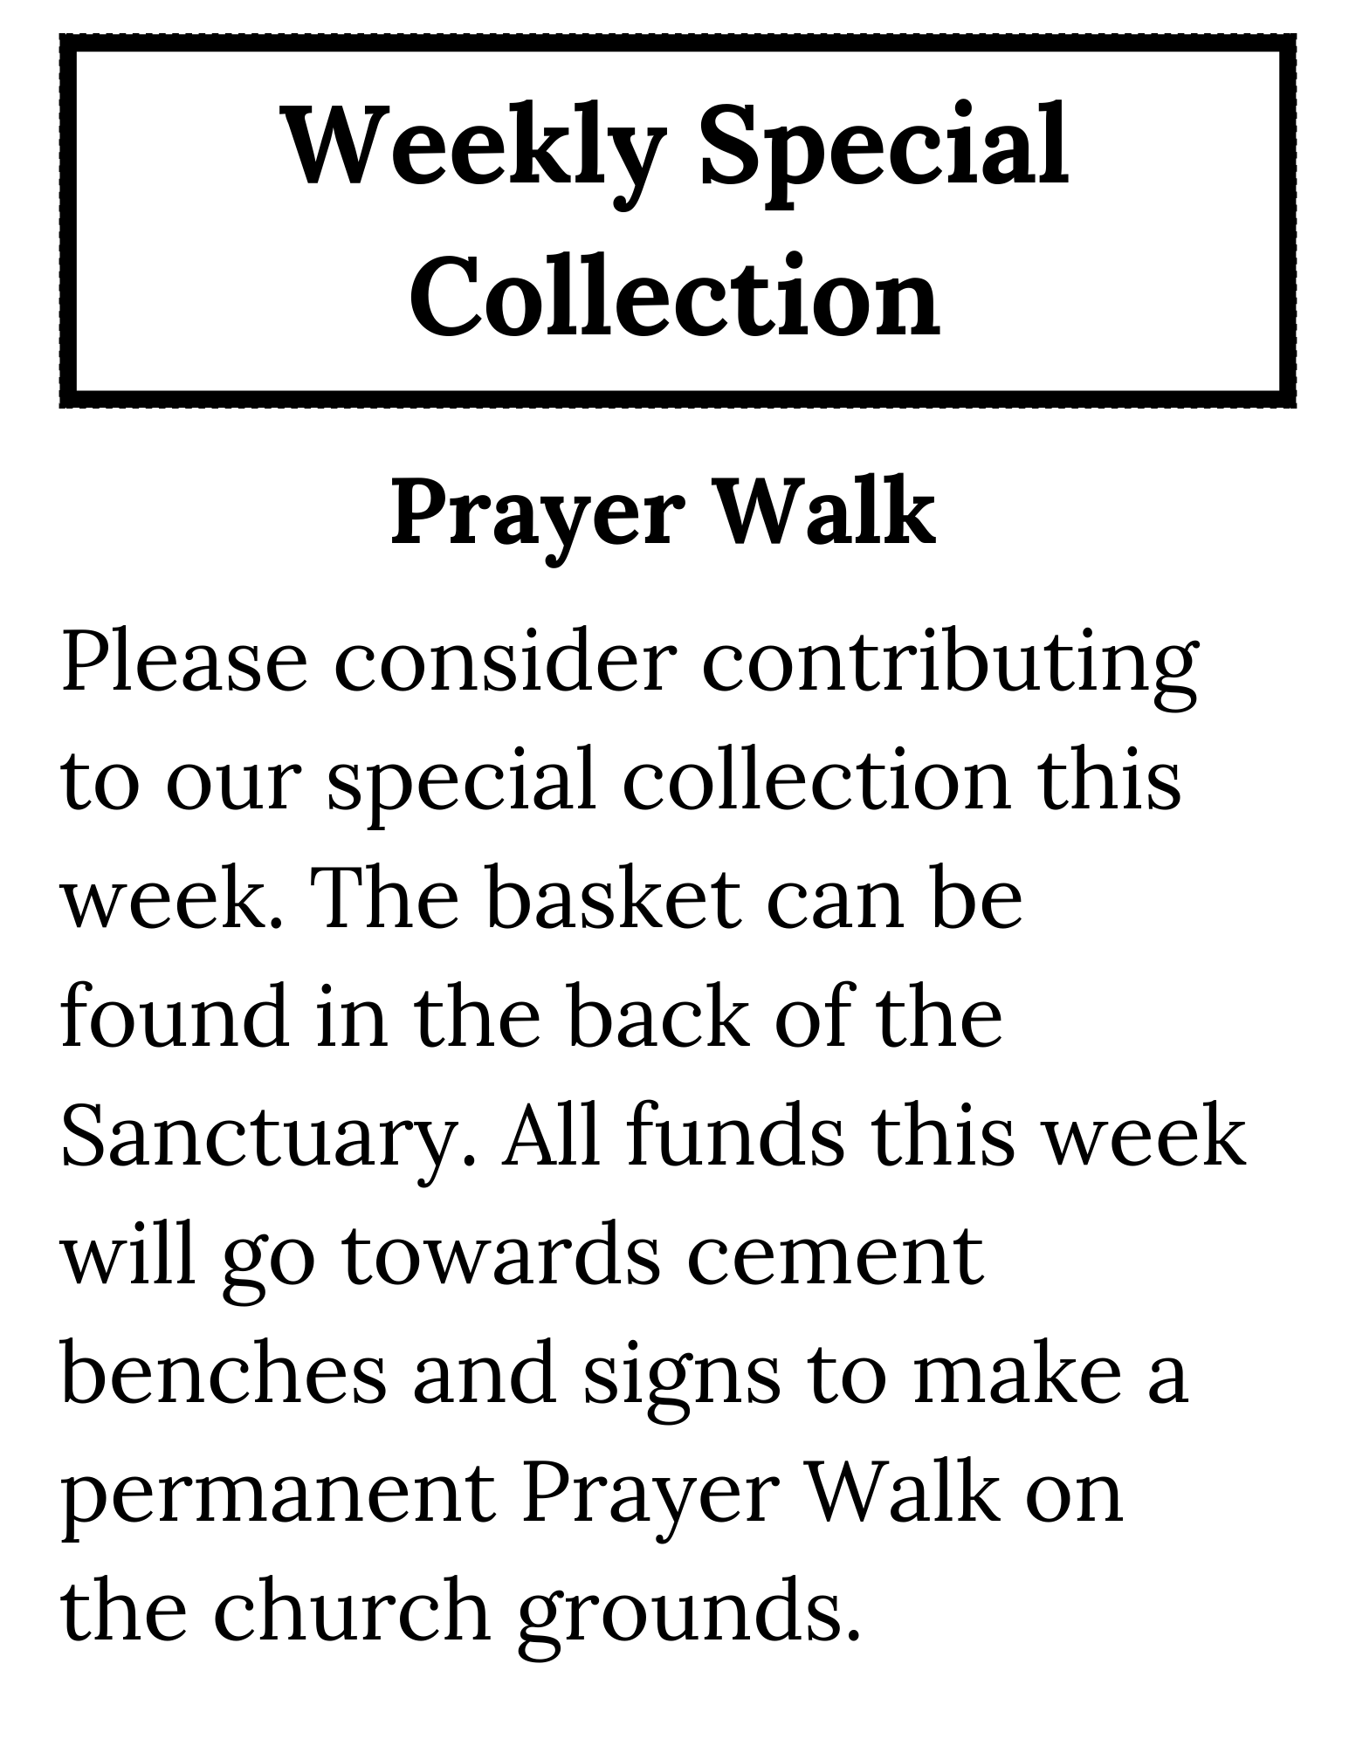
*Please contact the church office if you would like to donate a bench personally. Donated benches may be engraved with the name/text of your choosing.

