Seventh Sunday after Trinity
Sunday, July 14th, 2024
Divine Service 2, Page 167

Divine Shepherd Lutheran Church & School

7308 Wedgewood Drive
Black Hawk, SD 57718
“We are baptized children of God, forgiven and redeemed by Jesus. We are His family, called together to receive His gifts and serve others.”
Pastor Randy Sturzenbecher
Pastor Dennis Mercer

Office 605-787-6438 Pastor S. Cell 605-391-0428
Pastor M. Cell 443-980-7338
ECC 605-791-1131

Email: DSLCPSturz@divineshep.org
DSLCPMercer@divineshep.org
DSLCSecretary@divineshep.org
Greetings to all in the Name of the Risen Lord!
May our worship this glorious morning celebrate the joy and hope, peace and presence, of our Lord Jesus Christ, raised to life for us. We welcome all, especially our guests. If you do not have a church home, please consider Divine Shepherd. We would love to have you as part of our family. Please take a minute and sign our guest book.

A prayer before Worship
This is the day you have made, O Lord Jesus, a day of new life and eternal celebration! The stone is moved; death is defeated; heaven is open. As Your disciples first saw and believed Your victory over the tomb, so give us joy in the promise You made and keep for us: because You live, we live also! Amen.

The Lord’s Supper
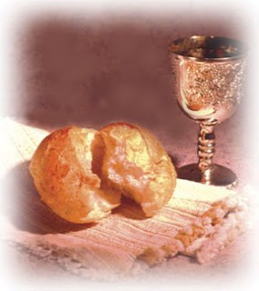
The Lord’s Supper is celebrated by us this morning in the confession and gladness that, as our Lord says, He gives into our mouth not only bread and wine but His very body and blood to eat and drink for the forgiveness of sins and to strengthen our union with Him and with one another. Our Lord Jesus invites to His table those who trust His Words, repent of all sin, and set aside any refusal to forgive and love as He forgives and loves us, that they may show forth His death until He comes.

Whoever, therefore, eats the bread or drinks the blood of the Lord in an unworthy manner will be guilty concerning the body and blood of the Lord.
(1 Cor 11:28 ESV) Holy Communion is a confession of the faith which is confessed at this altar. Any who holds a confession differing from that of the Holy Scriptures or are not a member in good standing with the LC-MS, are asked to speak with Pastor Sturzenbecher.

Special Music “Great is Thy Faithfulness”
Piano duet, Kathy Roling and Lynn Seifert

804 O Worship the King
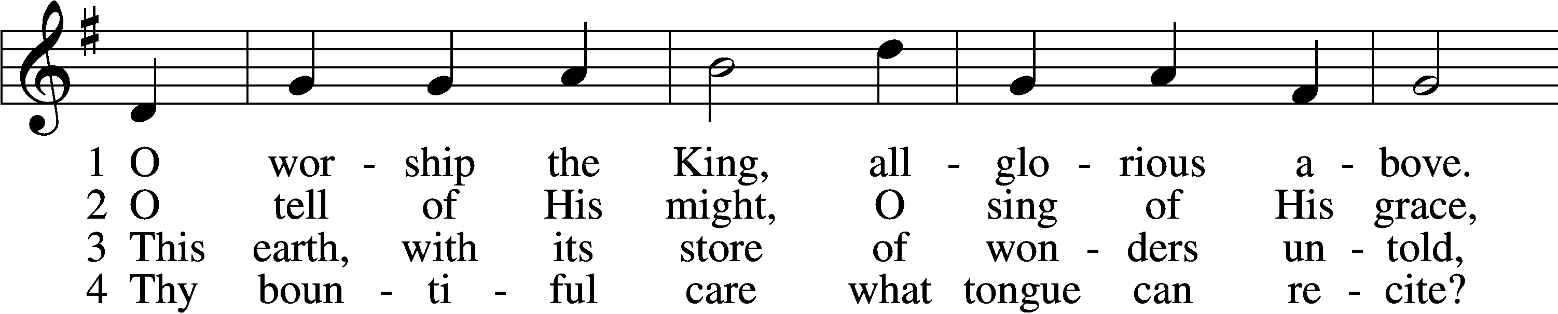
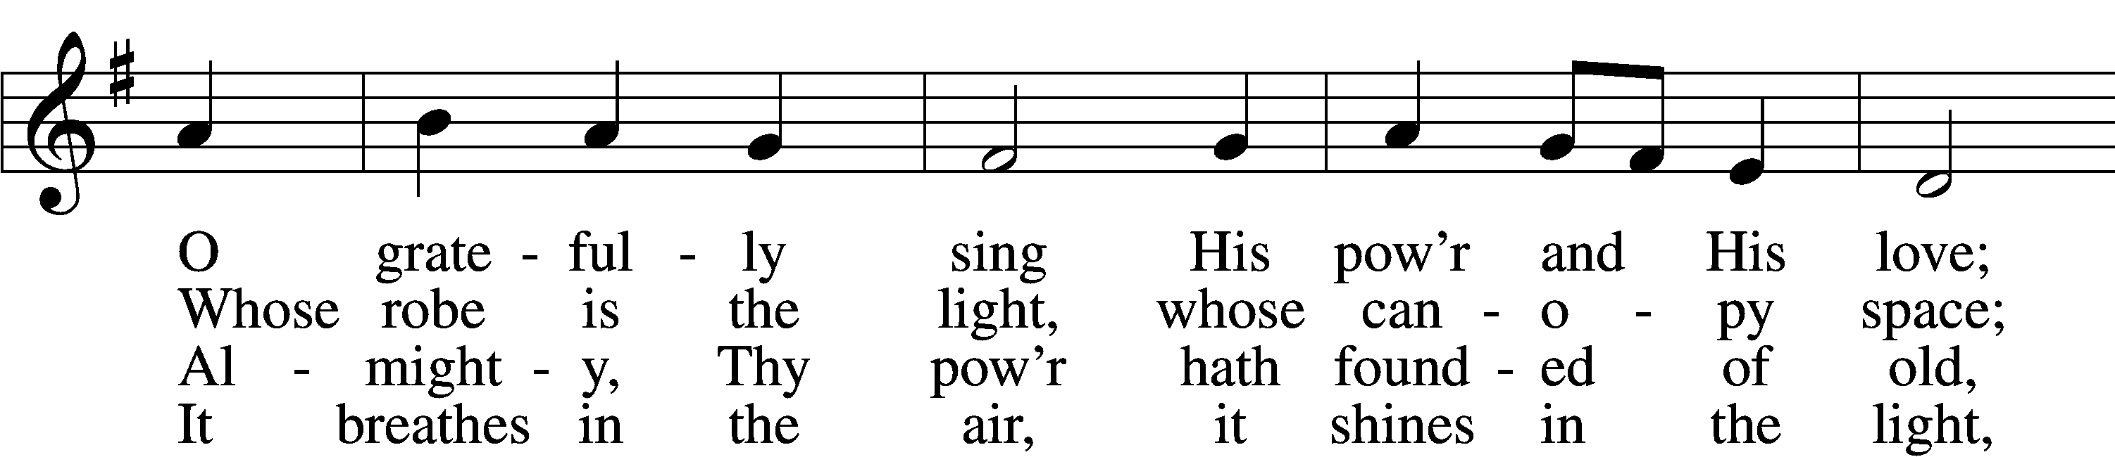
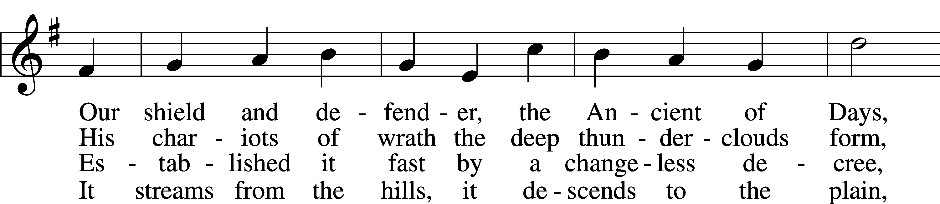
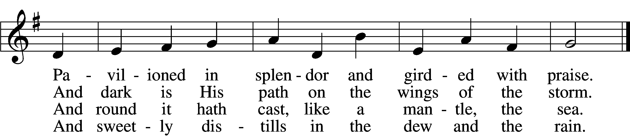

5 Frail children of dust
and feeble as frail,
In Thee do we trust,
nor find Thee to fail.
Thy mercies, how tender,
how firm to the end,
Our maker, defender,
redeemer, and friend!
6 O measureless Might,
ineffable Love,
While angels delight
to hymn Thee above,
Thy humbler creation,
though feeble their lays,
With true adoration
shall sing to Thy praise.
Text: Robert Grant, 1779–1838, alt.
Tune: William Croft, 1678–1727
Text and tune: Public domain

Invocation & Exhortation
P In the name of the Father and of the + Son and of the Holy Spirit.
C Amen.
P If we say we have no sin, we deceive ourselves, and the truth is not in us.
C But if we confess our sins, God, who is faithful and just, will forgive our sins and cleanse us from all unrighteousness.

Confession of Sins
P Let us then confess our sins to God our Father.
C Most merciful God, we confess that we are by nature sinful and unclean. We have sinned against You in thought, word, and deed, by what we have done and by what we have left undone. We have not loved You with our whole heart; we have not loved our neighbors as ourselves. We justly deserve Your present and eternal punishment. For the sake of Your Son, Jesus Christ, have mercy on us. Forgive us, renew us, and lead us, so that we may delight in Your will and walk in Your ways to the glory of Your holy name. Amen.

Absolution
P Almighty God in His mercy has given His Son to die for you and for His sake forgives you all your sins. As a called and ordained servant of Christ, and by His authority, I therefore forgive you all your sins in the name of the Father and of the + Son and of the Holy Spirit.
C Amen.

Introit Psalm 47:3, 6–8
Clap your hands, all | peoples!*
Shout to God with loud | songs of joy!
For the Lord, the Most High, is | to be feared,*
a great king over | all the earth.
He subdued peoples | under us,*
and nations un- | der our feet.
Sing praises to God, sing | praises!*
Sing praises to our King, sing | praises!
For God is the King of | all the earth;*
sing praises | with a psalm!
God reigns over the | nations;*
God sits on his | holy throne.
Glory be to the Father and | to the Son*
and to the Holy | Spirit;
as it was in the be- | ginning,*
is now, and will be forever. | Amen.
Clap your hands, all | peoples!*
Shout to God with loud | songs of joy!
For the Lord, the Most High, is | to be feared,*
a great king over | all the earth.
Kyrie
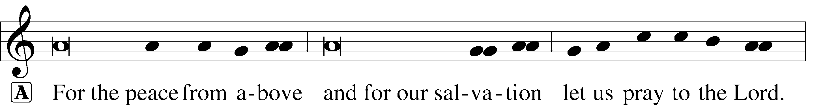

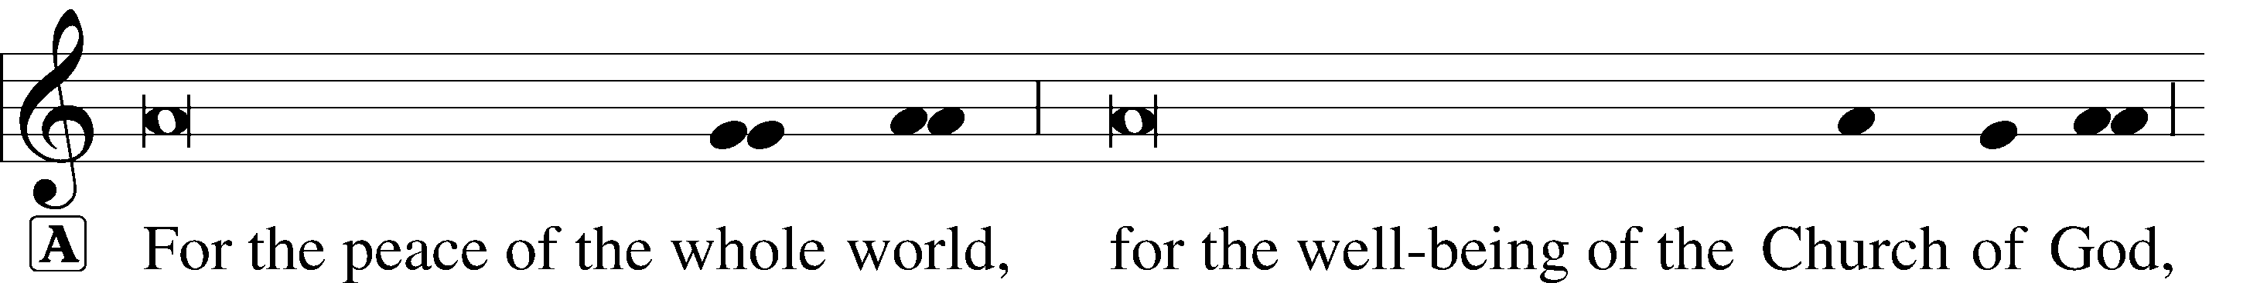

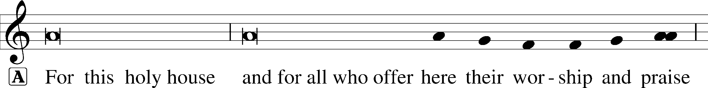

This Is the Feast
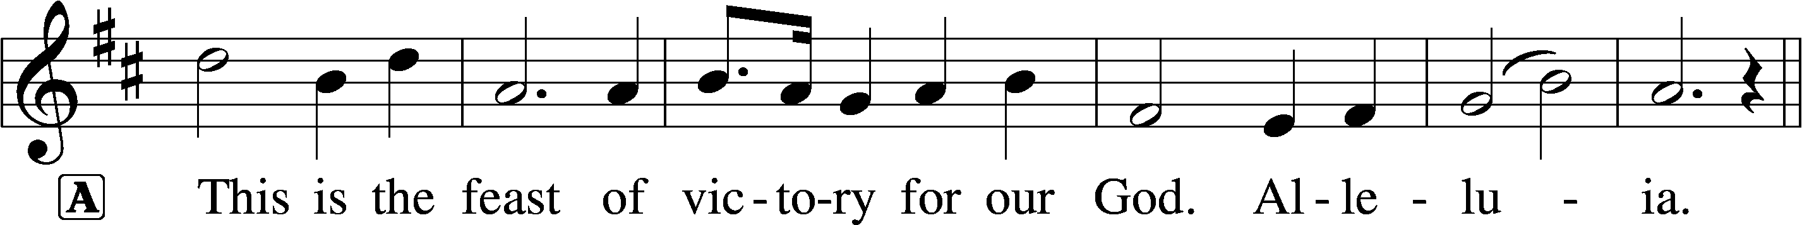
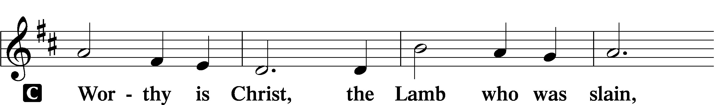
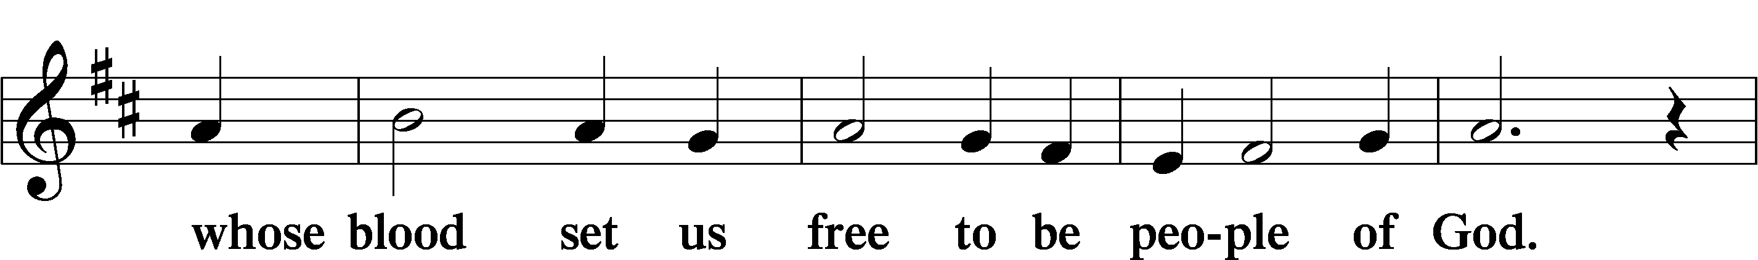
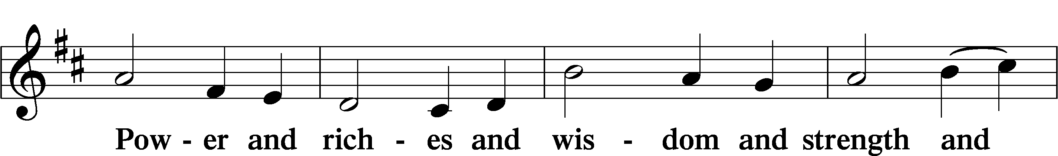
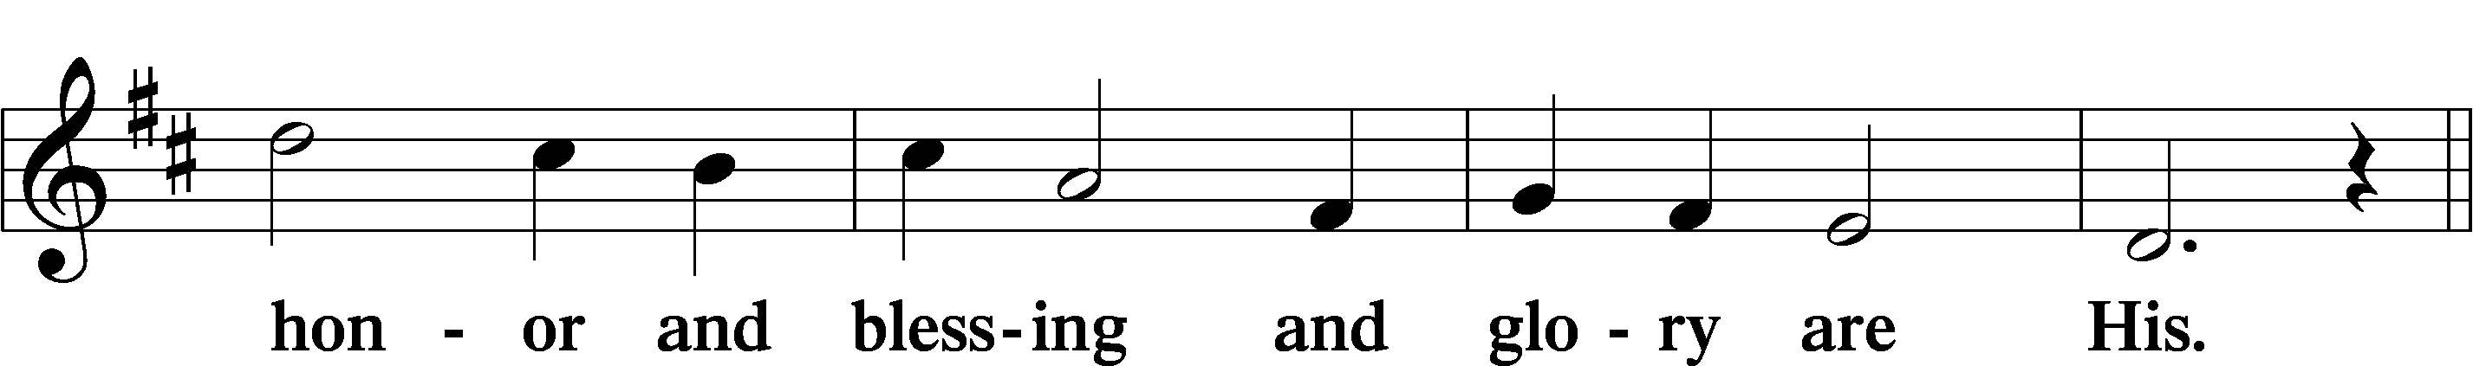
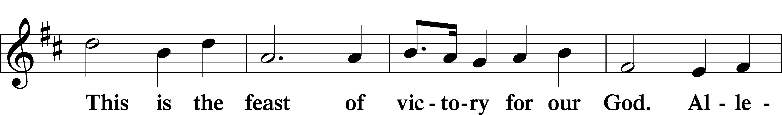
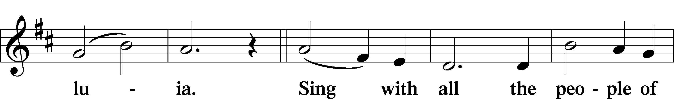
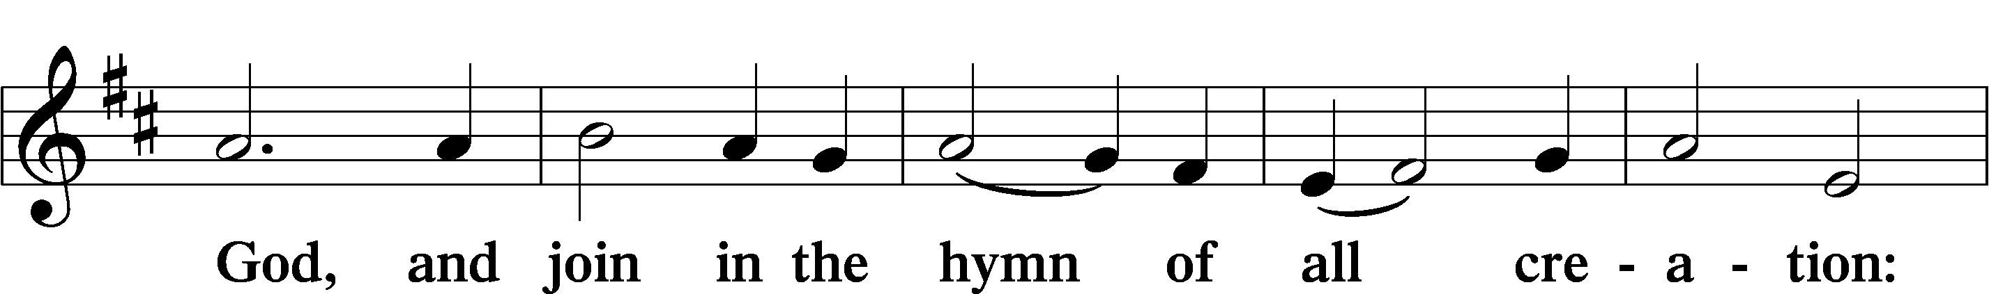
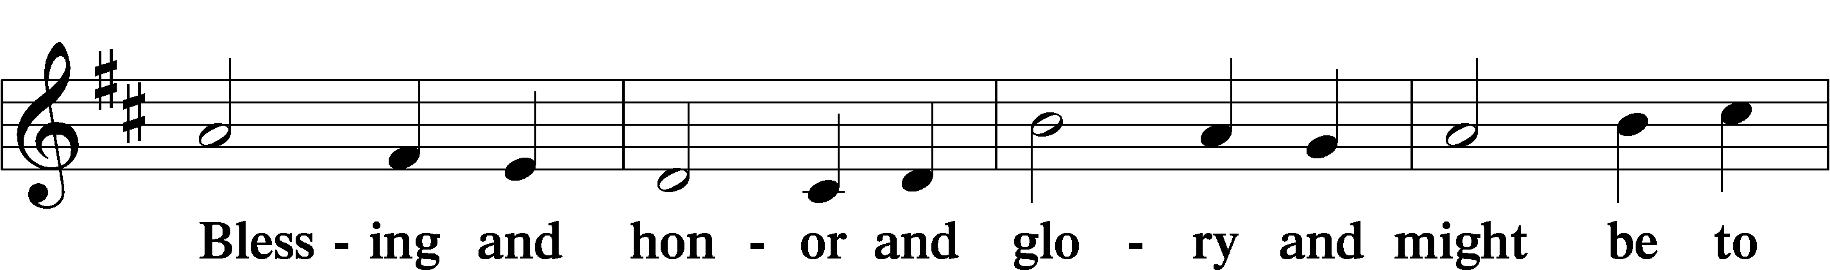
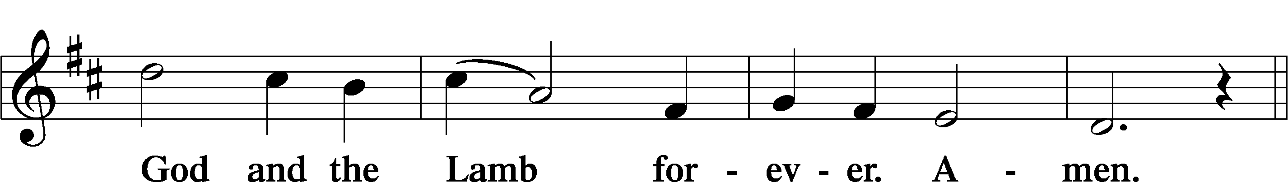
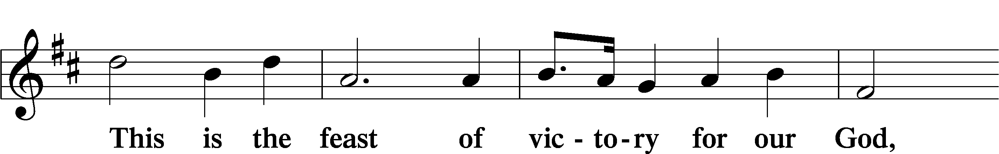
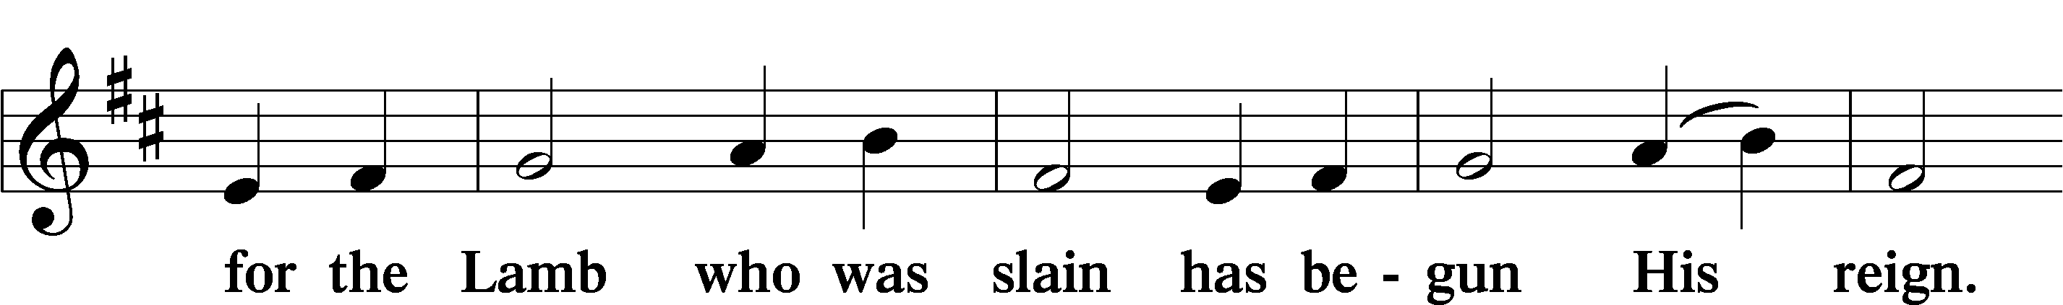
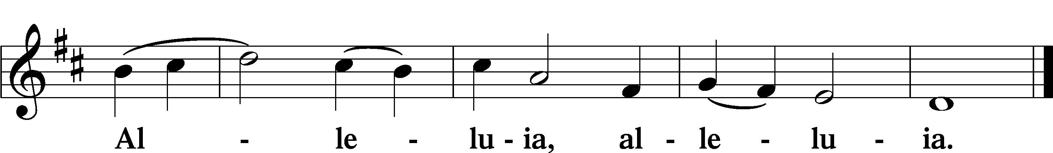

Salutation and Collect of the Day
P The Lord be with you.
C And also with you.
P Let us pray.
O God, whose never-failing providence orders all things both in heaven and earth, we humbly implore You to put away from us all hurtful things and to give us those things that are profitable for us; through Jesus Christ, Your Son, our Lord, who lives and reigns with You and the Holy Spirit, one God, now and forever. C Amen.
Old Testament Reading Genesis 1:1—2:3
¹In the beginning, God created the heavens and the earth. ²The earth was without form and void, and darkness was over the face of the deep. And the Spirit of God was hovering over the face of the waters. ³And God said, “Let there be light,” and there was light. ⁴And God saw that the light was good. And God separated the light from the darkness. ⁵God called the light Day, and the darkness he called Night. And there was evening and there was morning, the first day. ⁶And God said, “Let there be an expanse in the midst of the waters, and let it separate the waters from the waters.” ⁷And God made the expanse and separated the waters that were under the expanse from the waters that were above the expanse. And it was so. ⁸And God called the expanse Heaven. And there was evening and there was morning, the second day. ⁹And God said, “Let the waters under the heavens be gathered together into one place, and let the dry land appear.” And it was so. ¹⁰God called the dry land Earth, and the waters that were gathered together he called Seas. And God saw that it was good. ¹¹And God said, “Let the earth sprout vegetation, plants yielding seed, and fruit trees bearing fruit in which is their seed, each according to its kind, on the earth.” And it was so. ¹²The earth brought forth vegetation, plants yielding seed according to their own kinds, and trees bearing fruit in which is their seed, each according to its kind. And God saw that it was good. ¹³And there was evening and there was morning, the third day. ¹⁴And God said, “Let there be lights in the expanse of the heavens to separate the day from the night. And let them be for signs and for seasons, and for days and years, ¹⁵and let them be lights in the expanse of the heavens to give light upon the earth.” And it was so. ¹⁶And God made the two great lights—the greater light to rule the day and the lesser light to rule the night—and the stars. ¹⁷And God set them in the expanse of the heavens to give light on the earth, ¹⁸to rule over the day and over the night, and to separate the light from the darkness. And God saw that it was good. ¹⁹And there was evening and there was morning, the fourth day. ²⁰And God said, “Let the waters swarm with swarms of living creatures, and let birds fly above the earth across the expanse of the heavens.” ²¹So God created the great sea creatures and every living creature that moves, with which the waters swarm, according to their kinds, and every winged bird according to its kind. And God saw that it was good. ²²And God blessed them, saying, “Be fruitful and multiply and fill the waters in the seas, and let birds multiply on the earth.” ²³And there was evening and there was morning, the fifth day. ²⁴And God said, “Let the earth bring forth living creatures according to their kinds—livestock and creeping things and beasts of the earth according to their kinds.” And it was so. ²⁵And God made the beasts of the earth according to their kinds and the livestock according to their kinds, and everything that creeps on the ground according to its kind. And God saw that it was good. ²⁶Then God said, “Let us make man in our image, after our likeness. And let them have dominion over the fish of the sea and over the birds of the heavens and over the livestock and over all the earth and over every creeping thing that creeps on the earth.” ²⁷So God created man in his own image, in the image of God he created him; male and female he created them. ²⁸And God blessed them. And God said to them, “Be fruitful and multiply and fill the earth and subdue it and have dominion over the fish of the sea and over the birds of the heavens and over every living thing that moves on the earth.” ²⁹And God said, “Behold, I have given you every plant yielding seed that is on the face of all the earth, and every tree with seed in its fruit. You shall have them for food. ³⁰And to every beast of the earth and to every bird of the heavens and to everything that creeps on the earth, everything that has the breath of life, I have given every green plant for food.” And it was so. ³¹And God saw everything that he had made, and behold, it was very good. And there was evening and there was morning, the sixth day. ¹Thus the heavens and the earth were finished, and all the host of them. ²And on the seventh day God finished his work that he had done, and he rested on the seventh day from all his work that he had done. ³So God blessed the seventh day and made it holy, because on it God rested from all his work that he had done in creation.

Catechetical Review
The Second Commandment
You shall not misuse the name of the Lord your God.

What does this mean?
We should fear and love God so that we do not curse, swear, use satanic arts, lie, or deceive by His name, but call upon it in every trouble, pray, praise, and give thanks.

Epistle Romans 6:19–23
¹⁹I am speaking in human terms, because of your natural limitations. For just as you once presented your members as slaves to impurity and to lawlessness leading to more lawlessness, so now present your members as slaves to righteousness leading to sanctification. ²⁰When you were slaves of sin, you were free in regard to righteousness. ²¹But what fruit were you getting at that time from the things of which you are now ashamed? The end of those things is death. ²²But now that you have been set free from sin and have become slaves of God, the fruit you get leads to sanctification and its end, eternal life. ²³For the wages of sin is death, but the free gift of God is eternal life in Christ Jesus our Lord.

Alleluia and Verse
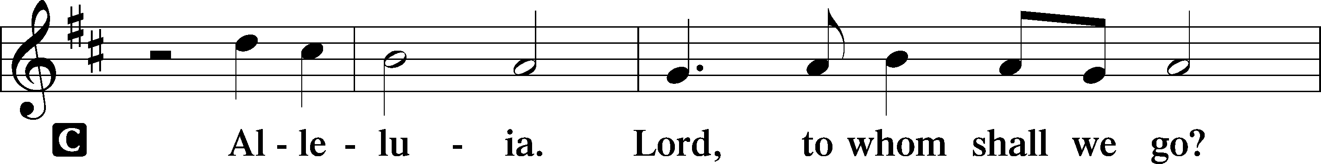
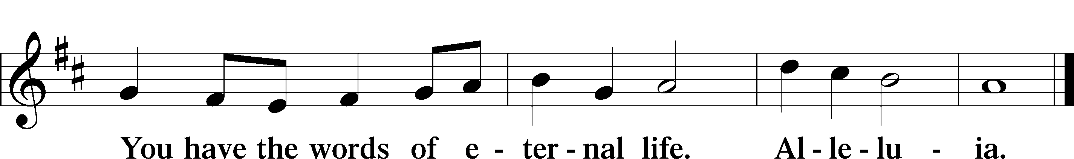

Holy Gospel Mark 8:1–9
P The Holy Gospel according to St. Mark, the eighth chapter.
C Glory to You, O Lord.
¹In those days, when again a great crowd had gathered, and they had nothing to eat, [Jesus] called his disciples to him and said to them, ²“I have compassion on the crowd, because they have been with me now three days and have nothing to eat. ³And if I send them away hungry to their homes, they will faint on the way. And some of them have come from far away.” ⁴And his disciples answered him, “How can one feed these people with bread here in this desolate place?” ⁵And he asked them, “How many loaves do you have?” They said, “Seven.” ⁶And he directed the crowd to sit down on the ground. And he took the seven loaves, and having given thanks, he broke them and gave them to his disciples to set before the people; and they set them before the crowd. ⁷And they had a few small fish. And having blessed them, he said that these also should be set before them. ⁸And they ate and were satisfied. And they took up the broken pieces left over, seven baskets full. ⁹And there were about four thousand people. And he sent them away.
P This is the Gospel of the Lord.
C Praise to You, O Christ.

Childrens Message
819 Sing Praise to God, the Highest Good
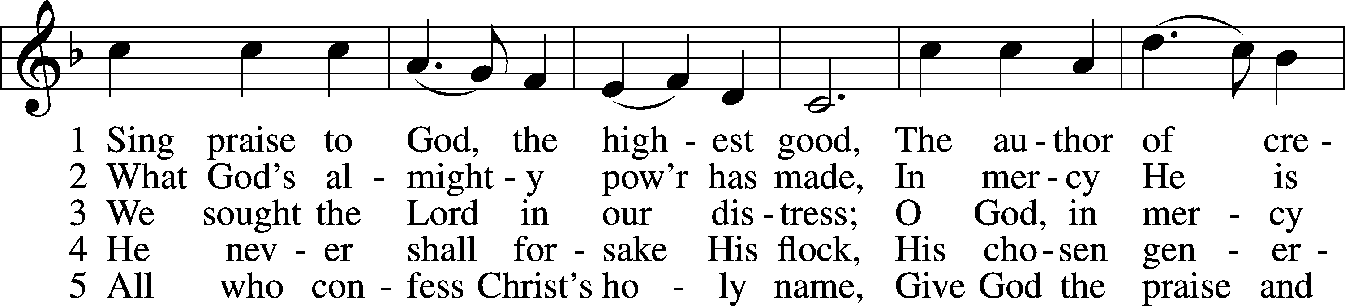
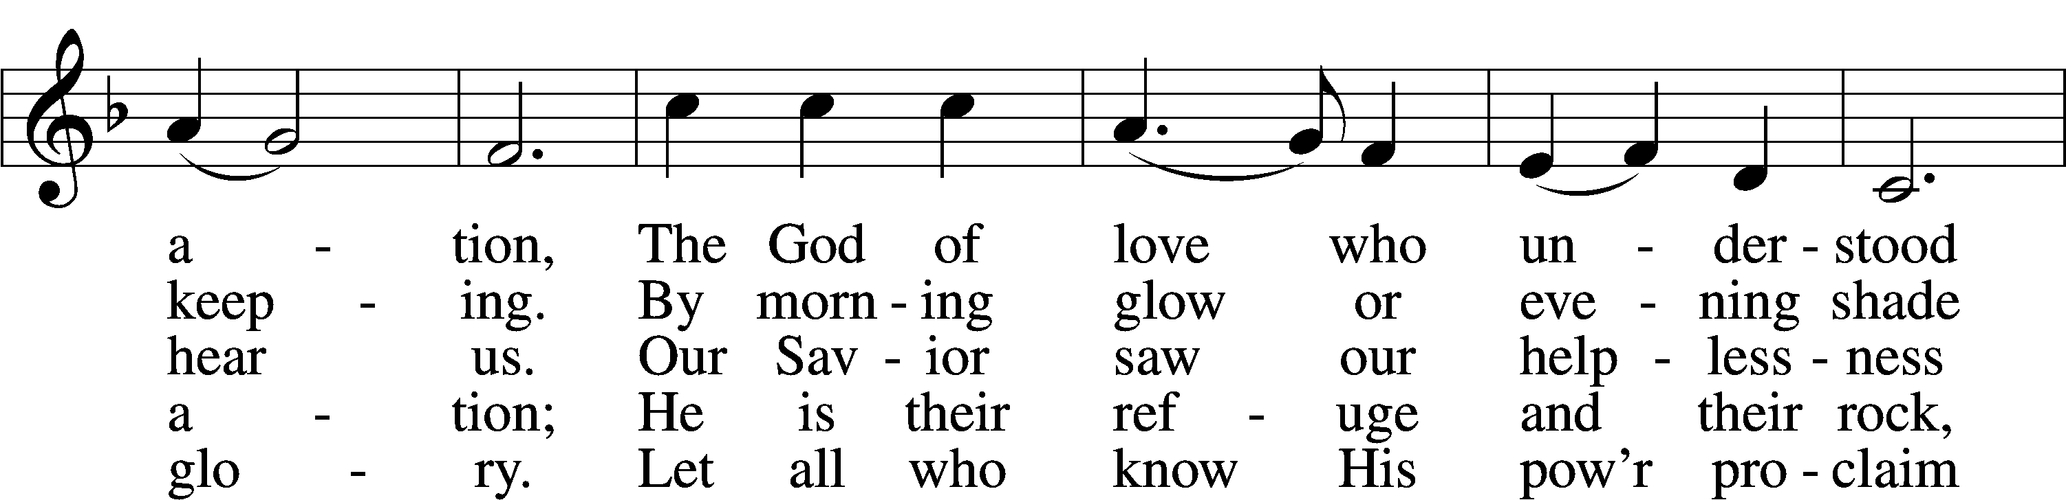
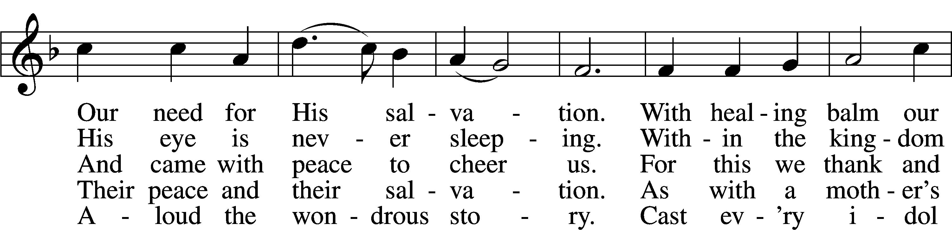
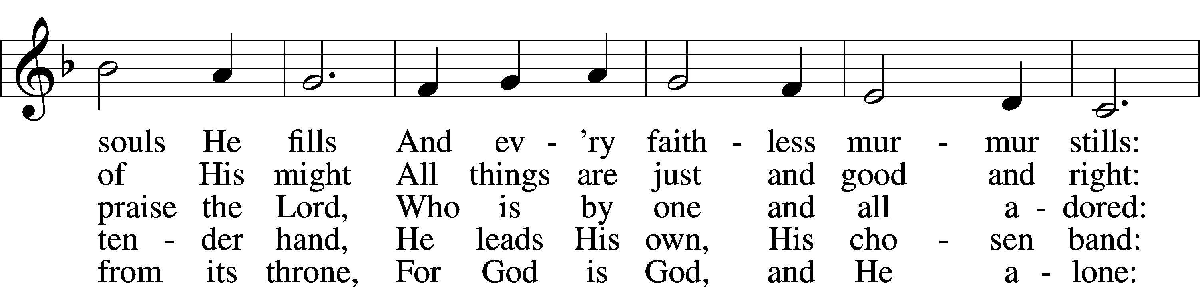
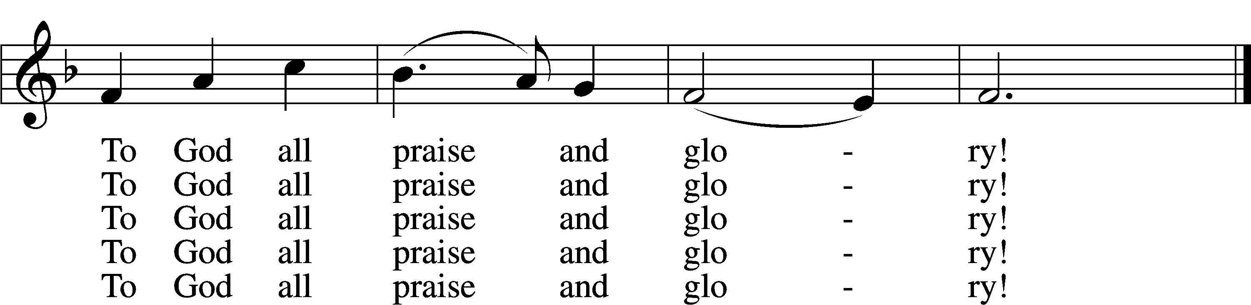
Text: Johann Jacob Schütz, 1640–90; (sts. 1–3, 5): tr. Frances E. Cox, 1812–97, adapt.; (st. 4): tr. Catherine Winkworth, 1827–78, adapt.
Tune: Melchior Vulpius, c. 1570–1615
Text and tune: Public domain

Sermon

Apostles’ Creed
C I believe in God, the Father Almighty, maker of heaven and earth. And in Jesus Christ, His only Son, our Lord, who was conceived by the Holy Spirit, born of the virgin Mary, suffered under Pontius Pilate, was crucified, died and was buried. He descended into hell. The third day He rose again from the dead. He ascended into heaven and sits at the right hand of God the Father Almighty. From thence He will come to judge the living and the dead. I believe in the Holy Spirit, the holy Christian Church, the communion of saints, the forgiveness of sins, the resurrection of the body, and the life + everlasting. Amen.

Prayer of the Church “Hear Our Prayer”

Offering, Special Music Marimba and Vibraphone
Joni Mercer

Offertory
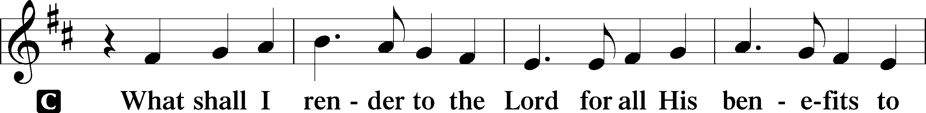
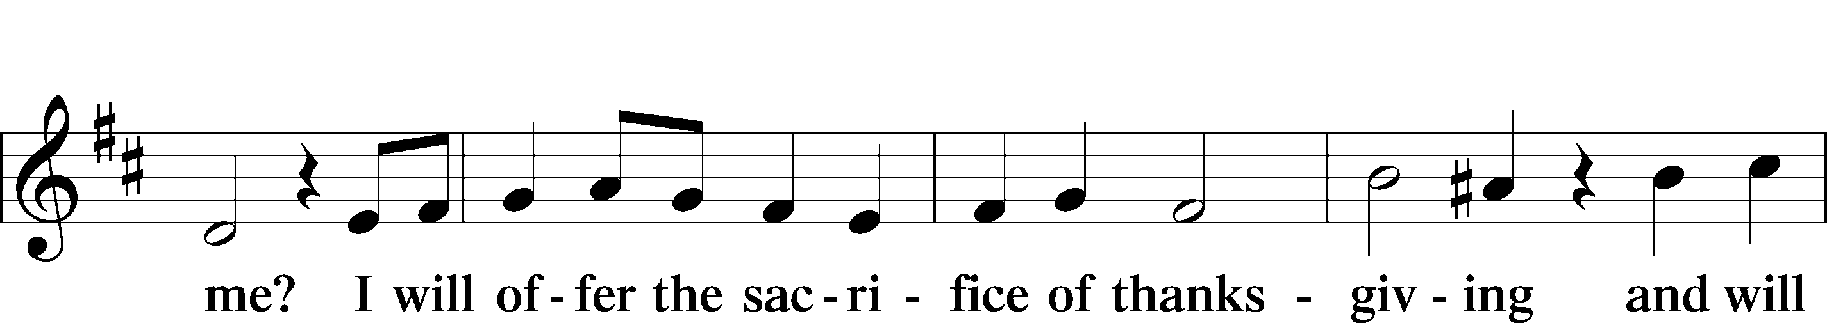
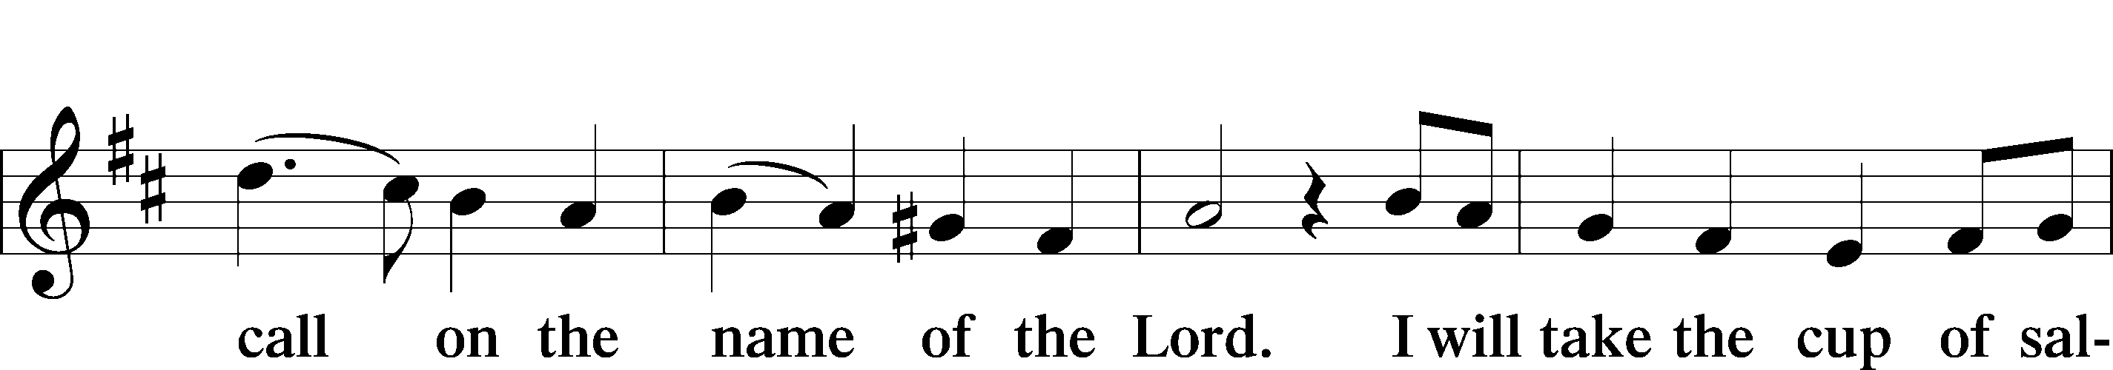
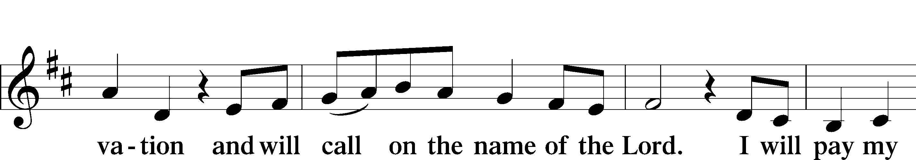
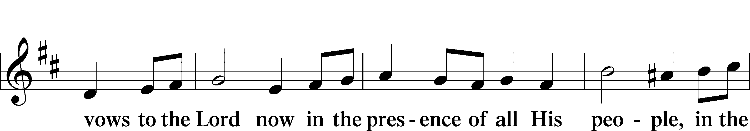
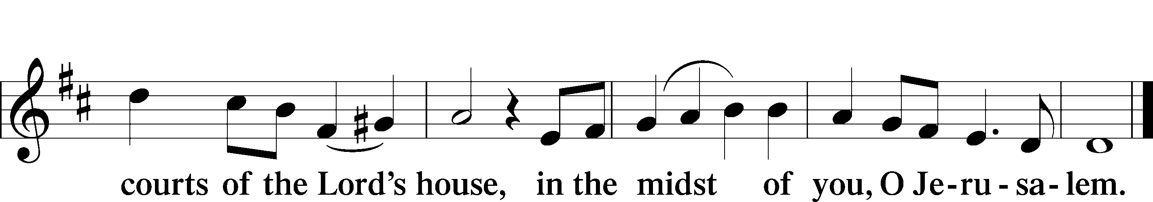

Preface

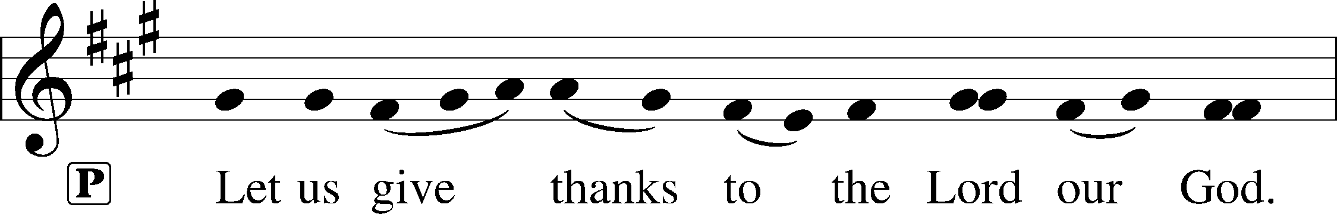
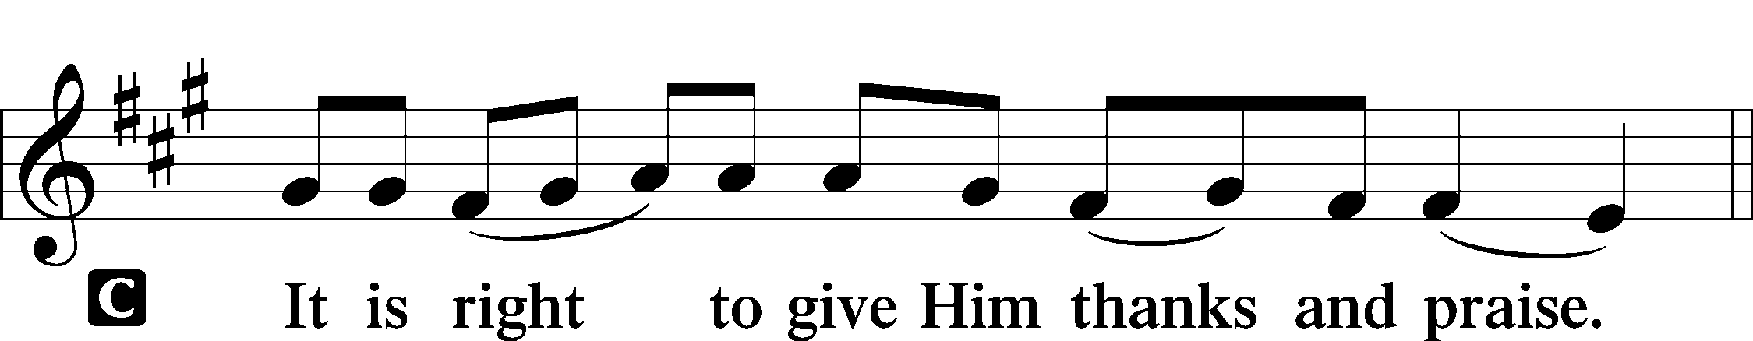

P It is truly good, right, and salutary that we should at all times and in all places give thanks to You, holy Lord, almighty Father, everlasting God, through Jesus Christ, our Lord, who overcame the assaults of the devil and gave His life as a ransom for many that with cleansed hearts we might be prepared joyfully to celebrate the paschal feast in sincerity and truth. Therefore with angels and archangels and with all the company of heaven we laud and magnify Your glorious name, evermore praising You and saying:

Sanctus
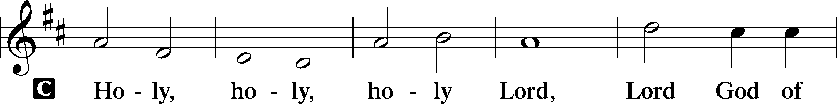
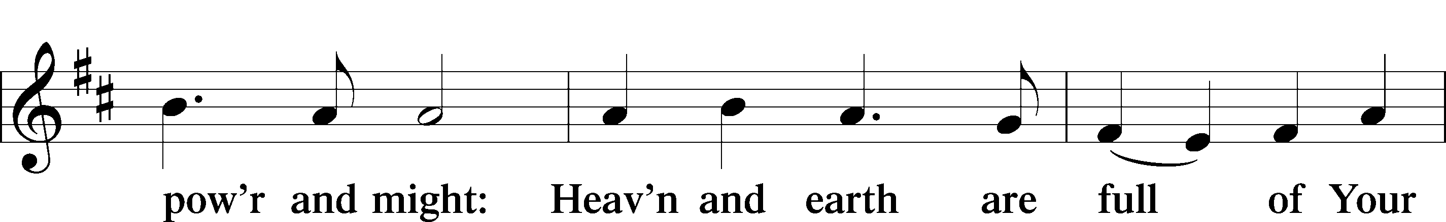
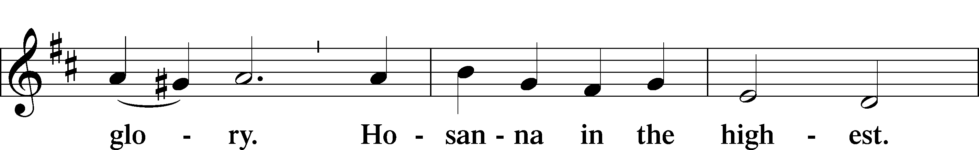
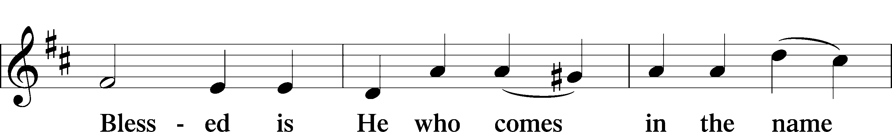
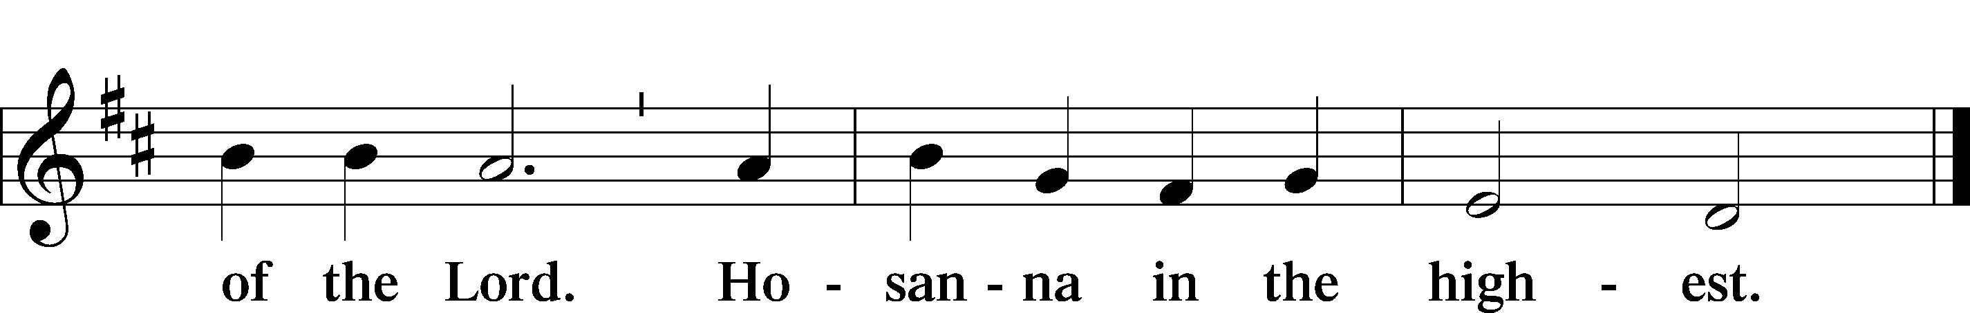

Lord’s Prayer
C Our Father who art in heaven, hallowed be Thy name, Thy kingdom come, Thy will be done on earth as it is in heaven; give us this day our daily bread; and forgive us our trespasses as we forgive those who trespass against us; and lead us not into temptation, but deliver us from evil. For Thine is the kingdom and the power and the glory forever and ever. Amen.
The Words of Our Lord
P Our Lord Jesus Christ, on the night when He was betrayed, took bread, and when He had given thanks, He broke it and gave it to the disciples and said: “Take, eat; this is My + body, which is given for you. This do in remembrance of Me…

Pax Domini LSB 180
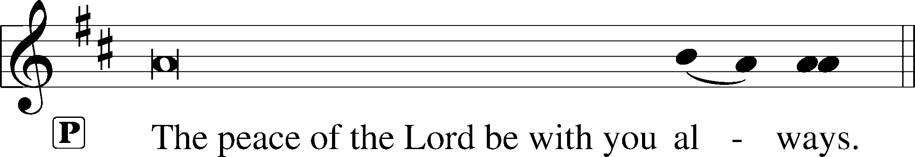

Agnus Dei LSB 180
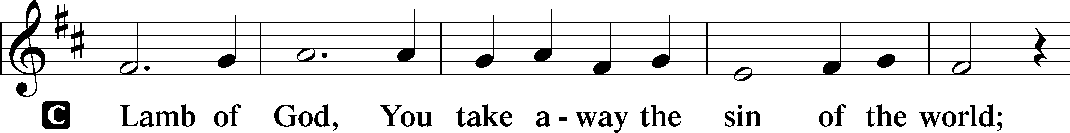
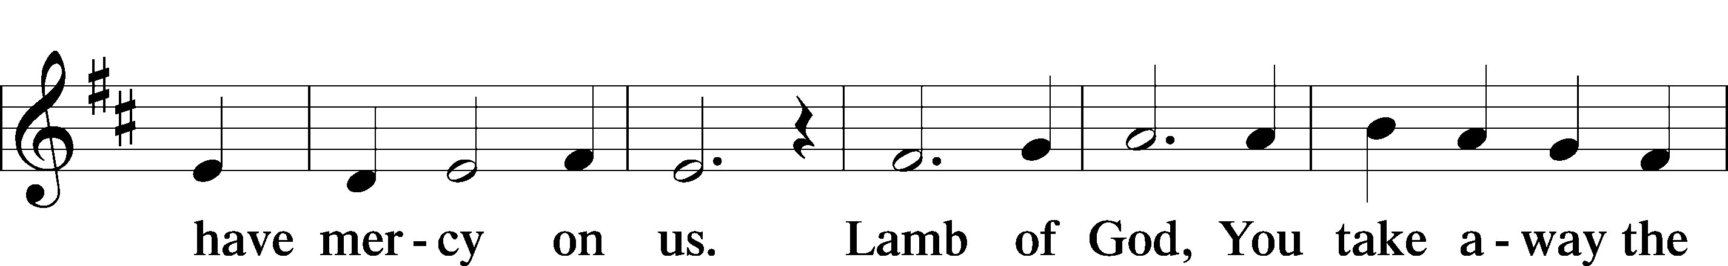
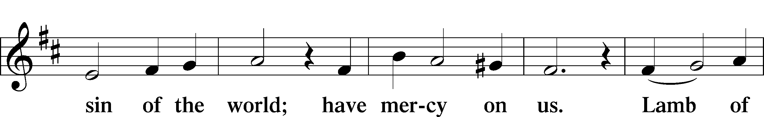
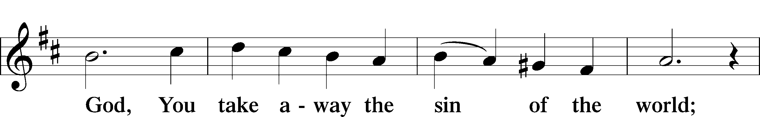
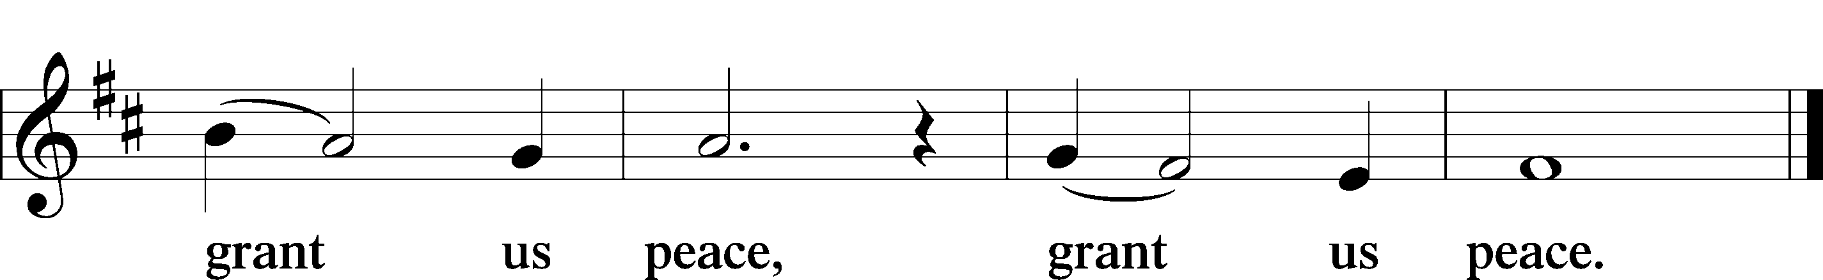
Distribution Hymns
566 By Grace I’m Saved
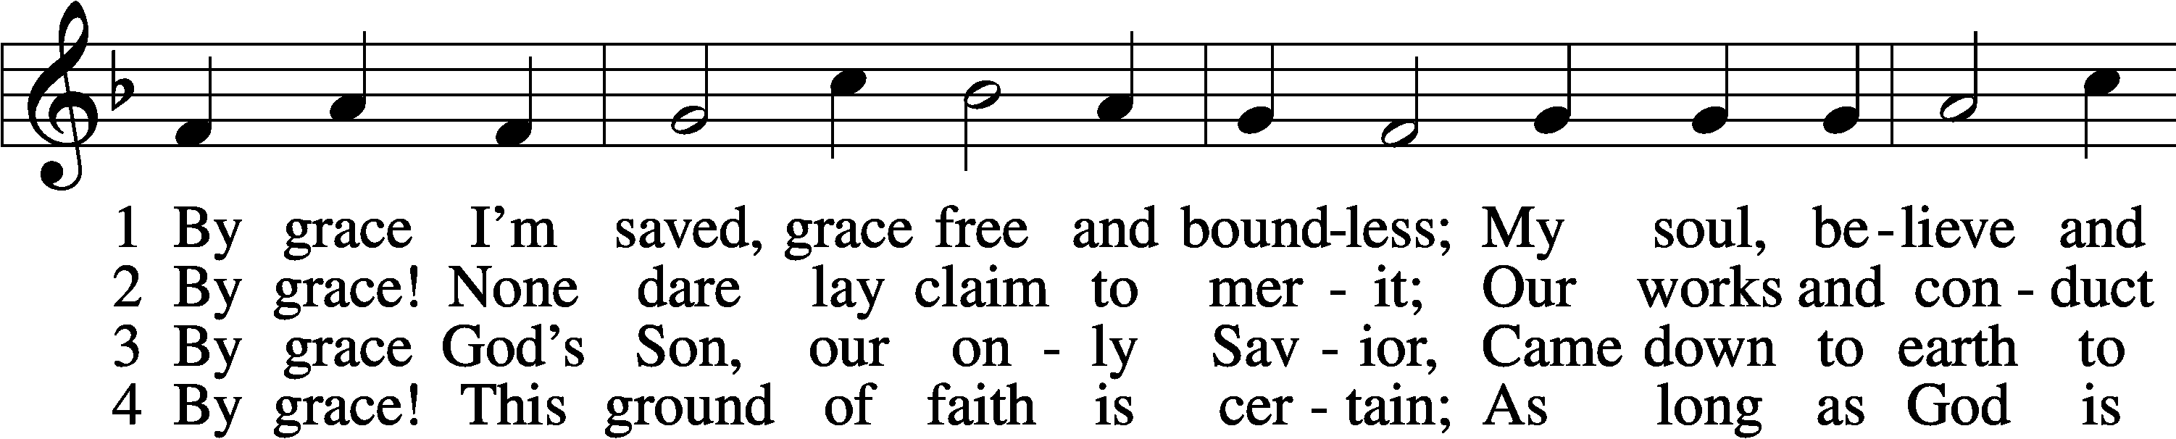
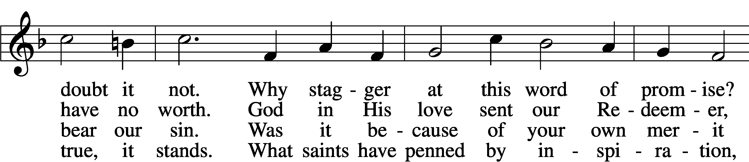
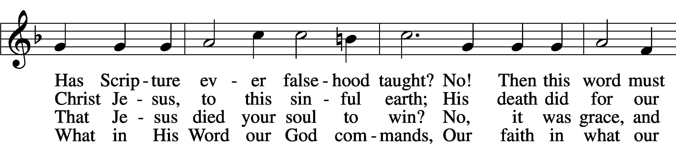
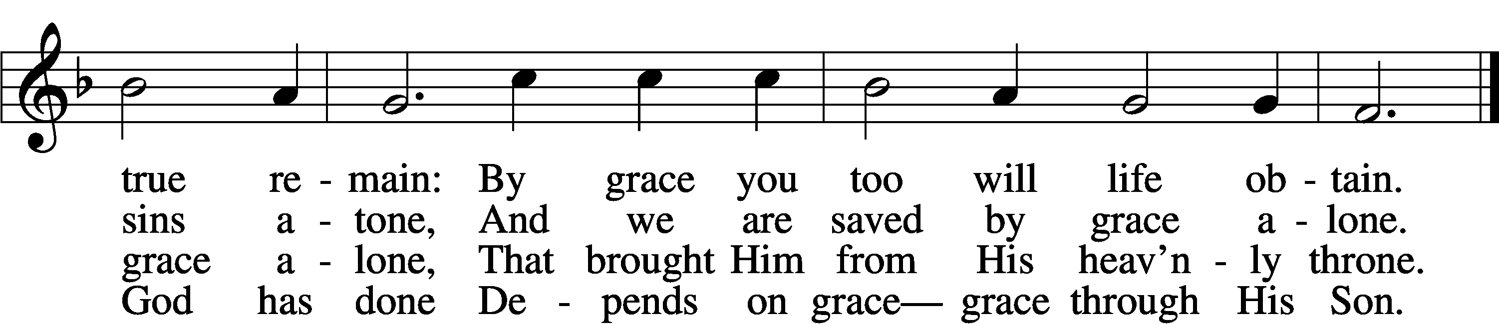

5 By grace to timid hearts that tremble,
In tribulation’s furnace tried,
By grace, in spite of fear and trouble,
The Father’s heart is open wide.
Where could I help and strength secure
If grace were not my anchor sure?

6 By grace! On this I’ll rest when dying;
In Jesus’ promise I rejoice;
For though I know my heart’s condition,
I also know my Savior’s voice.
My heart is glad, all grief has flown
Since I am saved by grace alone.
Text: Christian Ludwig Scheidt, 1709–61; tr. The Lutheran Hymnal, 1941, alt.
Tune: Cornelius Heinrich Dretzel, 1697–1775
Text and tune: Public domain

709 The King of Love My Shepherd Is
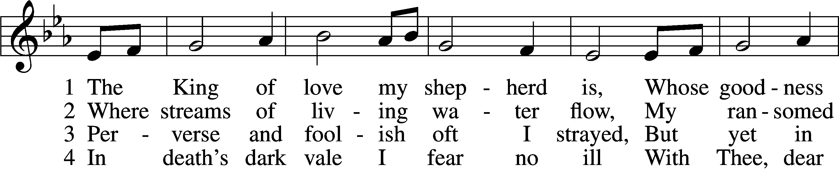
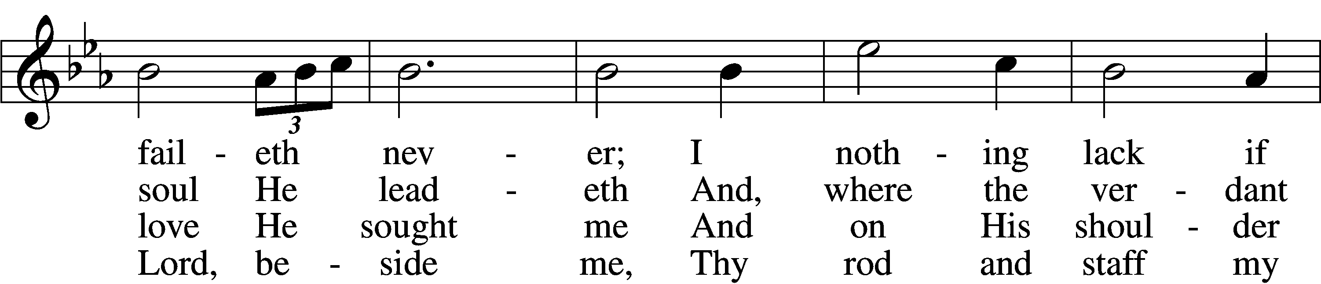
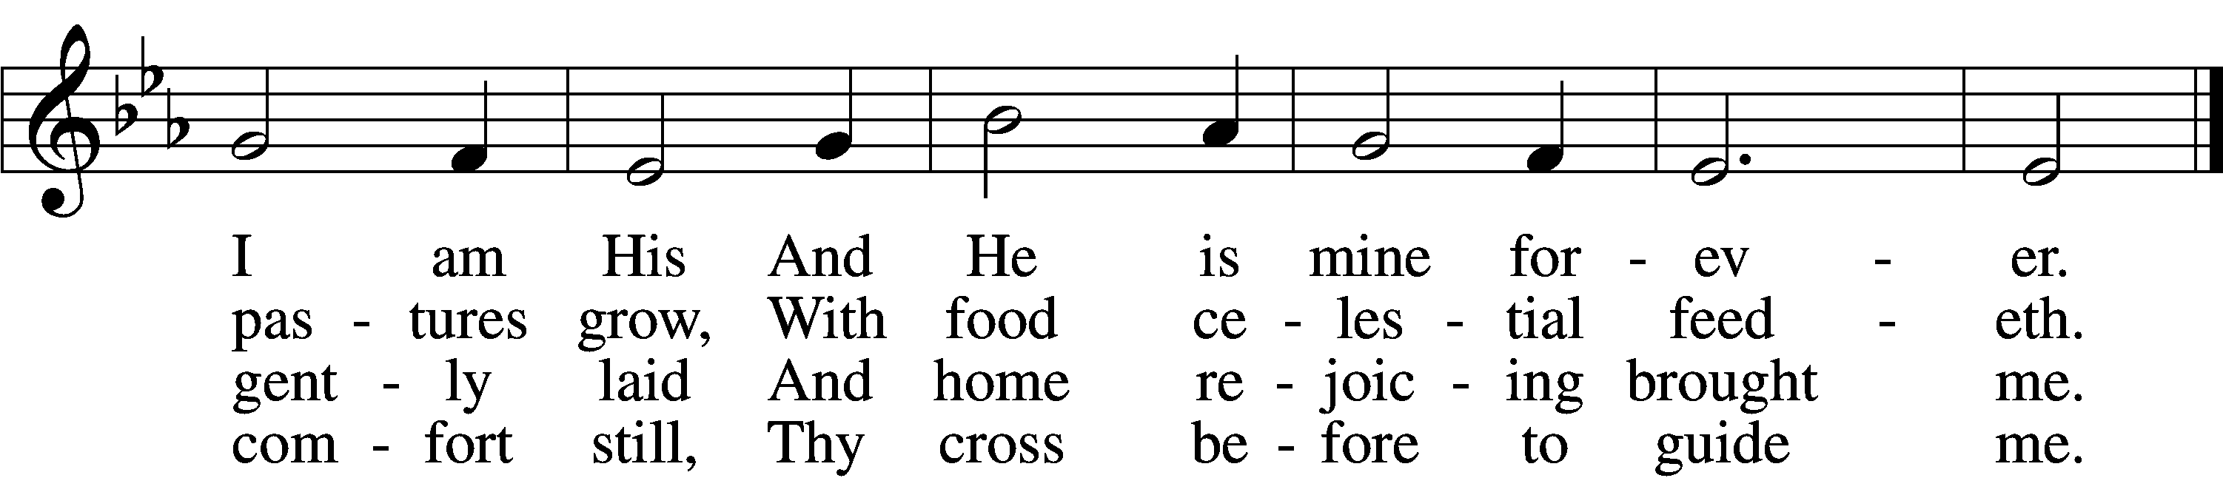

5 Thou spreadst a table in my sight;
Thine unction grace bestoweth;
And, oh, what transport of delight
From Thy pure chalice floweth!

6 And so through all the length of days
Thy goodness faileth never;
Good Shepherd, may I sing Thy praise
Within Thy house forever!
Text: Henry W. Baker, 1821–77
Tune: Irish, c. 18th cent.
Text and tune: Public domain

616 Baptismal Waters Cover Me
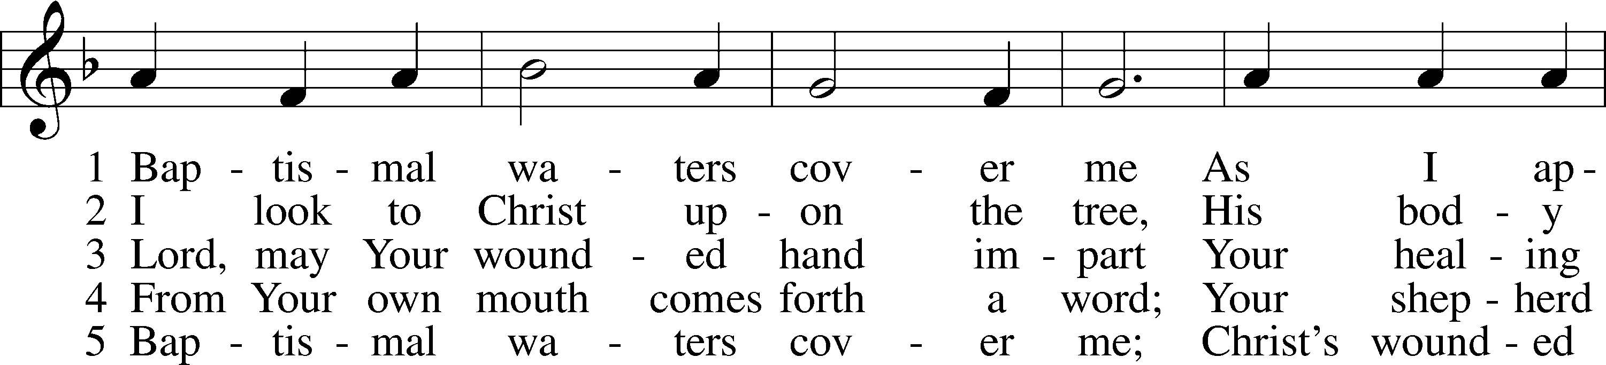
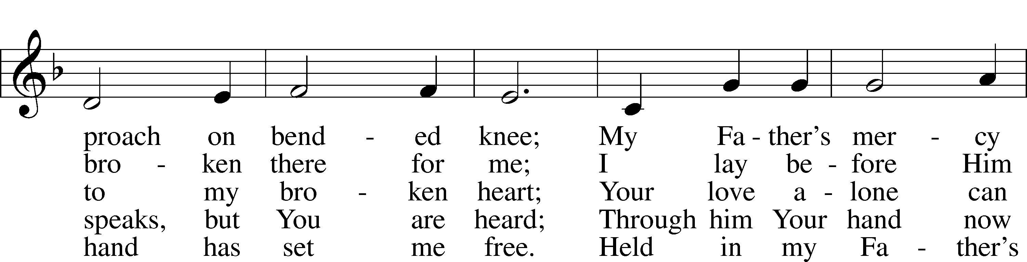
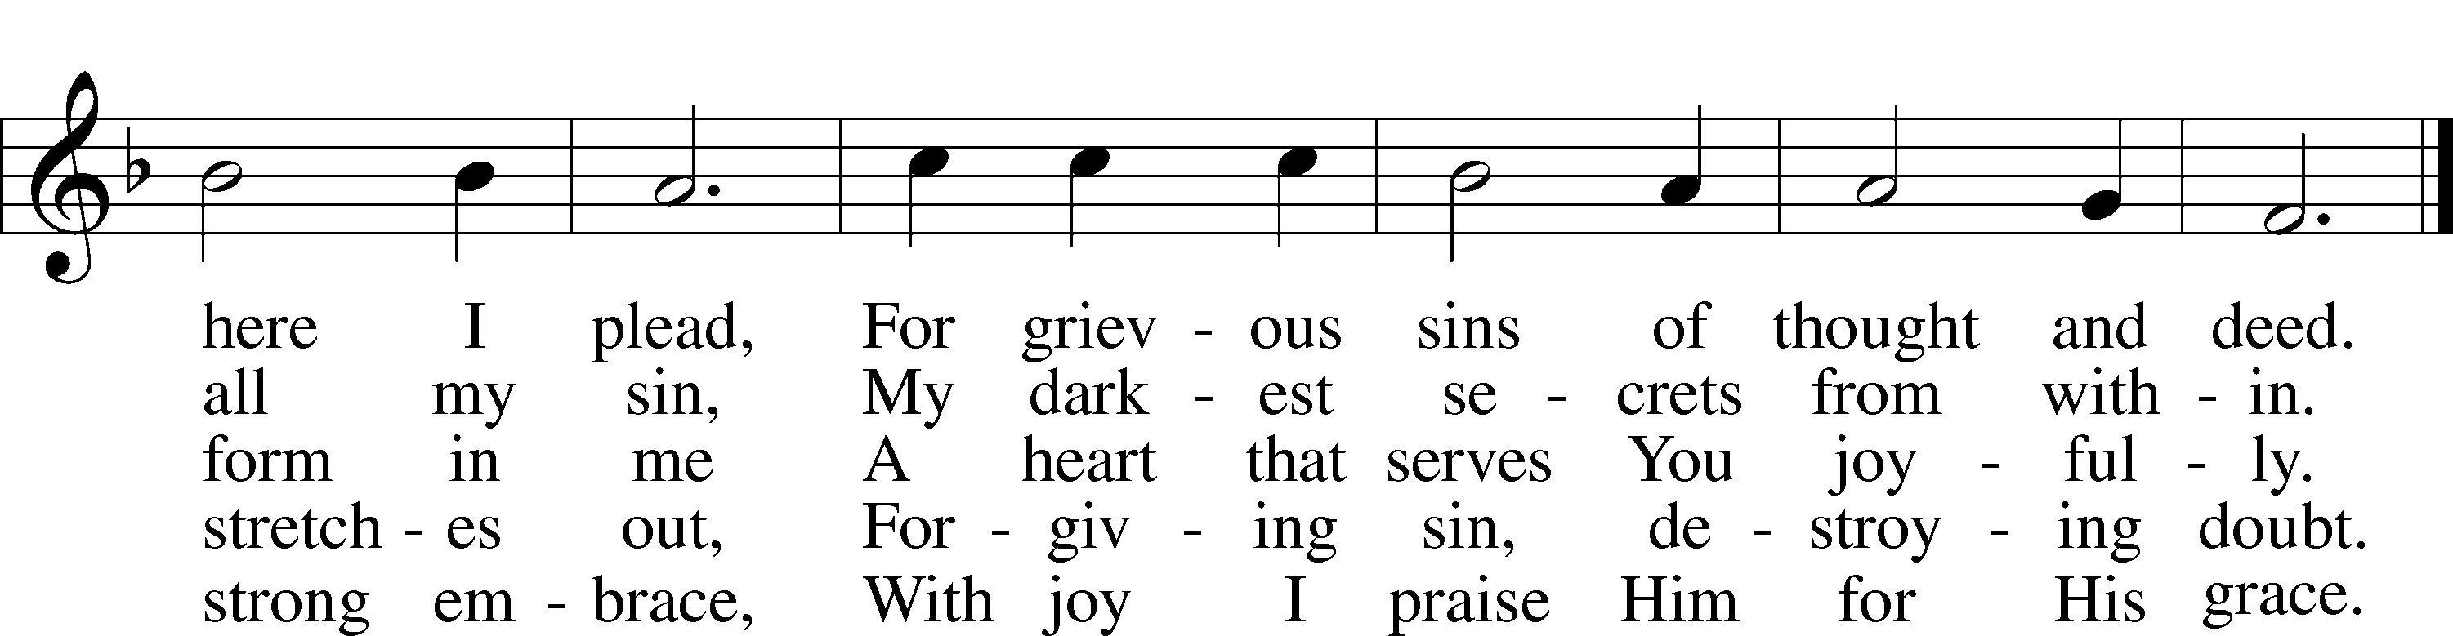
Text: Kurt E. Reinhardt, 1969
Tune: Sammlung alter und neuer . . . Melodien, 1742
Text: © 2003 Kurt E. Reinhardt. Used by permission: LSB Hymn License no. 110004822
Tune: Public domain

Thank the Lord
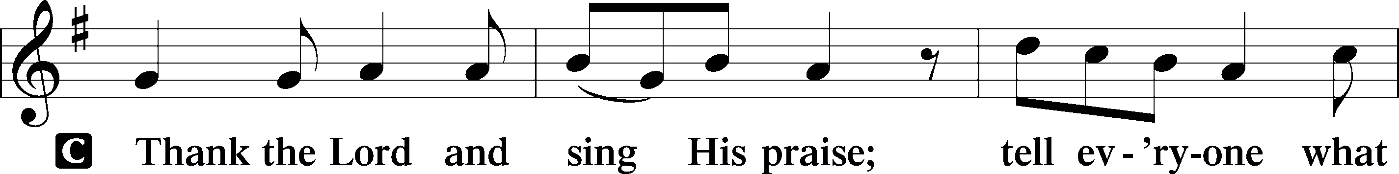
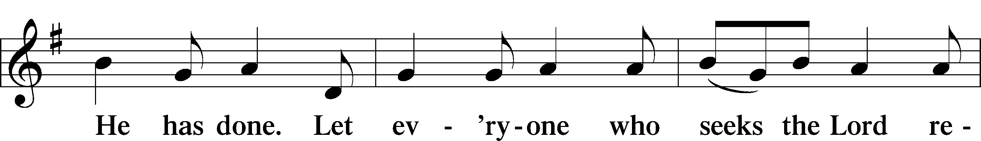
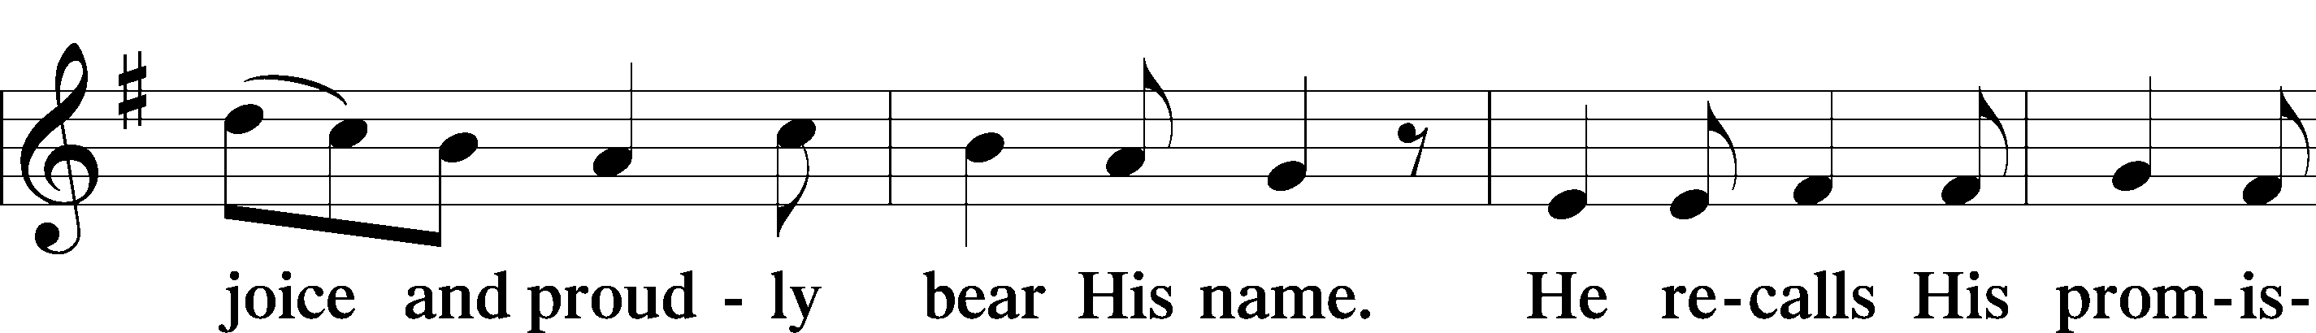
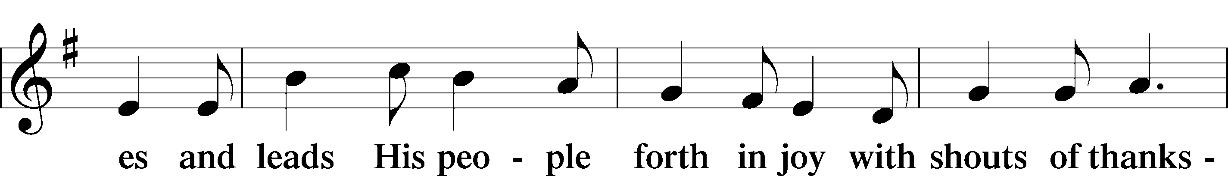
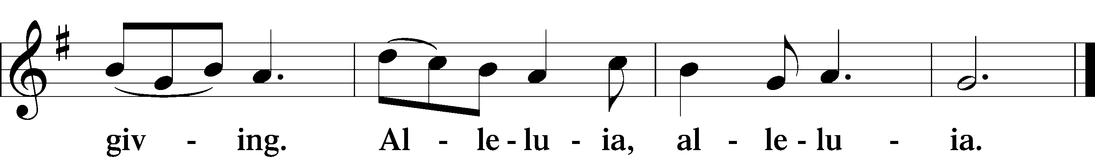

Post-Communion Collect
A Let us pray.
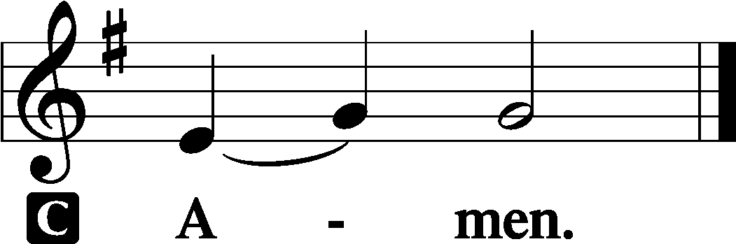

Benediction 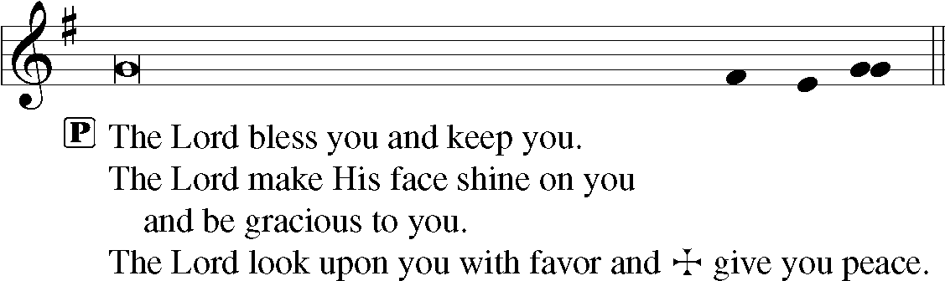
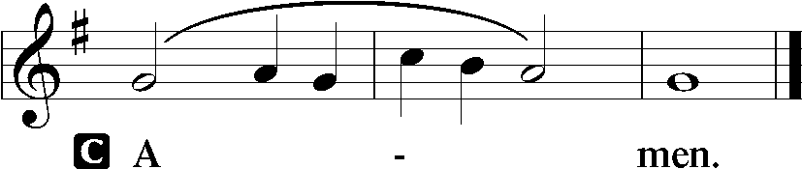

711 Savior, like a Shepherd Lead Us
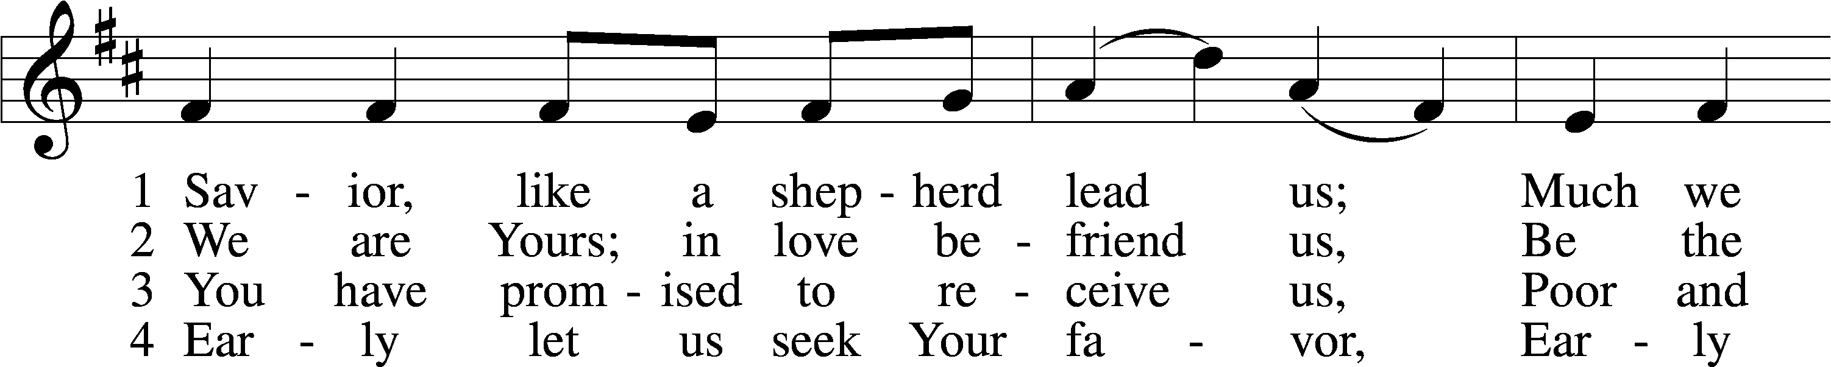
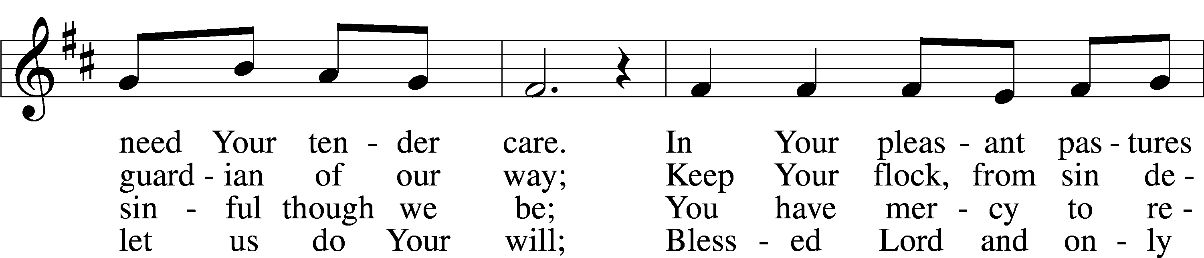
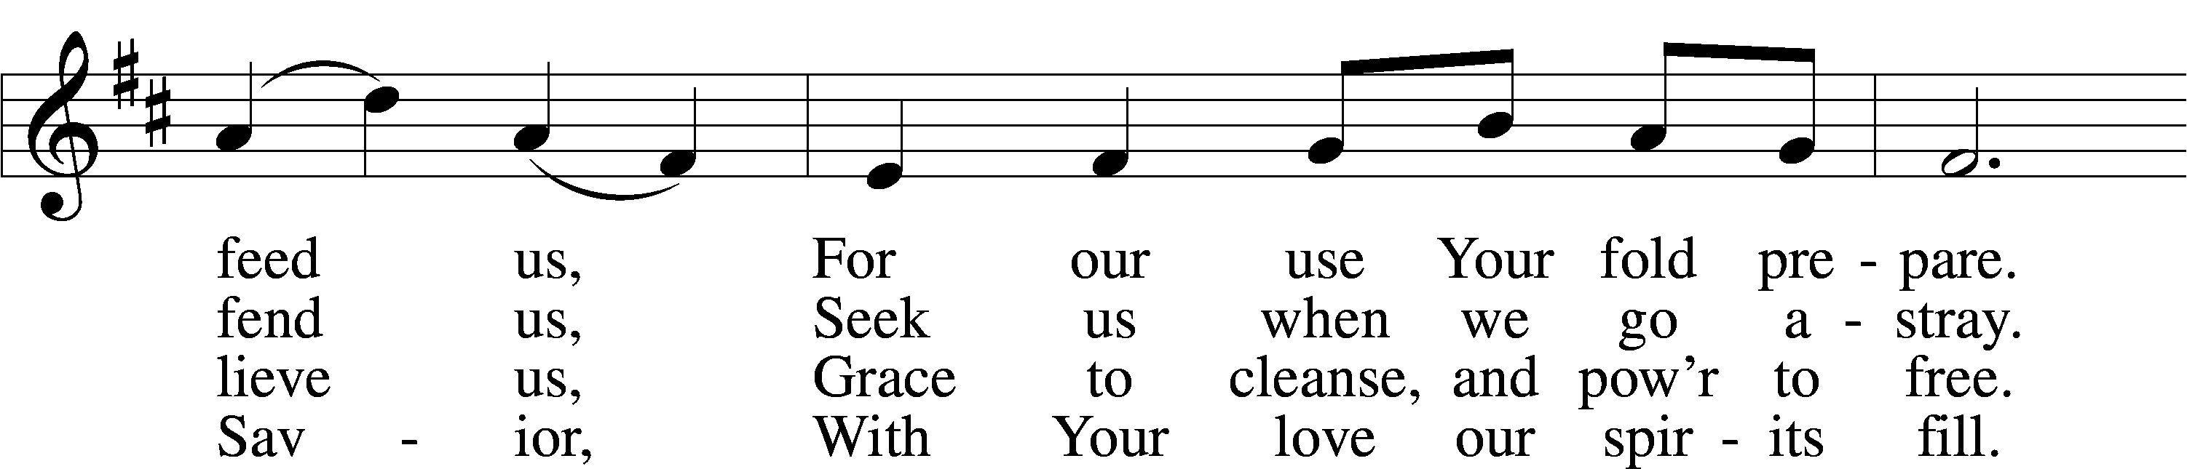
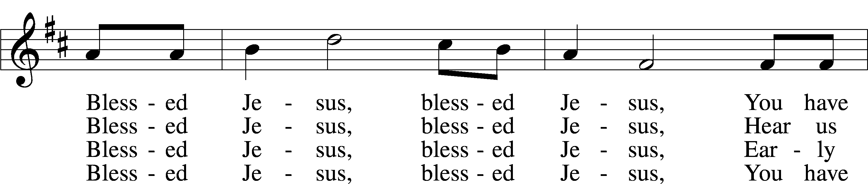
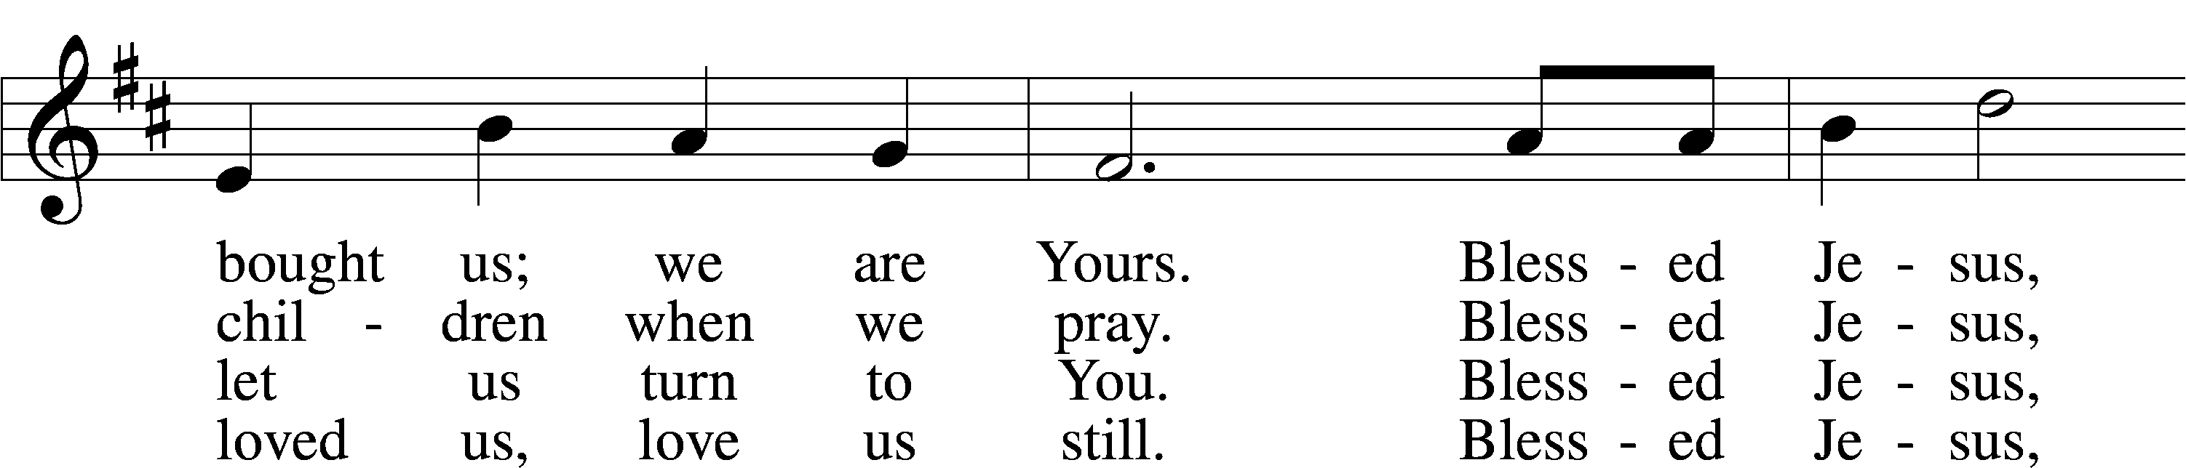
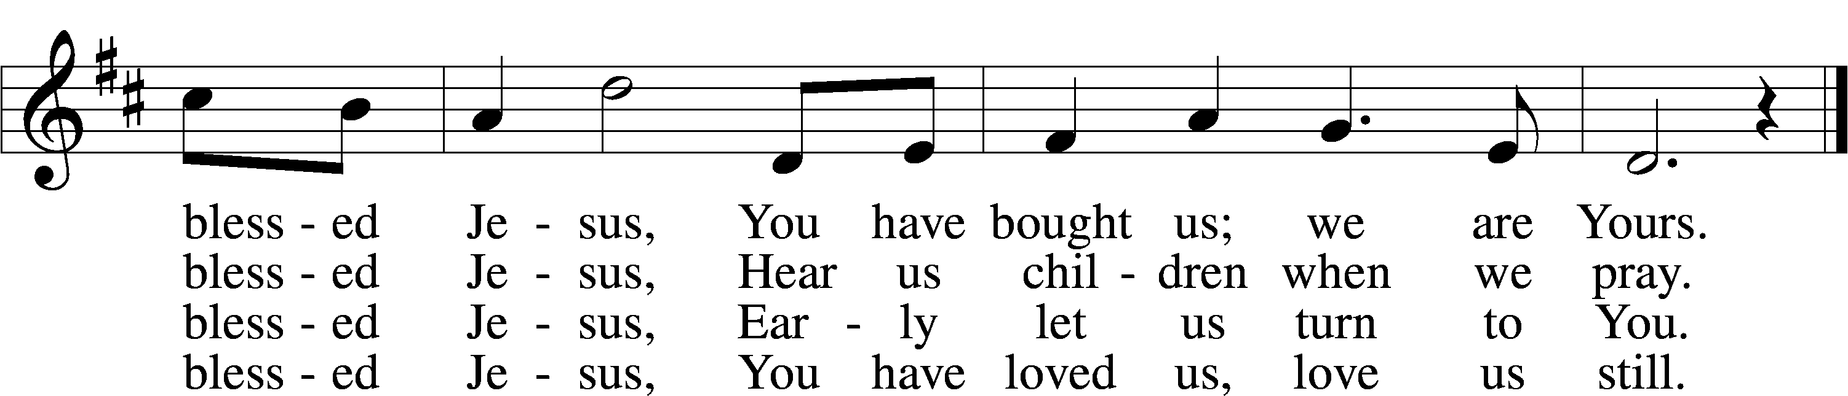
Text: Hymns for the Young, 1836, 4th ed., London, alt.
Tune: William B. Bradbury, 1816–68
Text and tune: Public domain

Divine Shepherd Calendar
Sunday, July 14th
Food Pantry Sunday
8:00 am Divine Worship Service
9:15 am Coffee & Cookies
9:30 am Adult Bible Study & Sunday School
10:30 am Divine Worship Service
Monday, July 15th
6:00 pm School Board Meeting
Wednesday, July 17th
5:30 pm Family Dinner
6:00 pm Vespers Service
Thursday, July 18th
9:30 am Ladies Bible Study
Sunday, July 21st
8:00 am Divine Worship Service
9:15 am Coffee & Cookies
9:30 am Adult Bible Study & Sunday School
10:30 am Divine Worship Service

The church calendar may also be found on our website at divineshep.org! Go to our website and scroll to the bottom.

Need to use the church for a special event? Reach out to the church secretary to fill out an event form! All events need to be approved by the Pastors and office beforehand.
Important Dates
Join the Heartland LCMS Singles Retreat at Camp Io-Dis-E-Ca (near Iowa City, Iowa) the weekend of July 19-21 for a time of indoor and outdoor recreation, Bible studies, fellowship, and the opportunity to meet other Lutheran singles from the Midwestern states. The conference is open to ages 21-41. $100 per person for two nights and four meals. Please register at https://www.faithwinterset.org/registration/

Please note that there will be no dinner or service on Wednesday, July 24th!

Sunday, August 11th, there will be one service at 9:30 am. We will be having a potluck afterwards to congratulate Pastor Dennis on completing his SMP program at Concordia Seminary-Ft. Wayne! The Elders will be cooking the meat. Please bring a side to share!

Divine Shepherd Prayer Walk-September 2024!
Divine Shepherd will be having a prayer walk on the morning of September 7th outside the church! We are looking for individuals that would be interested in volunteering and helping with the planning process. If you would like to help out in any way, please reach out to Kathy Swan (nawskat@gmail.com) or Katie Bierschbach (dslcsecretary@divineshep.org).

Zion Lutheran Preschool looking for aides!
Make a Difference! Zion Lutheran Preschool is looking for a special someone to help aide in the afternoon pre-kindergarten class Monday through Friday from 11:30am-3:30pm. This person would work closely with Mrs. Leyden, helping with lesson preparation, behavior guidance, and student support. For more information on this exciting opportunity, please call Hope at 342-5749 or email at zionpreschool@zionrc.org

